**Microdata.no – Ready, set, research!**

Johan Sjøberg, Statistics Norway[1], [sjj@ssb.no](mailto:sjj@ssb.no)

Andreas Skogmo Rønning, Statistics Norway1, [nga@ssb.no](mailto:nga@ssb.no)

**Abstract**

*Microdata.no is a technically innovative remote access solution that allows researchers and master/PhD-students instant access to register data with no application process, and at a low cost, from any computer.*

*A complicated application process, high prices and long delivery time are well known obstacles to research on register data. The microdata.no service removes these obstacles.*

*The solution is possible through a combination of a metadata driven approach and an automated statistical disclosure system. The user has no access to individual records, and noise is added to all output counts. The system is GDPR compliant.*

*Microdata.no was developed in the RAIRD[2]-project and launched in March 2018. Currently, 35 institutions and nearly 300 researchers and students are using the service, the first scientific article is to be published[3], Data Protection Agency (DPA) confirms that “RAIRD is important because of its privacy-by-design technology”[4], one university[5] has created a new position to develop knowledge on how to use microdata.no[6], and a ministry has asked for specific data to be included[7]. A number of institutions, among them Eurostat, have asked for in-house workshops and demonstrations of the service.*

*Approved research institutions gain instant access after signing an institutional agreement. User access is self-administered by the approved institution, without need for approval by Statistics Norway[8].*

*Version 1.0 of the system contains 124 variables on five main topics. New variables and updates of existing variables will be published annually. In 2019 40 new variables will be available in the system.*

*To serve a larger specter of research, SSB and partner NSD[9] have applied for additional funding from RCN[10] to develop microdata.no version 2.0. International access to the service, significantly more data and the ability to merge SSB data with sample data and third-party data from external registers will be the main addition in the new version.*

**Keywords:** instant access, low cost, register data, privacy-by-design, self-administrated

# A new way to conduct research

Statistics Norway (SSB) manages a large quantity of data in high demand from public administration, research and educational institutions. Data curated for statistical purposes is of great value for research, but a complicated and time-consuming application process as well as confidentiality issues with access to individual data, limit the access to these data (Microdata.no, 2015).

Together with Norwegian Centre for Research Data (NSD), SSB had an idea on how to avoid the whole application process by building a metadata driven platform with invisible data and anonymous output.

The result is microdata.no, a technically innovative remote access solution that allows researchers and master-/PhD-students instant data access with no application process, and at a low cost, from any computer while safeguarding the privacy of the registered individuals. Microdata.no was developed in the RAIRD-project, a joint effort between NSD and SSB funded by the Research Council of Norway (The Research Council of Norway, 2019).

The system allows researchers to work directly with 124 variables on population, education, labor marked income and property and social security data. The metadata driven approach, and an automated statistical disclosure system makes it possible to work with data, without access to individual records, where noise is added to all output counts.

# Microdata.no – First year of service

The research community shows considerable interest for the new research service. Since the launch of microdata.no in March 2018, more than 30 institutions have signed an institutional agreement to gain access for more than 300 end-users. The first scientific article based on analysis completed in microdata.no has been approved and is to be published (Ballo, unpublished). In addition, several other non-research institutions have applied for access, highlighting the potential of microdata.no.

The possibility to give cheaper and instant access to SSB register data leads to a bigger potential for usage from researchers and students who otherwise would not be able to access register data. Easy, cheap and fast online access to microdata for research should lead to more research and more published articles.

Microdata.no has great potential at universities and colleges as register data is expensive and difficult to obtain. Register data is expensive and difficult to obtain, and therefore seldom used as a part of the curriculum at universities and colleges. Microdata.no gives the institutions a possibility to use register data as a way of introduction to method analytics. The Norwegian University of Science and Technology has recently hired a doctoral candidate to explore how the institution can utilize microdata.no to its purposes.

One of the key features of microdata.no is the privacy-by-design that ensures that end-users are not able to identify individuals when analyzing data. The Norwegian Data Protection Authority (DPA) has previously stressed the importance of RAIRD because of its privacy-by-design technology (Buer et al, 2017) as “an advanced solution for data protection in research” (Thon, 2019) . Early 2019, microdata.no won a “Best privacy-by-design 2018”- competition hosted by DPA. The jury emphasized that microdata.no removes the privacy risk of research on microdata, as well as giving faster and less expensive access to data (DPA 2019).

# What is microdata.no

## *RAIRD online Statistical Environment – ROSE*

ROSE is the online workspace in microdata.no, and it allows the end-user to interact with data through analytical exploration and metadata available within the system. A Statistical Disclosure System (SDC) ensures that all output is anonymous. The system requires a web browser and is accessible to the end-user regardless of location. The SDC is used to ensure that confidential information is not revealed, and the measures implemented are described in the user-manual (Microdata.no, 2019). In short, they are as follows

* The end-users are not allowed to define populations of less than one thousand. Any attempt to do so will return an error from the system.
* To minimize the identification risk connected to extremes, microdata.no uses a technique called winsorization. When importing continuous variables, the platform changes the values of the highest 1% to the 99th percentile, and the value of the lowest 1% to the 1st percentile. It affects all counts, statistics, and graphical plots.
* All output counts are subject to noise. Noise addition follows the principles described in Thompson et al (2013). The noise is constant, resulting in the same totals when the same aggregations are made, based on the same data (Heldal et al, 2015).
* According to Heldal et al (2015) „Scatterplots must be presented in such a way that the value of the ‘second’ variable cannot be read too accurately from the ‘first’”. In microdata.no, hexbin-plot has been used as a protective measure. Hexbinplot divides the geopgraphical area in hexagons scaled from the smallest and largest values. These values are already affected by the previously mentioned winsorization. The number of observations in the hexagons are represented with different grades of colour as potrayed in figure 1. The range of units or individuals represented in each hexagon are equally long and automatically adjusted by the distribution of data (Microdata.no, 2019).

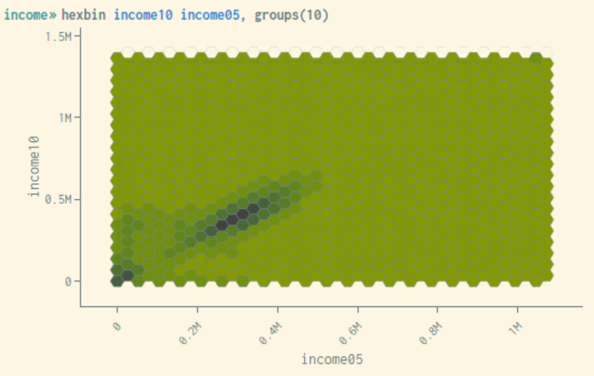

Figure 1: Hexbin-plot from microdata.no. Darker color in hexagons illustrates higher number of observations.   
source: www.microdata.no/rose

* All identifiers, both for individuals and organisations, has been replaced by a pseudonym to ensure no personal information is a part of the data files used in microdata.no.

## *Data*

In its present version, microdata.no contains data on 10,2 million persons, equivalent to everybody who has or has had a Norwegian national identity number. Data in microdata.no is categorized into four separate types of variables according to their temporality; accumulated, status, fixed and event variables. As seen in table 1, each set of data has a set of characteristics; an identifier, a measure or value and a start and stop date.



Table 1: Accumulated variables as demonstrated by data from the variable INNTEKT_WYRKINNT in microdata.no. All datasets consist of an identifier, measure (value), start- and stop date.

Accumulated variables will show the value for a set period. As seen in the example in table 1, an individual’s income is organized as previously mentioned, with the accumulated income of the 2016 as the measure. Each year the individual has had an income, it will be represented by a record in the dataset.

Status variables are a cross section of statuses at a specific time of the year. In SSB information about occupation is measured at the end of the reference week, which for the period of 2000 to 2014 has been the third week of November (SSB, 2019). 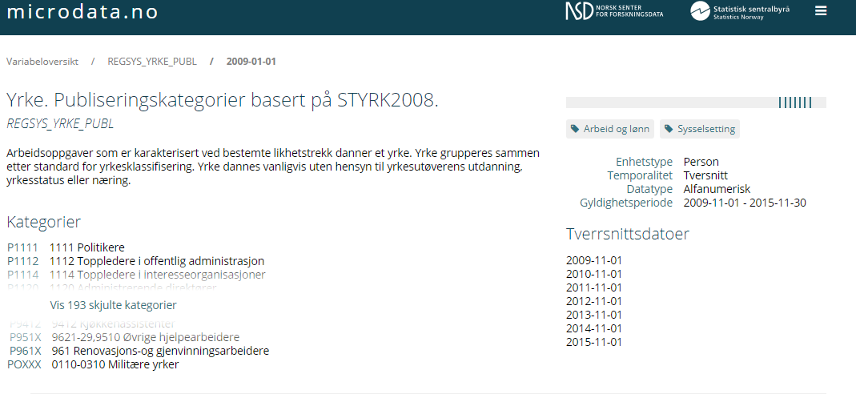

Figure 2: Possible dates when importing a status variable represented by REGSYS_YRKE_PUBL as seen in the variable library Discovery in microdata.no. source: www.microdata.no/discovery

Fixed variables are variables that do not change, and thus are not dependent on a start and stop date.

The most complicated group of variables is event variables, mainly due to the need for high data quality. Subjects in event variables have one record for each change in status.

## *General Data Protection Regulation - GDPR*

Statistics Norway must comply with GDPR when handling personal data[11], and since there are personal data in microdata.no, GDPR will apply. To ensure compliance in this phase, SSB has carried out a Data Protection Impact Assessment pursuant to GDPR article 35 no. 7. To minimize the risk of privacy breaches, SSB uses a pseudonym in the microdata.no database instead of the national identity number and other identifiers. Identifiers, the connection between pseudonyms and identifiers and the pseudonyms are kept separate from each other.

The users of microdata.no do not handle personal data, and due to the statistical disclosure measures all output are anonymous. It is not possible to relate the output to a certain person who can be identified directly or indirectly according to GDPR article 4 (1). Because of this, GDPR does not apply, as opposed to when researchers apply for regular (not-anonymous) microdata.

# How microdata.no is organized

Microdata.no is a joint service from NSD and SSB and responsibilities and support are divided in accordance to a cooperation agreement (Samarbeidsavtale, 2018). Most importantly NSD oversees ROSE and its functionality. This includes developing new features and analyzing methods before implementing them into the system. All new features are thoroughly tested by both NSD and SSB to ensure that they work together with the SDC.

All questions, whether it is to report a technical problem or to get help using ROSE, is directed to NSD through email or chat. In addition, NSD handles the webpage microdata.no, layout, login-system and help functions related to ROSE. The help section contains helpful features and information for the end-users. In addition to basics, such as contact information and an FAQ, it also includes examples of how to use some of the functionalities in the system and an extensive user manual. The user manual gives the end-users a step-by-step guide of how to use ROSE, its commands, and detailed information about the various SDC functions (Microdata.no, 2019).

Statistics Norway is handling the daily management of microdata.no. SSB interacts with institutions and end-users in enrolling into the service and gives support in questions about data and metadata. When preparing new variables to be published in microdata.no, SSB restructures data and collects metadata necessary for new variables to be approved in the system. Several tests are run to ensure that data and metadata in the facilitated variables corresponds, and any inconsistencies must be solved before the variables can be published. In addition to support and facilitating new variables, SSB is constantly developing the infrastructure to streamline any process required to provide end-users with a wider scope of data.

## *Who can gain access?*

For the time being, only approved research institutions, colleges and universities and institutions with a research project funded by RCN or similar, can gain access by signing an institutional agreement. This coincides with the institutions that can apply for microdata for research projects (Statistics Norway, 2019). The institutions agree to certain conditions by signing the institutional agreement, amongst them that “users who are registered are academic employees, master’s students or doctoral students at the research institution” (see appendix 1). The end-users agree by signing the end-user agreement to use the information gained through microdata.no “for statistical purposes in research, including preparatory work/planning of the research” (see appendix 2). Within these boundaries, the institutions are free to give access to an unlimited number of end-users at their own discretion. The end-user must be identifiable (at the moment by a Norwegian identification number) to be able to log into the system. Work is in progress to establish a universal access system with the same level of security.

## *How to gain access*

To gain access to microdata.no, interested institutions must sign an institutional agreement. The completion of the agreement is done electronically, and for the most part by the institutions themselves and is illustrated in figure 2. To initiate the process a person at the institution will have access to the agreement when identified through *ID-porten* provided by Agency for Public Management and eGovernment (DIFI, u.d.). When completed, the agreement will be sent via *Postens signering* (Posten, 2019) to a person with signing authority at the institution. When the agreement has been signed SSB will receive the agreement for approval. All administrators identified in the agreement will be automatically generated when the agreement is approved. It is up to the institution to decide who completes the agreement, however the person who signs the contract must be approved to do so on behalf on the institution.

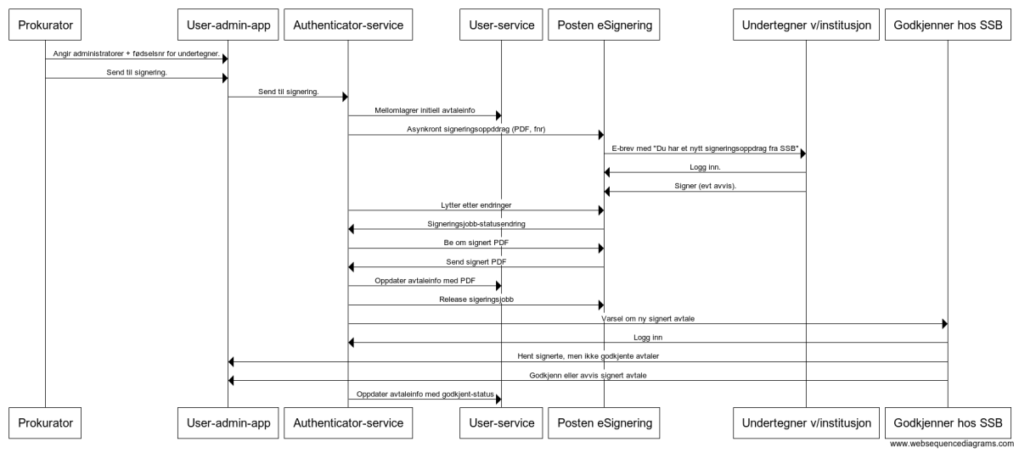

Figure 2: Sequence diagram of the process of entering an institutional agreement.

There is a goal that the institutions are as self-sufficient as possible when handling microdata.no. Except for initializing the institutional agreement, the institutions decide who completes the agreement, who should be administrators, changing of administrators, how many end-users and adding and removing end-users.

## *User roles*

Microdata.no has five user roles in the system. Four of them are available for the institutions, while the final one is an SSB and NSD user only. The *procurator* is the person who initiates the agreement process on behalf of the institution. By using the electronic ID as identification, the user is generated for this person and will be a visible option every time this person logs on to the system. The procurator will appoint the *administrators* as a part of the agreement and forwards the agreement to be signed. The procurator can at any time add or remove administrators by updating the agreement and re-send it for signing

The *administrator* is automatically generated upon approval of the agreement. Administrators log into the system via electronic ID and can generate end-users on behalf of the institutions. Administrators need the end-user’s national identity numbers to be able to create the user.

The *end-users* are divided into two types of users; one for researchers and one for students. Both types have the same access to data and functionality, but the length of the access varies. Researcher access must be renewed every two years, while student access must be renewed every year. After the end-users have been generated by the *administrators*, they log into the system via electronic ID and must sign an end-user agreement (see appendix 2) to gain access. It is the only user with access to ROSE.

Selected persons at SSB and NSD have *system administrator* access. This user can approve or deny agreements, create or adjust names of approved institutions, create and delete administrators and end-users if necessary. It can also access the institutional agreements to ensure they have been signed by an approved person.

# Microdata.no – Short term plans

The future success of microdata.no is closely connected with the ability to evolve, develop and expand. To remain status quo on functionality and available variables, would quickly lead to researchers losing interest in the service. Several short-term measures will be taken to ensure the service remains relevant and up-to-date.

The variables available in the system today are a small part of the vast scope of register data in SSB. To increase the scope of available data is a crucial short-term goal for microdata.no. This can be done by expanding the existing variables with new yearly issues and adding new variables not already in the system.

## *Annual updates of existing variables*

The data and metadata of the existing variables in microdata.no are under constant review based on feedback from end-users, our own testing of the system, and a desire to provide correct information about each variable. In addition to this, most available variables can be updated with releases once a year.

## *New variables*

In addition to regular updates of the existing variables, expanding the number of available variables is a short-term priority. Several ways to determine which variables should be adapted for use in microdata.no will be used. Based on the most sought-after variables when researchers apply for microdata, a long list of possible and relevant variables has been provided to choose from. Some variables will be chosen by SSB to complete the lists available to researchers to choose from (Statistics Norway, 2018). SSB will choose variables at their own discretion to include in the system, but external requests and concrete funded assignments will be prioritized. In addition, researchers are encouraged to suggest variables to be included in the system. Data provided in microdata.no today is individual data and therefore, expanding the scope of data to include businesses will be a part of the expansion.

## *Microdata-on-Demand*

A third way to expand the scope of variables is to allow end-users to request, and subsequently pay for those variables to be facilitated and used in microdata.no. Microdata-on-Demand will allow student and researchers to gain access to the variables they need to use microdata.no for their entire research project.

## *Functionality from user need*

The support function of microdata.no provides an active and direct dialogue between end-users and developers. End-users questions and feedback helps to identify needed functions not currently available in the system. From this, the developers can find and test different solutions to best accommodate the request from end-users, subject to approval of the SDC. A user-committee gives input and assessments of the current system, as well as specific suggestions as to features the systems needs to include for it to gain a wider range of usability for researchers and for educational purposes.

## *Expanding scope of potential customers*

In addition to the already approved research and educational institutions, a new Statistics Act has been proposed by The Norwegian Ministry of Finance. If implemented, the Act would grant expanded access to detailed data to public authorities[12]. For microdata.no this would mean more potential customers. The system has a feature of adding or removing institutions, which enables the system administrators to easily add new customers, should this be required. This makes microdata.no ready for any new institutions that have been granted access by new propositions.

## *Price*

As a part of the conditions for the grant received by NRC, the service is free to its users for a period of two years after launch. From March 2020, microdata.no will become a self-financed service where management of microdata.no will be paid for by its users or other financial sources. Finding a price structure that facilitates all types of institutions (educational, research, big or small) is a challenging task. To be self-financed by user payment, there are some key factors that needs to be addressed. Feedback from the user-committee points to the importance of microdata.no being a finished product and not a work in progress. To receive the necessary funds, microdata.no must attract a wide enough client base. This is done by ensuring that functionality and scope of available data is at a certain level for microdata.no to be a real alternative for the institutions. Furthermore, other sources for funding must be found to be able to develop microdata.no in the future.

# The future of Microdata.no – Microdata.no version 2.0.

In the fall of 2018, NSD and SSB submitted a new application to NRC to receive funds to further develop microdata.no. Subject to funding, the new version of microdata.no “builds on the core concepts of the current generation and expands the platform’s data scope, target audience and impact” (Statistics Norway & Norwegian Centre for Data Research, 2018).

One of the key new features in an upgraded microdata.no, is the possibility to merge third party data with the data available in microdata.no. The end-users will use microdata.no version 2.0 as a desktop, were they access data from different data owners by using a common metadata-system as a base. The data will be stored and curated by each data owner. In ROSE, the end-users will define their populations and variables and will run their analysis on data stored at multiple locations. NSD and SSB will collaborate with a third-party pilot partner, Cancer Registry of Norway, to find the best possible solution (Statistics Norway & Norwegian Centre for Research, 2018). In addition to add third party data, the ability for researchers to add their own surveys will be an important upgrade. This, however, will demand an administrative tool for final approval of formal compliance and additional risk mitigations strategies, as adding personal surveys represents a risk of confidentiality (Statistics Norway & Norwegian Centre for Research, 2018).

While the available variables will gradually expand through regular updates the application targets an extension of SSB-data scope by a factor of 10-50 throughout the project (Statistics Norway & Norwegian Centre for Research, 2018). To be able to increase the SSB-data scope, and with the inclusion of external data owners, a microdata manager must be created in order to make the process of publishing variables automated (Statistics Norway & Norwegian Centre for Research, 2018).

The infrastructure of microdata.no 2.0 will support access for international end-users, and thus also have English translation of metadata, supporting materials and procedures for institutions to gain access (Statistics Norway & Norwegian Centre for Research, 2018).

For end-users who require de-identified data and according to the new GDPR require legal applications, microdata.no 2.0 can be used as a digital access dialogue that “will integrate administrative and metadata-handling process” (Statistics Norway & Norwegian Centre for Research, 2018). This will enable the end-user to get an automated step-by-step application process that will also provide estimated price and time of delivery (Statistics Norway & Norwegian Centre for Research, 2018).

Referances

Johan Heldal, E. M. T. R. a. Ø. R., 2015. *The RAIRD Project: Remote Access Insfrastructure for Register Data..* [Online]   
Available at: https://www.unece.org/fileadmin/DAM/stats/documents/ece/ces/ge.46/20150/Paper_26_Session_5_-_Norway__Heldal_et_al._.pdf  
[Accessed 13 May 2019].

Norwegian Centre for Research Data & Statistics Norway, 2015. *RAIRD White Paper - Detailed Description.* [Internett]   
Available at: http://raird.no/whitepaper/whitepaper-detailed.html  
[Accessed 13 May 2019].

microdata.no, 2019. *Brukermanual for microdata.no.* [Online]   
Available at: https://microdata.no/brukermanual-en.pdf  
[Accessed 13 May 2019].

Statistics Norway, 2019. *Approved research institutions.* [Online]Available at: <https://www.ssb.no/en/omssb/tjenester-og-verktoy/data-til-forskning/godkjente-forskningsinstitusjoner>  
[Accessed 13 May 2019].

*Samarbeidsavtale* (2018). between Staistics Norway and Norwegian Centre for Research Data - Filed at Statistics Norway, In norwegian only.

The Research Council of Norway, 2019. *INFRASTRUKTUR – Nasjonal satsing på forskningsinfrastruktur.* [Online]   
Available at: https://www.forskningsradet.no/om-forskningsradet/programmer/infrastruktur/  
[Accessed 13 May 2019].

Thompson, G., Broadfoot, S. and Elazar, D. (2013). *Methodology for the Automatic Confidentialisation of Statistical Outputs from Remote Servers at the Australian Bureau of Statistics.* Joint UNECE/Eurostat work session on statistical data confidentiality.

DPA (2018) *Innebygd personvern i praksis – frokostseminar og premieutdeling.* Available at: <https://www.facebook.com/2107913795970367/videos/342643286386740/?t=0> [Accessed May 13th, 2019]

Buer, V. J., Alvheim, A. and Johansen, S. (2017) Kronikk: Norsk teknologi vil gi bedre personvern og mer effektiv forskning. *Forskning.no*. 26.september 2017. Available at: <https://forskning.no/kronikk-forskningsetikk-om-forskning/kronikk-norsk-teknologi-vil-gi-bedre-personvern-og-mer-effektiv-forskning/1161947>   
[Accessed: 13 May 2019].

Ballo, J. (2018). Labour market participation for young people with disabilities: The impact of gender and higher education. Work, Employment and Society Paper for Review, 2018, pp. 23-53.

Thon, Bjørn Erik, Director General at the Norwegian Data Protection Authority. Speech at microdata.no launch. Statistics Norway, Oslo, 23 May 2018.

Statistics Norway, 2019. *Data for research – step by step.* [Online]Available at: <https://www.ssb.no/en/omssb/tjenester-og-verktoy/data-til-forskning#Data_availability_and_mandatory_exemptions_from_the_duty_of_confidentiality>   
[Accessed 13 May 2019].

Statistics Norway & Norwegian Centre for Research (2018). *Microdata 2.0 - Norwegian microdata platform for national and international research, analysis and higher education.* (Unpublished) Project description. Available from Statistics Norway upon request. In Norwegian only.

**Appendix 1: Institutional agreement**

SSB-ref: WEBSAKNR

|  |
| --- |
| Norwegian Centre for Research Data (NSD)/Statistics Norway (SSB)  (herein ‘NSD/SSB’)  have entered into an agreement on the use of microdata.no.  with  INSTITUTION  (herein ‘the research institution’) |

1. Registration

This agreement entitles the research institution to register academic personnel and master’s and doctoral students in microdata.no who are affiliated with the institution and have a need for data from microdata.no for research purposes. Registration is valid up to and including 31 March 2020 for academic personnel. For master’s and doctoral students, registration is valid for 12 months from the date of registration, but no longer than 31 March 2020.

**2. Responsibilities of NSD/SSB**

NSD/SSB have joint responsibility for the administration and operation of microdata.no.

NSD/SSB bear no responsibility for the quality of the administrative registers on which microdata.no is based.

NSD/SSB bear no responsibility for errors that occur and/or losses that arise as a result of using the analysis tool in microdata.no.

NSD/SSB bear no responsibility for conclusions drawn by the research institution or other users which stem from their use of microdata.no.

NSD/SSB reserve the right to make changes to the services that are included in microdata.no.

**3. Rights and responsibilities of the research institution**

**3.1 The research institution’s right to register users**

The following persons may register users on behalf of the research institution:

|  |  |
| --- | --- |
| **Name** | **National identity number (11 digits)** |
|  |  |
|  |  |
|  |  |
|  |  |
|  |  |

**3.2 Responsibilities of the research institution**

The institution is responsible for ensuring that the users who are registered are academic employees, master’s students or doctoral students at the research institution, cf. section 1.

The research institution is responsible for ensuring that the users use microdata.no in accordance with this agreement and the terms of the individual user agreement.

**4 Costs**

The research institution’s users can use microdata.no free of charge up to and including 31 March 2020.

Free use does not include services related to courses/training/guidance.

**5 Breach of agreement**

Data must only be used for statistical purposes in research, including preparatory work/planning of the research.

Identity disclosure and attempts to reconstruct the identity of a statistical unit (person/enterprise) in the data are not permitted.

Breaches of rights or responsibilities (cf. section 3) may result in the research institution and/or the user being suspended from microdata.no and from accessing other microdata from SSB.

**6 Termination**

The agreement is valid up to an including 31 March 2020. Upon expiry of this agreement, a new agreement must be entered into for extended use.

The research institution and SSB/NSD may terminate the agreement with six months’ notice.

All customers and users, as well as the Research Council of Norway, will be given six months’ written notice in the event of any decision by NSD/SSB to discontinue microdata.no.

Any objections to the cessation of the service must be submitted to NSD/SSB within one month of notice being given. If the decision is nevertheless made to discontinue microdata.no following an assessment of the objections, notification will be given as soon as possible, and at least four months in advance.

**7 Disputes**

Efforts must be made to resolve any conflicts or disagreements through dialogue between the parties.

If the situation is not resolved through dialogue within a reasonable period of time and the customer is a central government agency, the situation must be resolved out of court through standard administrative procedures.

If the situation is not resolved through dialogue between the parties within a reasonable period of time and the customer is an independent legal entity, the case may be brought before the ordinary courts. Oslo is the stipulated legal venue.

**8 Signatures**

|  |  |  |
| --- | --- | --- |
| Place/date:  For NSD/SSB |  | Place/date:  For the research institution: |
|  |  |  |
| Name/job title in block capitals:  __________________________________________ |  | (Head of research at the research Institution)  Name/job title in block capitals:  ________________________________________ |

**Appendix 2: End-user agreement**

|  |
| --- |
| Agreement on the use of microdata.no between  Norwegian Centre for Research Data (NSD)/Statistics Norway (SSB)  (herein ‘NSD/SSB’)  and  END USER  (herein ‘the research institution’) |
|  |

**1. Introduction**

This agreement entitles the user to use microdata.no for research purposes. The agreement assumes that a research institution (the registering institution) has registered the user as a user and signed an institutional agreement with microdata.no.

**2. Responsibilities of NSD and SSB**

SSB bears no responsibility for the quality of the administrative registers on which microdata.no is based.

SSB bears no financial responsibility for losses that arise as a result of the quality of data.

SSB bears no responsibility for errors that occur and/or losses that arise as a result of using the analysis tool in microdata.no.

SSB bears no responsibility for conclusions drawn by users or the registering institution which stem from their use of microdata.no.

NSD/SSB reserve the right to make changes to the services that are included in microdata.no.

**3. Duties, rights and responsibilities of the user**

**3.1. Responsibilities of the user**

Data must only be used for statistical purposes in research, including preparatory work/planning of the research. Privacy is protected in microdata.no through built-in measures that prevent the disclosure of data that can be linked to individuals. Attempts to compromise this protection are not permitted.

**3.2. Responsibilities of the research institution**

The user is aware that the registering institution is responsible for the user’s use of microdata.no in accordance with section 3.2 of the institutional agreement and sections 3.1 and 3.3 of this agreement.

The registering institution is also responsible for ensuring that the users are academic employees, master’s students or doctoral students who are affiliated with the institution.

**3.3. The user’s right to use microdata.no**

Approved users can use microdata.no free of charge up to and including {EXPIRY DATE}.

Free use does not include services related to courses/training/guidance.

The user confirms their affiliation with the registering institution at each log-in. The agreement will automatically expire if the user is no longer affiliated with the institution.

The user is aware of the consequences of breaching the agreement (cf. section 4), both for the user and for the registering institution.

**4. Breach of agreement**

**4.1. Breaches and erroneous use**

Breaches of rights or responsibilities (cf. section 3) may result in the user and/or overarching research institution being suspended from microdata.no and from accessing other microdata from SSB.

**5. Validity and termination**

The agreement is valid as long as the user is affiliated with the registering institution, but not beyond {EXPIRY DATE} for users who are academic employees. The agreement will automatically expire if the user is no longer affiliated with the registering institution.

For master’s and doctoral students, the agreement is valid for as long as the user is affiliated with the registering institution, but no more than 12 months from the date of registration, and not beyond {EXPIRY DATE}.

The agreement may be terminated by the user or SSB/NSD with six months’ notice.

All registering institutions and users, as well as the Research Council of Norway, will be given six months’ written notice in the event of any decision by NSD/SSB to discontinue microdata.no.

Any objections to the cessation of the service must be submitted to NSD/SSB within one month of notice being given. If the decision is nevertheless made to discontinue microdata.no following an assessment of the objections, notification will be given as soon as possible, and at least four months in advance.

**6. Disputes**

See section 6 of the institutional agreement for information on disputes.

Oslo/Bergen, {DATE}.

For NSD/SSB: ...

1. Statistics Norway, Oterveien 23, N-2211 Kongsvinger, Norway
2. Remote Access Infrastructure for Register Data - [www.raird.no](http://www.raird.no)
3. Ballo, J. (2018). Labour market participation for young people with disabilities: The impact of gender and higher education. Work, Employment and Society Paper for Review, 2018, pp. 23-53.
4. <https://forskning.no/meninger/kronikk/2017/09/norsk-teknologi-vil-gi-bedre-personvern-og-mer-effektiv-forskning-raird-registerdata>
5. Norwegian University of Science and Technology
6. <https://karrierestart.no/ledig-stilling/1155414>
7. Ministry of Local Government and Modernisation, data on dwelling conditions
8. Statistics Norway
9. Norwegian Centre for Research Data
10. Research Council of Norway
11. Regulation (EU) 2016/679.
12. <https://www.regjeringen.no/no/dokumenter/prop.-72-ls-20182019/id2640136/sec6>