The wage effect of commuting
– An analysis of the gender wage gap in local labour markets
John Ekberg, Swedish national mediation office, john.ekberg@mi.se
Daniel Widegren, Statistics Sweden, daniel.widegren@scb.se
Abstract
Using a matched dataset on Swedish wage statistics, where information on both the local labor market and the workers commuting distance is included, the gender wage gap is investigated. The purpose of studying local labor markets is to describe the functioning of the labor market for geographical areas that are relatively independent of the outside world in terms of supply and demand of labor. The second part of the paper examines aspects of gender differences in commuting distance. By calculating, the distance between the work place and the workers registration address, using GPS-coordinates, gender differences of commuting in local labor markets are analyzed. Finally, the paper examine the effect of commuting on the gender pay gap.
The results show that the wage levels and the gender wage gap varies considerably across local labor markets. The analysis also reveals large gender differences in commuting distance within and across the local labor markets. It turns out that commuting distances seem to covariate, with wage and gender at sector–, occupational– and individual level. Although the covariation seams quite weak. When comparing short and long commuting regions it is found that commuting and wages co-vary - mostly for men. Analysis also show that longer commuting in occupations with a large wage dispersion is associated with higher wage for men.
Keywords: Gender wage gap, local labour market, commuting distance, GPS coordinates, data visualization

1 Introduction
In this paper, the pay gap between women and men in 71 local labour markets is studied. By calculating the distance between the population registration address and the workplace, it is also possible to study gender differences in commuting distance and commuting patterns and whether there are any connections between commuting and wage differences.
The paper specifically analyses the following questions: Does commuting distance and wage co-vary, and if so, is there a difference between the genders? How does commuting distance and wage co-vary in local labour markets with short and long commuting? Finally, does the covariation between commuting distance and wages vary between gender, in occupations with low and high wage dispersion, respectively.
The analysis shows that the gender wage gap varies between local labour markets; this depends largely on the men's wage dispersion. Women's wages vary less across the local labour markets.
Common to the local labour markets is that men commute longer and that longer commuting distances seem to be associated with higher wages. It turns out that commuting distances seem to covariate, with wage and gender at sector–, occupational– and individual level. Although the covariation seams quite weak.
Commuting patterns also differ between women and men in different local labour markets. Anyone who can commute longer also has a greater choice when it comes to job matching - and it is the men who commute the furthest. In a majority of the local labour markets, a covariation between longer commuting distance and higher wages is found.
When comparing short and long commuting regions it is found that commuting and wages co-vary - mostly for men.
There is less wage dispersion in women-dominated occupations. Longer commuting in occupations with a small wage dispersion does not give higher wages. Longer commuting in occupations with a large wage dispersion is associated with higher wage for men. The fact that wage dispersion is lower in women-dominated professions can be a partial explanation for the fact that women's commuting on average is shorter. Instead of higher pay, it is plausible that they are looking for other values, such as shorter commuting.

2 Matched data – Wage statistics and the workers commuting distance
By combining information from the wage structure statistics with micro data from register-based labour market statistics (RAMS), one can get information about the employees' population registration address and the workplace's address. Then you can calculate the commuting distance for each person by using GPS coordinates to measure the distance. The intention is to capture day commuters, why individuals who commute more than 200 kilometres (single journey) are not included in the analysis. The wage structure statistics supplemented with the variable commuting distance, single trip, covers just over 2.4 million observations, which are listed equivalent to 3.6 million employees.
It is important to point out that the commuting distance is an estimate because the distance is measured as the bird path between the two addresses. In the dataset, there is also no information on commuting time or means of transport.

3 Analysis of local labour markets
In this section, differences in average wages between women and men in the various local labour markets are analysed. The division into local labour markets (LA) are based on Statistics Sweden's statistics on employment commuting across municipal boundaries. An individual belongs to an LA if the workplace is located there. The source is Statistics Sweden's register-based labour market statistics. A detailed description of how Statistics Sweden develops local labour markets (LA) can be found on Statistics Sweden's website.
Figure 1 shows the average wage in 2016 according to local labour market and gender.
In the figure, the LA´s have been divided into four groups according to the number of persons employed: small, medium, large and metropolitan regions. The groups are sorted by rising wage for men. The wage dispersion between the different regions is greater for men than for women. A closer examination also shows that the men's average wages are higher the greater the LA region is. For women, the difference is not as tangible. A region stick out from the others with the highest average wages for both men and women. It is Älmhult and it is easy to believe that this is because a large employer dominates the local labor market there, which means that the professional structure differs from other municipalities. Not far behind are the metropolitan regions.

Figure 1 Average wage 2016, by gender and local labour markets
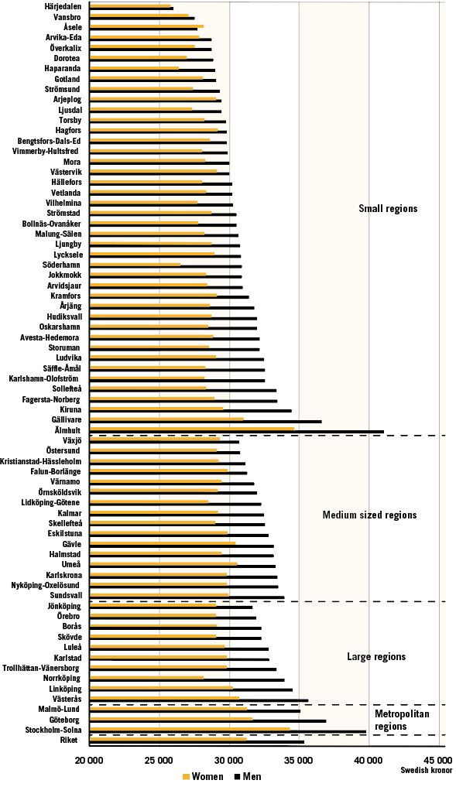
Source: SCB and Swedish National Mediation Office
Based on the wage in Figure 1, one can calculate the wage differences between women and men in the different LA’s. In diagram 2, the average wage differences for the different LA regions are marked by yellow circles. The gender wage difference (in percent) is shown by the y-axis and the average monthly wage of the x-axis. The size of the LA region is described by the size of the circle.
Figure 2 Gender wage gap, unadjusted and adjusted, by local labour markets
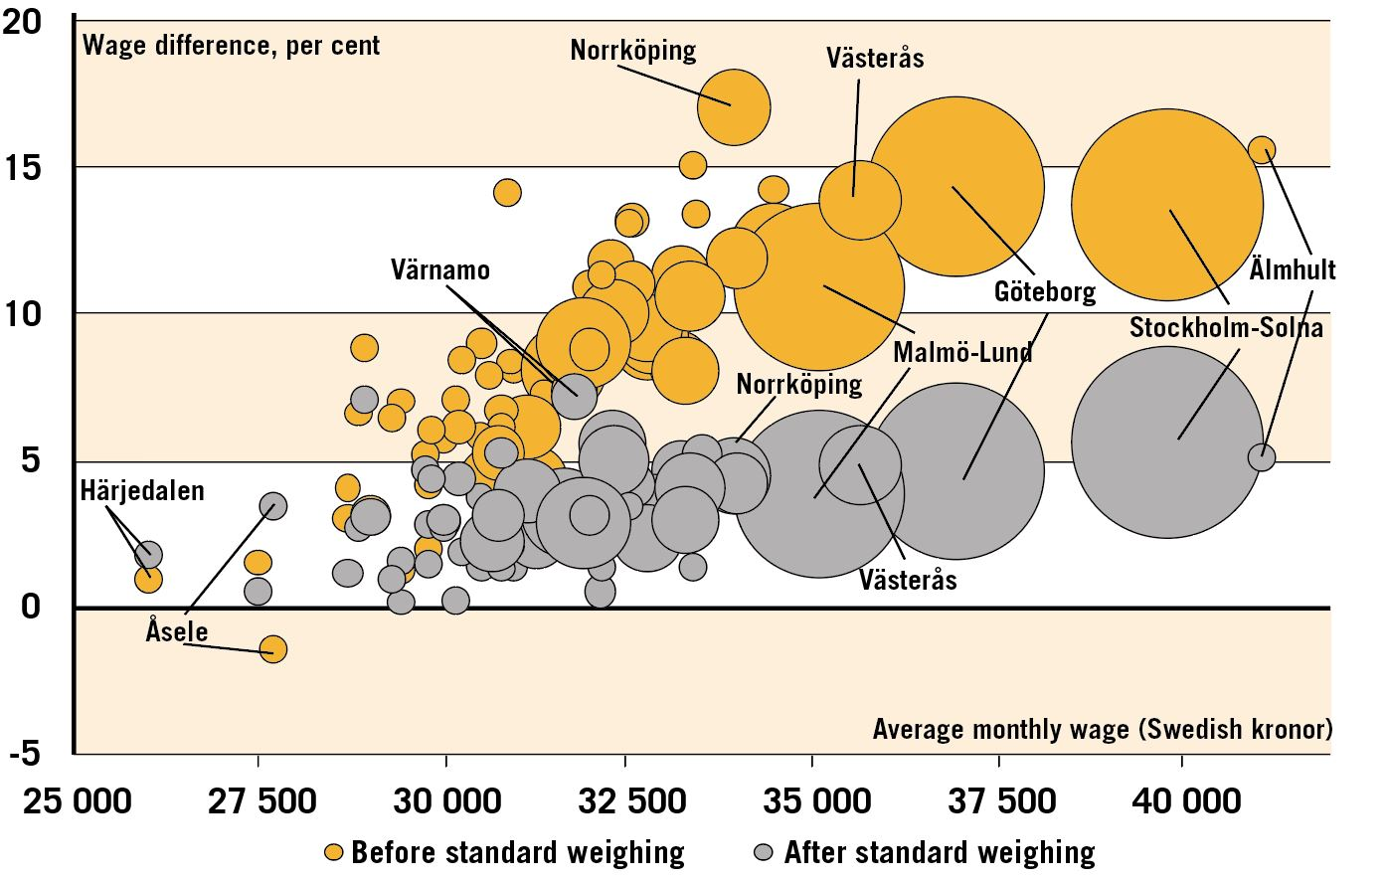
Source: SCB and Swedish National Mediation Office
The biggest difference is the pay gap in Norrköping's LA region, followed by Älmhult, which also has the highest average wage. At least the wage difference is in the Härjedalen LA region. The largest LA region is Stockholm (with among others Solna and Uppsala) and there is the second highest average monthly wage. You can see a positive covariation between monthly wage and wage difference. With higher pay, it seems to follow a larger pay gap between women and men. As wage dispersion is larger between men in the different LA regions and the differences between women's wages are less, the variation in wage difference between the genders is driven primarily by the men's wage levels: higher average wages for men co-varies with greater wage difference.
By means of so-called standard weighing, one can statistically take into account gender differences in the composition of the occupation, age, sector and education. Then there remains an unexplained difference between women and men. The weighted values are shown in grey circles. After standard weighing, the wage differential in almost all regions decreases. In Norrköping, where the difference before standard weighing was 17.1 per cent, after standard weighing an unexplained difference of 4.5 per cent remains. Åsele is an exception. There the effect goes in the opposite direction when we take into account the differences in age, education and so on. The largest unexplained wage difference is in Värnamo's LA by 7.2 per cent. In most LA, the unexplained wage difference is below 5 percent. Thus, there seems to be a positive co-variation between the unexplained wage difference and the average wage level after standard weighing.

4 Gender differences in commuting distance
Job commuting is an important part of households' everyday puzzles and can be seen as a link between private life and working life. The decisions that households take on commuting and travel times affect the family members' opportunities in the labour market. The greater the opportunity you have to commute, the more the choices will be in the labour market. For those who want to and can commute longer, the matching is enabled with a suitable employer.
Commuting patterns can be analysed in many ways. In this section, gender differences in commuting distances from a local labour market perspective are mainly analysed.
4.1 Different commuting patterns between women and men
It is well documented that there are gender differences in the commuting patterns in Sweden. The State Institute for Communication Analysis (Sika, 2002) has, among other things, show that:
• Women and men make roughly the same number of trips, but men travel far longer each day
• Women’s workplaces are generally closer to the home than men’s are
• Men drive cars to a greater extent while women to a greater extent travel collectively.
Based on the wage structure statistics supplemented with commuting distance, it is possible to analyze differences between women and men in several different ways. In the following, we show gender differences in commuting with respect to sector, age, education, wage and occupation.
Table 1 shows average commuting distance, single journey, total and by gender and sector. The table shows that the difference in average commuting distance, single trip, between women and men total is 3.6 kilometers (15.4–11.8).
Table 1 Average commuting (km) by gender
 | Total | Women | Men | Difference  in kilometers | Difference  in per cent
All sectors | 13,6 | 11,8 | 15,4 | 3,6 | 23,6
Public sector | 14,5 | 12,8 | 15,6 | 2,8 | 17,8
Blue collar | 13,8 | 11,9 | 14,8 | 3,0 | 20,1
White collar | 15,3 | 13,6 | 16,5 | 2,9 | 17,7
Public sector | 11,6 | 10,6 | 14,4 | 3,8 | 26,3
Municipalities | 9,3 | 8,6 | 11,4 | 2,7 | 24,1
Regions | 13,7 | 13,2 | 15,3 | 2,1 | 13,8
State | 17,0 | 15,6 | 18,5 | 2,8 | 15,4
Source: SCB and Swedish National Mediation Office
The table also shows differences between and within the different sectors. In all sectors, however, the men's commuting distance is longer than the women’s are. Women in the municipalities have the shortest commuting distance, 8.6 kilometers, compared with state-employed men who commute 18.5 kilometers. The fact that the difference is greater for all sectors than in the sectors individually is because women and men are unevenly distributed across the different sectors.
Figure 3 gives an illustration of the differences in commuting distributed by age. While men's commuting distance increases with increasing age, the opposite is true for women. In all age ranges, men commute longer than women.

Figure 3 Average commuting by gender and age group
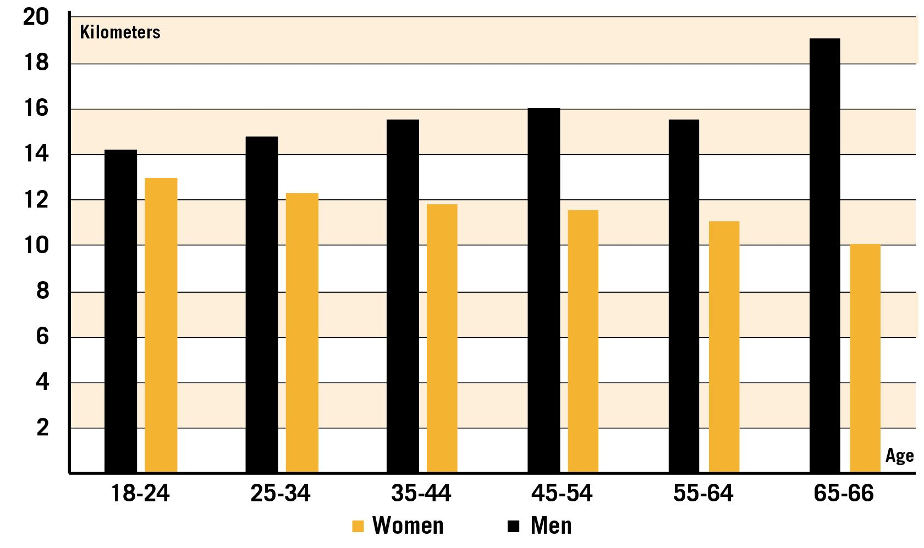
Source: SCB and Swedish National Mediation Office
Figure 4 shows the wage difference between women and men and the difference in commuting distance by age (left y-axis in the diagram).
Figure 4 Wage and commuting difference, by age
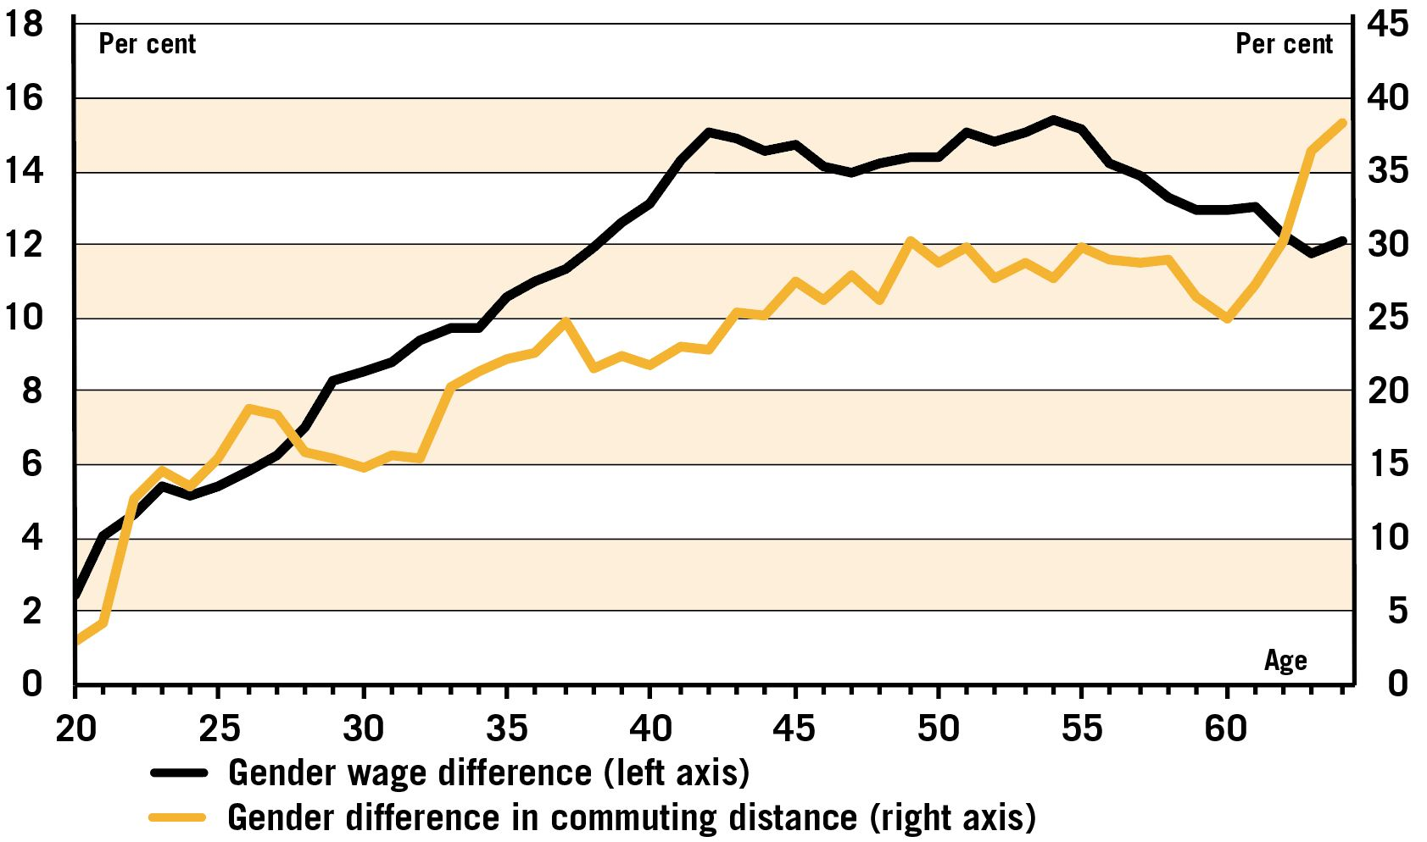
Source: SCB and Swedish National Mediation Office
The wage gap increases up to the age of 40 to then level out and eventually decrease slightly. When we add the difference in commuting distance in the chart (in percent on the right axis), a similar pattern appears until the age of 60. There seems to be a positive covariation so that an increased difference in wage and commuting distance is followed, although the difference in commuting distance initially increases slightly steeper and flattens out somewhat earlier. The rise in commuting difference after the age of 62 is due to a smaller increase for the men, while there is a slight decrease for the women.
Another way of analyzing the relationship between commuting distance and wage difference is to compare women's and men's wage distributions. Figure 2.8 shows the percentage wage difference between women and men for each percentile (grey line). The diagram shows that the wage differential increases in the distribution of wages. This phenomenon is usually called "glass ceiling". The explanation for this is mainly the occupation and occupational segregation that exists in the labor market and which, among other things, shows that the proportion of female managers is lower than the proportion of male. Figure 5 also shows the average commuting distance for women and men within each percentile.(black line for men, yellow for women)
Figure 5 Wage gap and commuting, by percentiles
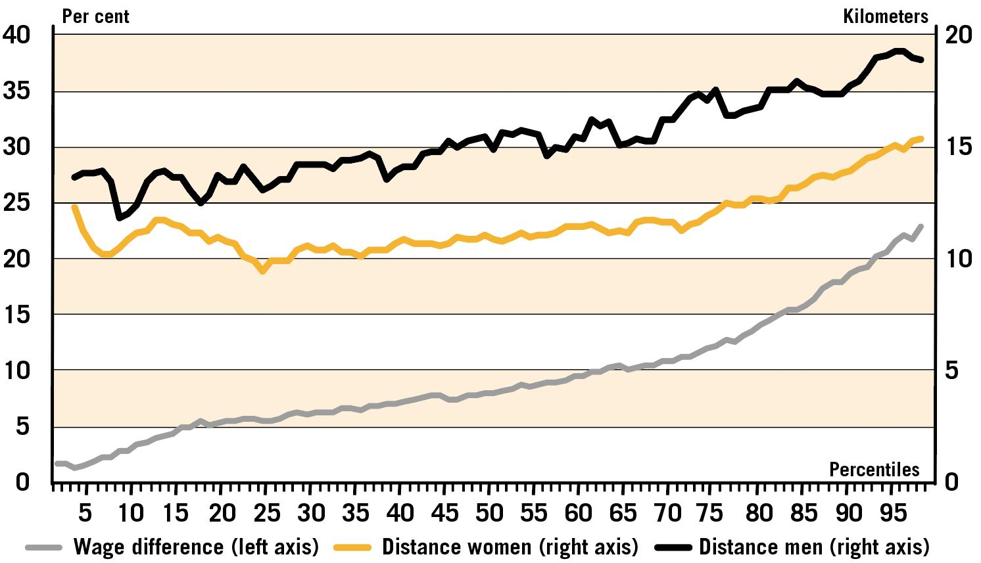
Source: SCB and Swedish National Mediation Office
The diagram shows that there is a difference in commuting distance between women and men. The men commute more at all wage levels, but for both sexes length of commuting distance tend to increase with the wage.

5 Covariation and gender
There is a covariation between commuting distance and wage at the individual level. Through a so-called regression analysis, one can investigate whether an extra 10 kilometers in commuting varies with higher pay. The result of such an analysis shows that 10 kilometers extra commuting on average corresponds to SEK 524 higher monthly wage. This must be considered as a small increase. An increase in the commuting distance by 10 kilometers single trip in relation to the average travel length corresponds to an increase of 74 per cent. The corresponding change in average wages is 1.6 per cent.
There is positive covariation between commuting distance and wages at individual level. However, how the direction in the relationship looks is a difficult question to answer. Does the wage level influence the individual's commuting pattern or is it the length of the work trip that affects the level of the wage? Or do all factors affect each other? The question is addressed in various ways in the literature.
The co-variation between wage (or income) and work commuting has been analyzed in various academic disciplines, including in cultural geography and economics. Usually econometrics is used to test theories on data and determine the size of the effects. Commuting distance can be explained by wage/income or by allowing wage/income to be explained by commuting distance. The commuting distance may be determined by various factors where wage is also included. It is then said that the commuting distance is endogenous with respect to wages. When there is endogenity, we cannot say whether it is the commuting that affects the wage or if it is the level of the wage that affects commuting, we cannot say anything about the causal link (causality). In the following we will only highlight the covariation between the variables.
One way to consider commuting is to see it as a cost for career or career choice. The "cost" can be economical, but also consist of the time spent on work trips and the problems that arise when it comes to the life puzzle. For various reasons, it can be different between women and men what cost one is prepared to take. In previous sections, we have shown that men make longer work trips.
In the following, we investigate whether women and men have different "returns" in the form of higher salaries on the length of the commuting (everything else equal). We do this by estimating two different regression models. That is, a model that takes into account the individual's gender, age, level of education, profession, scope of service (full or part-time) and sector. The unexplained wage difference that remains in the material we examine here is 3.8 percent.
Model 2 reports the unexplained wage difference when we also take into account commuting. The model takes into account that the "return" on another 10 kilometers commuting may vary between genders. Table 2 shows that the commuting distance contributes marginally to explaining another part of the wage difference between women and men. When taking into account the length of work travel, the unexplained wage difference between women and men becomes 3.5 per cent.
Table 2 Regression results
 | Model 1 | Model 2
Unexplained wage difference | -3,8 | -3,5
“Effect” men |  | 0,54
“Effect” women |  | 0,13
Source: SCB and Swedish National Mediation Office
The table also shows that the wage after another mile of commuting is higher for both sexes, but varies in size. After another 10 kilometers of commuting, the men have a wage of 0.54 per cent higher. For women, the corresponding figure is 0.13 percent.
In conclusion, the analysis indicates that there is a covariation between commuting and the wage level, but that it differs between the sexes. The covariation is stronger for the men. The level of the estimates should be interpreted with caution, but indicates a difference.

6 Wages and commuting in LA regions
The results in the previous section raise questions about the wage relationship of 10 kilometers extra commuting differing between regions with different average commuting distances and if there are differences between the sexes.
The question is whether longer commuting distances benefit the men. Figure 6 initially shows the average wage and commuting distance by sex and the number of women and men in the LA regions (shown in the size of the circles).

Figure 6 Commuting by gender and local labour markets
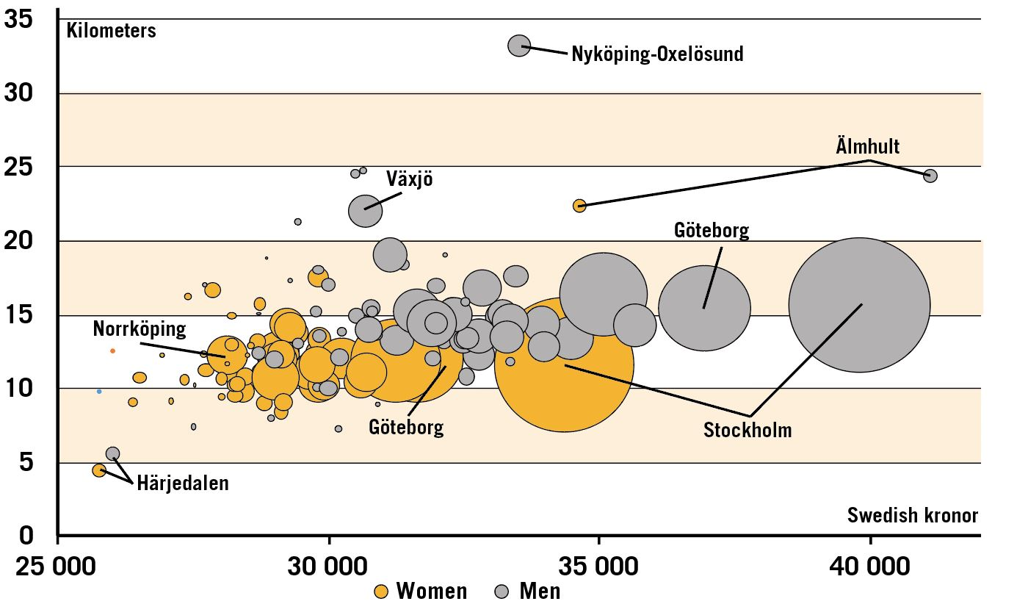
Source: SCB and Swedish National Mediation Office
For men, there seems to be a covariation between pay and commuting and the size of the LA region. In a large number of LA regions, women have lower pay and shorter commuting distances, and the covariation is not as clear. The questions can be further analyzed by redoing the estimate of model 2 in the table 2 for each of the LA regions. One way to show the results of these calculations is to make diagrams with distributions of the commuting effect on wages for women and men respectively. By creating so-called (kernel density) curves, it becomes easier to separate the distributions from one another than if one shows differences using several overlapping histograms. The distributions in figure 7 are reported in two groups: one group consisting of the half of LA regions, which has the shortest average commuting distance and the other group of the half commute the furthest.
Figure 7 Distributions of wage-communting ”effect”, by local regions groups and gender
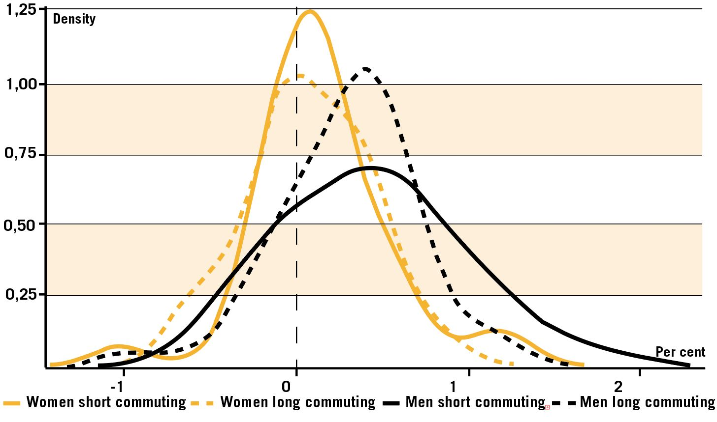
Source: SCB and Swedish National Mediation Office
The spread is much greater for the men at another 10-kilometer travel in regions with shorter commuting distances. For women, the distributions for both groups are centered on zero. The men's distributions are to the right of zero, centered on 0.5. This means that the "return" for men is higher at a 10 kilometers extra commuting trip. In the regions with the longest commuting distance, it pays slightly less to travel an extra 10 kilometers for the men compared to men in regions with shorter commuting distance.

7 Commuting and wage dispersion at the occupational level
The wage dispersion differs between different occupations. Figure 8 shows that the wage dispersion in a occupation co-varies with the average commuting distance in the profession.
Figure 8 Wage dispersion and commuting by occupation, size and gender composition
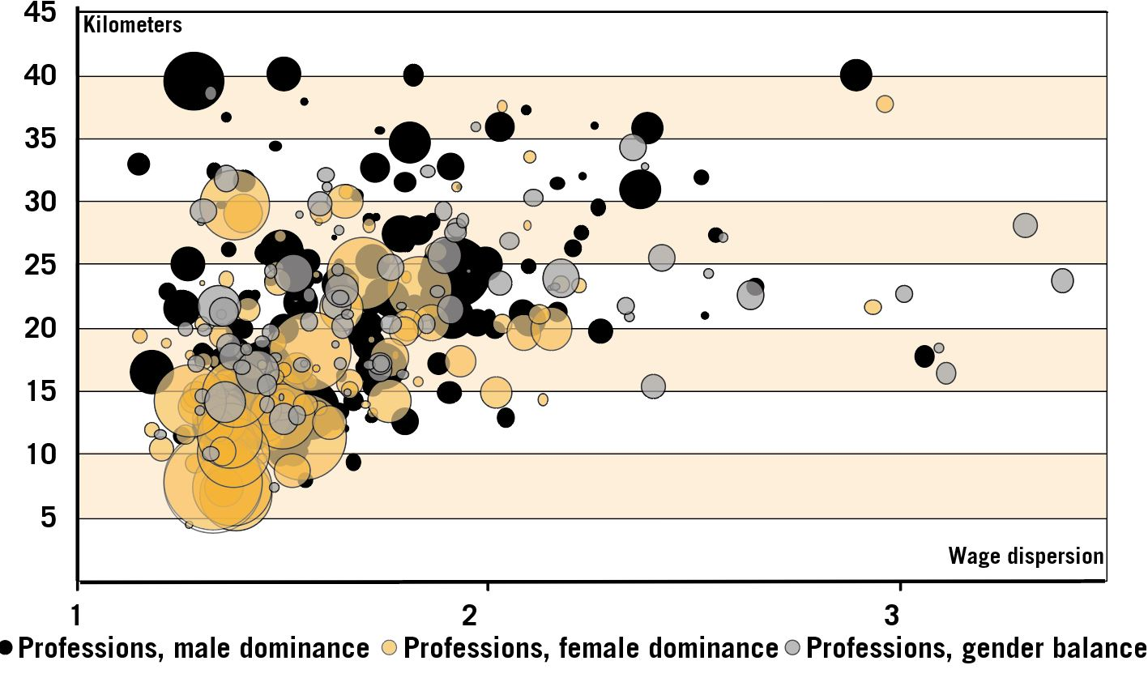
Source: SCB and Swedish National Mediation Office
It is reasonable to assume that in occupations with low wage dispersion, the commuting cost exceeds the profit of expanding its search area. When a longer commuting distance does not yield any profit, it is natural to instead reduce its "cost" by striving for a shorter commuting distance. It could explain that commuting distances are shorter in occupations with low wage dispersion.
We have previously shown that an extra 10 kilometers of extra commuting (single trip) on average corresponds to SEK 524 higher monthly wage. When we divide the 398 professions we study in two halves after the level of wage dispersion within the profession, we see that the professions with a lower wage spread had SEK 212 higher wages after another 10 kilometers commuting, while the corresponding figure for the half who had higher wage dispersion was SEK 550.15
Figure 9 shows a distribution after another 10 kilometers commuting for the two occupational groups with high and low wage dispersion. The estimate corresponds to model 2 in table 2, with the difference that the regression is estimated for each individual occupation.

Figure 9 Distributions of wage-communting ”effect”, by occupational groups and gender
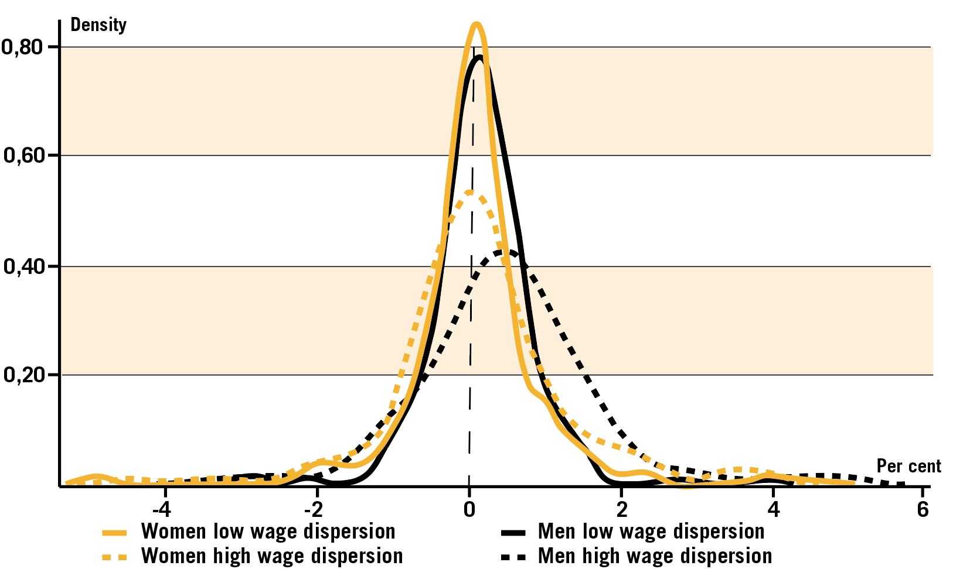
Source: SCB and Swedish National Mediation Office
From the diagram, it can be seen that the distributions after a further 10 kilometers commuting are centered near zero and symmetrical for both women and men in the group of occupations that have less wage dispersion. It simply means that for most occupations with a lower wage dispersion, it is not worthwhile to make longer work trips. In the group that has a larger wage dispersion, it is clear that the distribution is shifted to the right for the men's pay effect. The distribution of women is still centered on zero, but has a slightly larger spread than in the occupations with lower wage spread. Overall, the chart shows that it is more profitable for men in occupations with higher wage dispersion to make longer work trips than for the other groups where the "effect" on wages seems to be low.

8 Concluding remarks
A division into local labour market regions shows that men's wages vary more than women's between the LA regions. In general, it can be said that with larger regions higher wages follow the men. It should be noted in this context that the size is measured in number of employees - not in geographical size. The fact that men's wages vary more, while women's rates are slightly closer to each other, in the different regions can say that it is the men's wages that are responsible for the wage differences between women and men changing in the different regions. Larger regions tend to have a greater difference in gender pay. This may be because the structure of the business sector differs between the regions, for example, because in larger regions there are more head offices or large companies with more managerial levels.
In this paper, we have been particularly interested in possible links between wage differences, LA regions and commuting patterns. It turns out that commuting distances appear to co-vary with different variables.
• On average, men travel longer than women, 15.4 kilometers, single journey, compared to women's 11.8 kilometres. The longest average commute have state employees. Shortest commute has female municipal employees.
• Longer commuting distances seem to coincide with higher salaries both in terms of the economy as a whole, at sectoral level and at professional level. This is clearer for men than for women.
The covariation between commuting patterns and wages can have several explanations.
With longer commuting, a larger search area follows and thus a greater opportunity to find a well-paid work.
The infrastructure in society can be another part of the difference. Male dominated occupations, for example in industry, often have workplaces located outside city centres and residential areas. Female dominated occupations have their workplaces placed more accessible, such as health centres, pre-schools and elderly care. Workplace location and infrastructure thus lead to longer work trips for the men. Since male-dominated professions often have a higher wage level, it may be a partial explanation for the covariation between average wages and commuting distances.
Access to cars is an important factor. Men commute more often by car, which makes it possible to make longer work trips on the same travel time. Women go to a greater extent collectively. Access to public transport differs between rural and urban areas and it would be interesting in the future to examine in more detail how it affects the commuting patterns.
One factor that can affect the commuting distance, but which is not necessarily gender-bound is the housing market. In particular, for those who change jobs, the choice of workplace can come first and the local housing market can become what controls where you live. It is not certain that you can afford to live close to their workplace. It may also be that, depending on, for example, the family situation, a longer distance to work is chosen to increase their quality of life.
Attitudes and gender roles can also be important. The fact that women often take a greater responsibility for home and family can influence how far they are prepared to commute. A study on Swedish data (Eriksson et al 2012) shows that women are more restrictive than men in their choice of search area. It is less likely that women seek work far from their home.
The results in another study (Brandén et al 2018) show that employers tend to disadvantage jobseekers who live far from the workplace. This tendency is stronger for women, both for mothers and for women without children.
An important explanation, however, may be family formation and the distribution between home work and gainful employment. The results in our study show that there is a covariation between part-time work and shorter commuting. There are international studies that show that the commuting pattern changes with family formation.
The UK Investigation Institute (IFS 2018) shows that men have longer commuting time to work than women. The analysis shows that the difference in commuting time increases after the first child's birth in the family and continues to increase for about a decade after that. The development of the difference in commuting time is also linked to increased wage differences in families in the UK.
A study on Danish data (Angelov et al 2013) shows similar results. Women earn considerably less after they have children. The decline in income among these women reflects that women work less when the children are small and receive a poorer hourly wage when the children get older. One of the explanations is that these women switch to lower paid jobs that are closer to home.
The various wage spreads of the profession are also an important explanation that is supported in this report. The profession with little wage spread - often female dominated - has shorter commuting distances. It could be explained by the fact that when commuting does not pay in a wage-wise manner, one chooses to make a "profit" in quality of life through a shorter commuting distance instead. The disposable income then also increases through reduced travel costs.

9 References
Angelov N, Johansson P, Lindahl E., ”Det envisa könsgapet i inkomster och löner – hur mycket kan förklaras av skillnader i familjeansvar” Institutet för arbetsmarknads- och utbildningspolitisk utvärdering, IFAU, rapport 2013:12 (2013).
Brandén, M. Bygren, M. och Gähler, M, ”Can the trailing spouse phenomenon be explained by employer recruitment choices”, Population Space and Place Vol 24 (2018).
Eriksson, S och Lagerström, J, ”The Labor Market Consequences of Gender Differences in Job Search”, Journal of Labor research 2012, vol 33 pp 303-327.
Institute for Fiscal Studies – IFS (2018). www.ifs.org.uk.
SIKA – statens institut för kommunikationsanalys (2002) ”Jämställda transporter? Så reser kvinnor och män”

The individual does not necessarily have to be resident there. The intention is to capture day commuters why individuals who commute more than 200 kilometres are not included in the analysis.
https://www.scb.se/contentassets/c2d754bcaf964bcca33ac7cc2510c765/metoden-att-skapa-lokala-arbetsmarknader.pdf

