Use your own statistical experts to set the agenda and build reputation
Kristin Fredriksen, Statistics Norway, Department of communications, kristin.fredriksen@ssb.no

Abstract
The world is turning: We live in the age of fake news, and in the new fragmented media world social media is becoming the most important news channel for many, especially the young population. We are bombarded with approximately 6-7000 messages daily. How can we break through?
In Statistics Norway’s current strategy (2017-2020) one of the strategic themes is SSB news. Earlier release times and an increased emphasis on spokespersons are two of the measures implemented. We believe a spokesperson from Statistics Norway gives a greater impact on setting the agenda than if one only refers to the numbers and Statistics Norway as an institution.
Tables and numbers can be difficult to understand and find. Therefore, we have seen the need to explain and take an active part in explaining different challenges in society. For instance; gender equality, the decline in birth rate or the mechanisms behind the consumer price index.
In 2017 we had 604 interviews in national newspapers and broadcasters. In 2018 we reached 886. Many of these interviews are direct results of our commitment to publish own news articles where we let different experts from Statistics Norway explain why things are changing in society.
How do we do it?
- Publish news articles based on statistics and research with quotations/ interviews
- Building spokespersons
- Contact with journalists for direct interviews after publication.
Keywords: News article, expert role, media, quotations, set the agenda

Table of contents:
- Introduction
- Chapter 1: News and user communication as a strategic theme
- Chapter 2: Quotations from spokepersons in news articles
- Chapter 3: Building experts – mediatraining and contact with the media
- Chapter 4: Set the agenda – Three examples
- Evaluation and dilemmas

- Introduction
That Statistic Norway’s employees offer their expertise and explain relationships builds credibility and trust. We see this not least when there are quotes in articles on ssb.no. Quotes can also relieve some of the pressure from journalists calling for comments after a publication. Having some quotes ready can also help create more peace around publishing if the statisticians do not have much experience with interview situations.
Some results: In the year 2017 there were 605 quotation and 3,900 news articles in the national and national regional media associated with Statistic’s Norway numbers and publications that the communication department had edited.
In 2018 the number had increased to 886 citations from employees in Statistics Norway.
If we look into the first quarter in 2019 we have registered 4,765 news articles in the national and national regional media and 395 quotes. In 2018 we had an average of 17 spokespersons from Statistics Norway per week. So far in 2019 there have been 20 spokespersons per week. We believe this means that our systematic work has paid off with a stabile increase in citations for every year since the beginning.
The aim of this paper is to share experience and give some approaches to set the agenda in the news.
1. News and user communication as a strategic theme
Why did we change the way we presented and communicated statistics?
Statistics Norway’s News is one of six strategic themes in the Statistics Norway strategy for the period 2017 to 2020. The purpose is to achieve better coverage and cover more users' needs. The goal is to summarize and present the knowledge we are familiar with in relevant, understandable news articles, and to help ensure that Statistics Norway's figures are used in relevant public debates.
We contribute as an important and neutral supplier of facts to an informed public debate.
We are better off by summarizing and presenting the knowledge we have in relevant, understandable news articles. In this way, we will also make the content on ssb.no more accessible via external search engines. In the next chapters I will try to tell how we gave life to the strategy with new content.

2. Quotations from spokespersons in news articles
The mass media has undergone enormous changes in recent years. Just a few years ago, we had a handful of media that released news at fixed times every day, with specific deadlines and permanent journalists and photographers.
Now there is publishing 24 hours a day in far more channels than before. The competition has never been harder, and the time has never been scarcer. There are fewer journalists with more surfaces to cover. One of the consequences of this pressure is that we have to take more responsibility for nuanced and thoroughgoing coverage.
This means that we all need to make changes to meet demands and possibilities within communication of statistics.
Active spokespersons in the media in some cases contribute to strengthening Statistics Norway's role in the public debate. The media and readers care more about people and less about organizations. Thus, a spokesperson from Statistics Norway gives a greater impact on the media than if one only refers to the figures and Statistics Norway as an institution.
Statistics Norway's own employees explaining the figures can contribute to increasing attention and giving more space to the various media. A simpler language can also hold on to an interested reader. Not everyone are statistical experts!
Quotations give an added value not only to us, but also to articles from our national newspapers. We discovered before we started with SSB news that articles on our website often was used in a newspaper clip, but it didn’t lead to much more debate or was given a broader perspective. In other cases, experts from other institutions, such as chief economists in private banks, were used as experts. It is positive that others also use our figures and comment on them, but readers can lose the primary source out of sight and only sit with the pre-interpreted meaning of another expert who may have a completely different agenda. We have seen that using quotes, the national news agency uses more space on the coverage of our figures and also interviews or more frequently uses citations from Statistics Norway’s experts. This is important for two reasons:
- To prevent journalists and others from interpreting the figures the wrong way or adding numbers other than their own.
- It allows us to remind people who we are. This can be valuable because readers, viewers and listeners are potential respondents another day. Then it is important that they know that we are an independent, national bureau and not a private institution that potentially could sell data.
It’s easier than ever to publish, harder than ever to be heard. So what can statistical bureaus do to meet this challenge in concrete ways?
In this chapter I will mainly focus on how we in the communication department at Statistics Norway have developed the news article and how we have worked with quotations.

2.1 Early publishing
In the spring of 2016, the directors decided to move the release time for statistics and articles on ssb.no from kl. 10:00 to 08.00, which came into force on 23 September 2016.
The motivation behind moving the release time was, among other things, to increase Statistics Norway's visibility and impact. The idea was that earlier release would provide more media coverage, and also provide more opportunities for arranging breakfast seminars.
The communication department's experience has been positive: The statistics are referred to more often and by more media, and one tends to see more media writing their own stories rather than copying the national Norwegian news agency, NTB, in great detail. The new publication time makes this easier, as the editors now receive the Statistic Norway’s publications before their morning meetings. The media often publishes articles already at eight, in addition to contributing to further spread through other media organizations and channels. Earlier release time therefore appears to have led to several editorial reviews and greater media coverage in general, due to a better exploitation of the news day. The media has given us positive feedback that the figures are available earlier in the morning.

2.2 Select publications
With approximately 1,200 publications we had to narrow it down and select the statistics we thought had most to gain by having some quotations who could explain and set the figures in a context. In our weekly ‘News meeting’ we discuss what kind of publications we think have possibilities to set the agenda, if Statistics Norway has scheduled press conferences we should put extra effort into, or if there are some external events, specific holidays or such we should hook our statistics or experts on to.

2.3 Different types of articles
In addition to quotations we also saw that we had a lot to gain if we had a better teamwork with the statistics departments and use their knowledge to produce articles. We believed that we in a larger degree needed to divide the articles in two types:
- Shorter news articles with a well-defined angle and quotations from our own experts where media is the most important user group.
- Longer analyses where users were given the opportunity to specialize in selected topics.
Just to show an example: For the publication of the statistic ‘Attitudes towards immigrants and immigration’ in December 2017 the communication department edited the news article from researcher Svein Blom and suggested to turn some paragraphs into quotations. With this change the breakthrough in national media was doubled.
In the year 2016 there were 24 news articles in the national and regional media that registered the news article linked to the publication. Svein Blom was quoted 7 times
In 2017 there were 42 news articles in the national and regional media and 30 was with citations or interview.
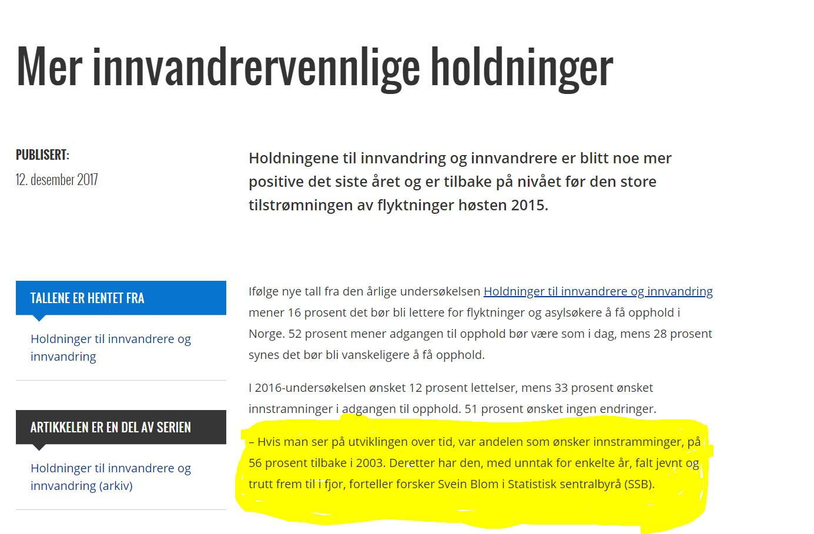
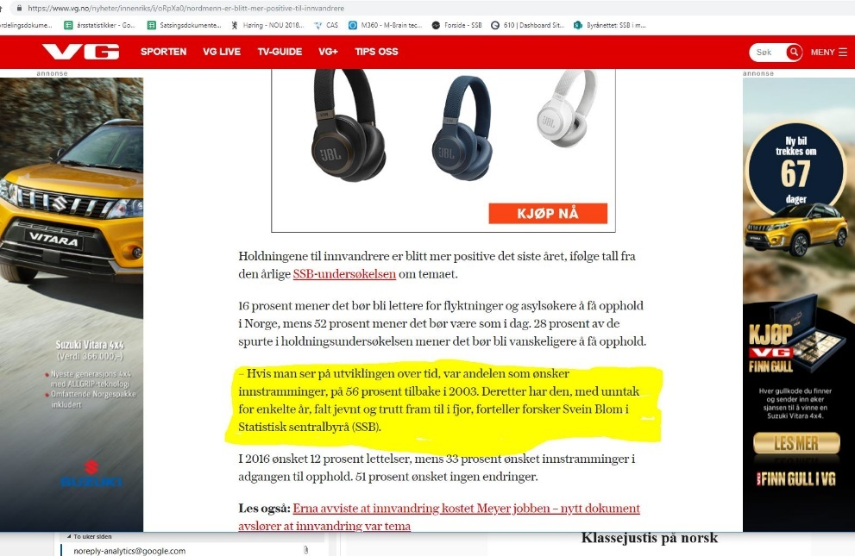
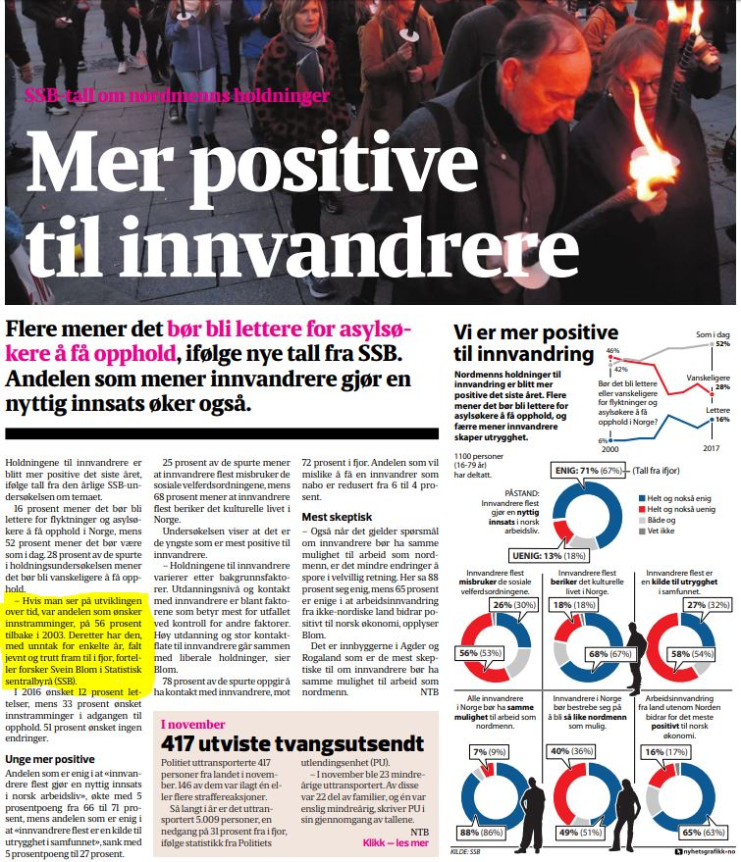

2.4 Tactical publishing
Journalists work for a checklist they call the news criteria, and timeliness and relevance are amongst these. Therefore, writing and tactical publishing of news articles is an important part of the news venture. When we get to this, we reach out with what we have - even though the statistics been in store for a while.
This May the communication department and the statistical department of culture and education worked together on a news article about confirmation using the latest figures from our municipality database. In Norway spring is the most common time for teenagers to go through the confirmation ceremony. The article was filled with quotations which the press used.
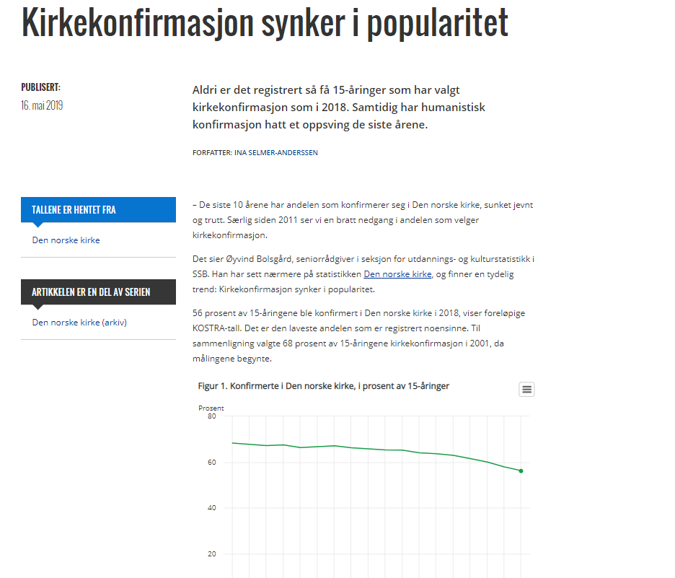
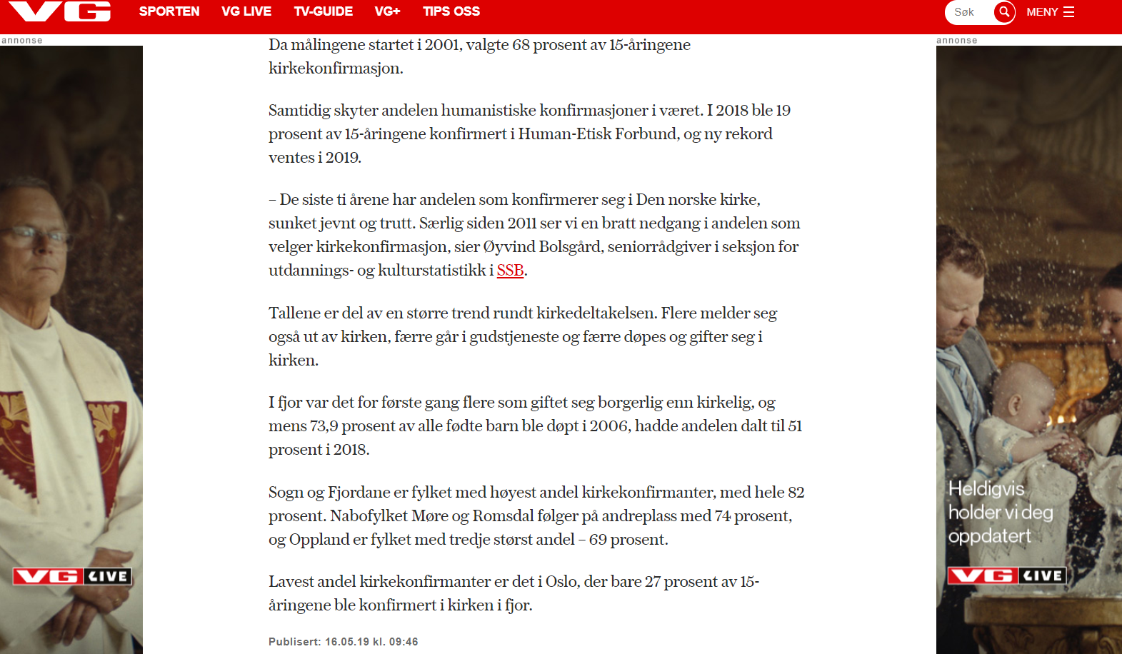

3. Building experts – media training and contact with the media
Employees in Statistics Norway are all experts in their areas. Media training has always been an important part of communication advisors work. But when we started to work with Statistic Norway’s News we started to work more strategically with the media training. Our ambition is that expertise should be used and made visible in the media and elsewhere. Media also asks for people who can comment on the statistics and analyses we produce. Since 2017 we have been keeping monthly media training courses and collaborate with the research and statistics departments on breakfast seminars and press conferences with media potential. Beforehand we have media training with the spokespersons and speakers. Our ambition is that our spokepersons should feel comfortable and can handle difficult questions. We use camera and microphone to have the exercise so close to reality as possible. In the media training we also emphasize posture and cadence.

4. Set the agenda – Three examples
4.1 Make your own publication one of the most important and shared news of the day
The name statistics are not among the most important statistics, but it shows the breadth of what we do, it contributes a lot to increased knowledge of Statistics Norway, especially among those who may not be the most frequent users, but who may be drawn to participate in one of our surveys. For many, it is perhaps the first meeting with ssb.no, not least among young adults.

The name statistics is the most visited statistics in ssb.no. Our statisticians and researcher Jørgen Ouren is already an experienced spokesperson and has for many years been interviewed by mass media. It was therefore an easy place to start testing our strategy on this publication.

We tested our strategy for the first time on the 2017-publication. This is what we did:
News article: One in the communication staff wrote a news article with several quotations from Jørgen Ouren.
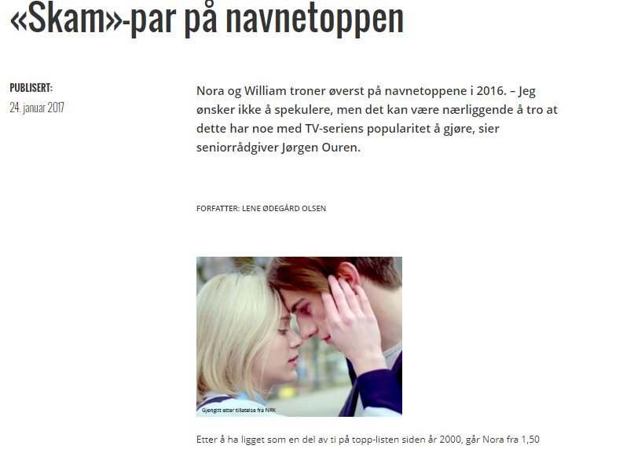
And perhaps we had some beginner's luck when the names Nora and William from the Norwegian hit-TV series ‘Skam’ was the most popular names in 2016. The headline gave itself.

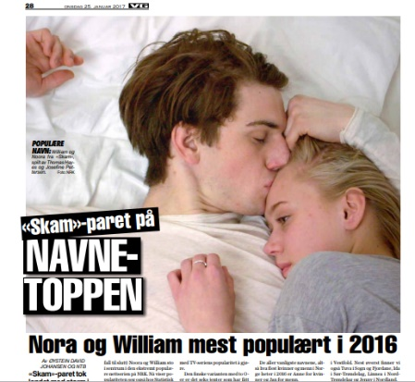
Approximately 30 national and regional newspapers used Ouren’s quotations from our article. And journalists also called our name-expert and wanted interviews because they found the article interesting. For example, VG – the largest newspaper in Norway.

Contact with journalists: This was the first time we could publish at 8 AM instead of 10 AM and that gave us a much better possibilities to offer Ouren as an expert to the morning news shows. It is a lot easier to set the agenda for the day if you get a good start. Prior to the day of publication we contacted morning shows on TV and radio. The result was that Ouren attended two morning shows on TV 2. He also attended two radio shows on NRK – one of them ‘Nitimen’ has approximately 700.000 listeners every day. Later on, he was also interviewed by the evening news on the national broadcaster NRK. NRK’s youth-channel, NRK super, also used our story on their social media channels.

In 2018 we followed our own recipe. The broadcasters and some of the newspapers were so happy they invited Jørgen Ouren in studio and we arranged telephone interviews. We didn’t need to contact them. This time we also used one of the heads of division in our own department for radio and tv-interviews in the morning, in order to spread the name statistics even wider.
One outcome was that we have beaten our daily page view-record for the name statistics every year since we started in 2017 with approximately 40.000 views at ssb.no. We have also seen that we have increased page views from a younger audience and from mobile.

4.2 Hook onto special holidays, celebrations and other special days
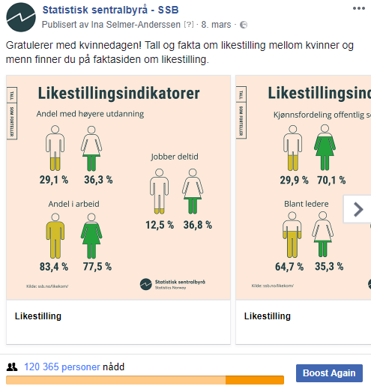
News articles before the Women's Day contributed in 2017 to over 70 entries in the media, and a special designed chart of the gender equality indicators led to a strong Facebook-record for Statistics Norway.

We started with an editorial meeting and brainstorming. The purpose was to find statistics and figures that could say something about gender equality. We came up with this:
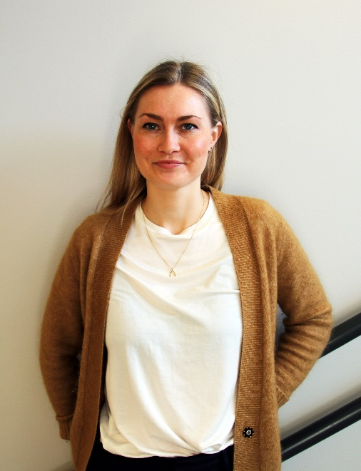
- News articles which focused on gender equality.
- Media training with spokespersons
- We contacted the national broadcasters,suggested topics and introduced the spokespersons they could interview. We had two female (of course!) spokespersons drilled on two different topics: One talked about the gender equality indicators in the major morningshow ‘Nyhetsmorgen’ on NRK-radio. The other a was interview live on our national newschannel TV2 Nyhetskanalen about a publication with emphasis on the number of women in company boards.
Expert on gender equality: Karin Hamre
- We also sent a newsletter where we listed publications, statistics and research that tell a story about gender equality in Norway.

Results:
- 50 articles in the media
- Four interviews in national media
- Increased use of web site
- Record on social media

  - Experts used by media
Statistical experts making themselves available when something is happening in the society, is also an excellent way of highlighting expertise.
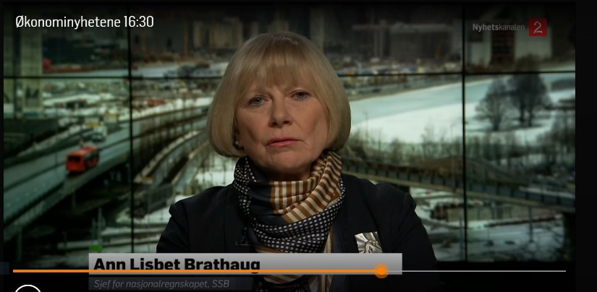
At Statistics Norway we are lucky to have a lot of experts with communication skills in both the research department and the statistics departments. Therefore, we also have a deal with the national broadcaster ‘TV2 Newschannel’ to offer some of our experts when we have publications that they could be interested in. This mostly apply on our economic publication like the Consumer price index and National accounts. The heads of these divisions are highly appreciated by the channel as experts, and are used on a monthly basis.

5. Evaluation and dilemmas
Three years into our news strategy - what have we learned?
First of all, it’s much easier to collaborate with statisticians and researchers that are interested and share our ambition to ensure that our statistics are used in relevant public debates. Many statisticians are still unaccustomed to short articles and quotations. Many are more comfortable with statistical jargon and think it’s either difficult or simply wrong to use a more ‘tabloid’ language. For us it’s important to understand these different views within the organization, and choose different approaches
Unfortunately, we lack good spokepersons on several statistical areas. Some in the statistical departments are reluctant or uncertain about participating in working with the news strategy. We see this as a journey where we will not come to the end in several years. In some cases statisticians also make valid points – not all statistics are readily suitable for short quotes and popularisation.
How neutral is it possible to be when you’re commenting on different figures? It’s not always easy to be neutral when it comes to different topics in the public debate, for instance the immigration and immigrants-debate.
To find enough time: It takes a lot of time to talk to and be available for journalists. Everyone have a lot of tasks and demands they are committed to do, and lack of time is an issue we have to take into account.

We changed our method for media monitoring news articles in 2017. Therefore the figures for news articles for 2017 and 2018 cannot be used as a direct comparison.

