Hack4ssb in Statistic Norway
Kristin Glomsås, kristin.glomsas@ssb.no

Statistic Norway (SSB) has organized their first internal hackathon in 2018, Hack4ssb. Hackathon means that you can design, use data and make a program. Working with coding and other digital solutions intensely over a few days, like a marathon. We would like to tell other statistical agencies in the Nordic countries about our experience with our first hackathon. We also like to present some of the ideas that was developed in the hackathon in Hack4ssb.
All the managers in SSB had approved that their employees could attend. It was an open arrangement for all employees in SSB, and one of our goal was that all the departments had a participant in the hackathon. The hack was arranged over four days, three and a half days with planning, designing and development. The fourth day all the participants had a presentation of their work, and the winners were awarded.
One of the reasons why we arranged the hackathon, was to achieve more innovative employees, and more social commitment between departments. At the same time get them to know SSB’s own data better, by using our open data. Our impression was that the employees and management in SSB got new ideas on product that makes it easier to both understand and find our statistics. This also gave the employee the opportunity to try to make a product out of an idea. We had 37 participants on 8 teams in our first hackathon. We got a lot of good feedback afterwards and are planning to arrange a new hackathon in 2019.
Keywords: Hackathon, innovation, interdisciplinary teams, Open data, new ideas.

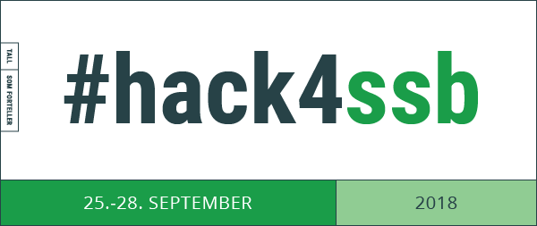

Hack4ssb in Statistic Norway (SSB)
The most valuable output when arranging a hackathon, is to encourage innovation and learn new ways to develop ideas, different from what you would learn in your daily work. It is an event that brings motivation and a lot of fun in a social arena and gives us an opportunity to work with people that you rarely work with. This is an event for new and creative ideas made by our own employees.
A hackathon is a frenzy of ideas, creativity, business model creation, coding and designing. You can build a prototype, or you can present a concept, a great solution to a problem, or innovative visualizations. A lot of organization and schools have arranged it for many years, and they do it year after year because it gives a lot of god ideas and satisfied participants.
Hackathon gives us a freedom to explore and accomplish. At the same time, it can be the start for our organization to establish a new culture that promote innovation and changes – and risk taking in a safe setting.

How to promote innovation in statistical agencies
In the early evening on Friday September 28th, 2018, after nearly four days of intense work in small groups scattered around meeting rooms in Statistics Norway with increasingly poor air quality, the team “Words to number” won the jury prize in Statistics Norway first ever hackathon, Hack4ssb. The team had conceptualized and prototyped a program that analyzes text and then give relevant statistics suggestions from SSB back to the user. The jury pointed to among other things the use of machine learning and forward-looking anticipation of user needs as justification for the prize.
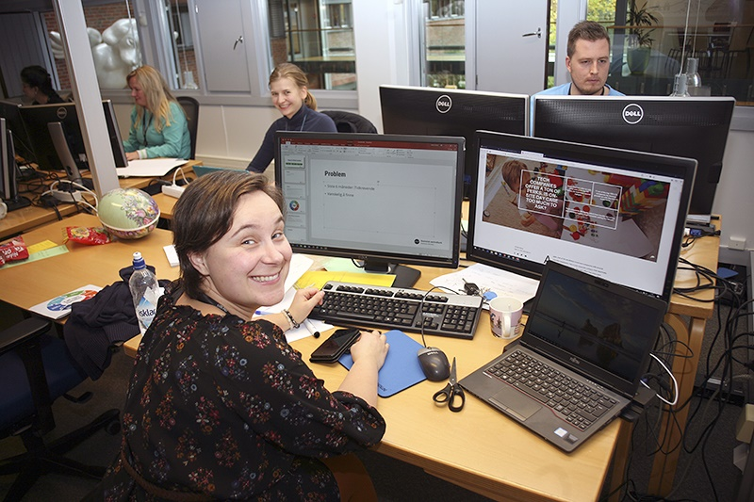
The people’s prize was awarded the team” The more you know”. They made a prototype that linked geolocation with statistical data in a quiz that challenge the users understanding and assumption about the area nearby where you are.
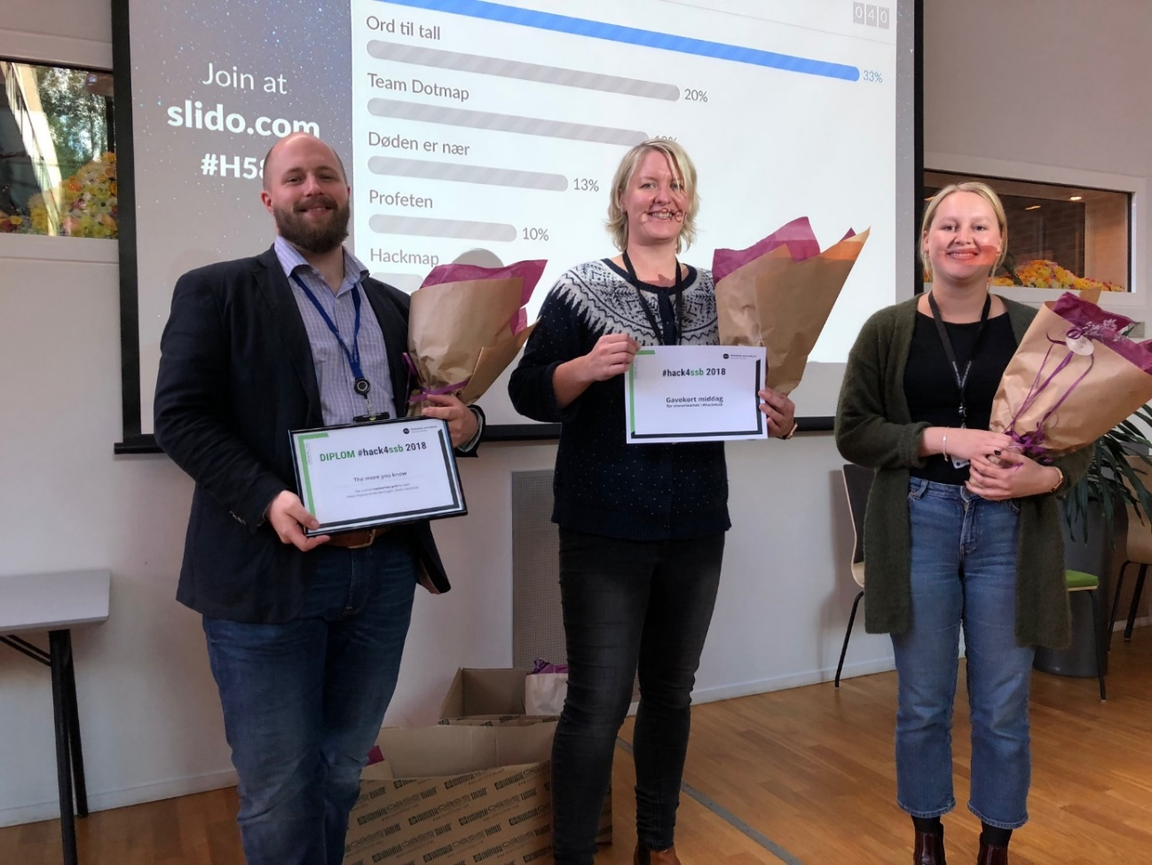

What is a hackathon?
Hackathon means to make prototypes of ideas in small groups over a limited amount of time, and to see if it is possible to develop one or more of these in the organization later. A team in a hackathon in a statistical agency can involve employees from IT, statistical groups, scientists and communication/designers. In Statistics Norway all employees were invited to take part in the hackathon, and in the end 37 people participated in the weeklong event.
The organising committee felt that all employees regardless of their area of work could contribute and having groups with a wide range of competences. This would give the group a better perspective on the task they would do together.

The rationale behind organising an internal hackathon in Statistics Norway
Why should we in Statistic Norway (SSB) arrange our own hackathon? Shouldn’t we use our employees to just work with statistics and how to publish them to public use? These were some of the questions that were raised when we started planning the hackathon. The initial inspiration for the hackathon event came from employees who had participated in external hackathon events. Other participants had pointed out the goldmine of information that is in ssb.no, and how they could use our API (open data solution) in their hackathon events.
Our future goal is to arrange an external hackathon in SSB Kongsvinger together with the local academy. We have a lot of local company promoter in this area and think it will be a win win situation for all. Everyone will learn more about our data, and we can get good ideas on new products and solutions that can be in help for the modernizing of statistic production.

To foster innovation
A main goal of the hackathon was to foster more innovative thinking and capacity in the organisation by giving employees in Statistics Norway the opportunity to take time out of busy schedules to focus completely on one task for nearly one week and giving them access to new software, new tools, new data.

To create ideas for the modernizing of statistical production
Statistics Norway has a lot of old IT systems in need of modernize, and the idea was that maybe we have employees with fresh ideas on improving working processes and tools in statistical processes. SSB is currently undergoing large modernizing projects of our IT systems, both on how to get data from outside easier into SSB, and a more common solution on how to use method and system to make statistics. A goal for the hackathon was to produce new ideas and functionality to these projects.

To foster more innovative dissemination of statistics
As mentioned above, the initial inspiration came from people outside Statistics Norway gushing about our solutions for open data and the endless possibilities these presented when it came to creating applications based on statistical data. An important goal was to create new ideas in the dissemination of statistics.

To foster cross-departmental cooperation
Another goal of the hackathon was for people to work with people from other areas of expertise. We hoped this would encourage new ways of thinking and new ways of looking at things.

Success factor for organize the Hack4ssb
Hackathons have been organized worldwide for years, and a lot of good ideas have been developed in these events. Senior management agreed to let all the employees in Statistic Norway could join the hackathon, if they wanted. The management agreed that the participants had to be relieved of their duties during the four-day hackathon event. This was of major importance to the hackathon’s eventual success.

The actual hackathon – how did it go?
Tuesday until Friday at 12 o’clock all the teams worked with their tasks. All the groups had to prepare a 15 minutes presentation for Friday afternoon. The minimum for the presentation was a PowerPoint about the task, but we hoped they also had a prototype to show.
We had decided to have two winning teams – The jury gave out one prize and all the participants in the hackathon were given the opportunity to vote for their favourite presentation.

Did we achieve our goals for the hackathon?
The hackathon event was a success. After the hack we asked the participants to give us feedback about the hack4ssb, and improvements for next time. Nearly everyone gave us feedback, and it was very positive acknowledgement. They told us that they liked the professionality in the arrangement, they felt Statistics Norway treated the hackathon as an important event and liked the celebration afterwards. It was a working-boost for our organization.

Closer relations between employees in different departments
The participants liked that the team had members from different departments with different tasks and background, that helped the team forward in the working process. Everyone had an important role. We also hear that some of the teams still have contact after the hack even if they work in different departments.

Not enough cross-departmental participations
Most of the participants came from the IT, methodology or communications departments. Only few participants were from the statistical units and there were none from the research department. We think the reason for that is the uncertainty about what a hack is. A lot of employees think a hack is very technical and forget that it is a lot of different tasks in a hack that is not technical. Also, we think they forget that very often it is the data from their departments that will be used in a hack, and they are the best experts on their own data.
Some leaders of the statistic departments also arranged internal working-trip for the whole department the same week as the hack.
To achieve the goal of cross-departmental participation and the bonus of having different kinds of competences in the same team, we need to improve recruitment of statisticians and researchers. We will have presentations and explain more about the hack in our organization before next hack, and specially to the statistic and research department. There we will tell them about all the benefit for their department with more innovative employees that can try out ideas that will give an advantage to the department. We have an internal Yammer-page about the hack, where we will promote the hack more. This time we have experience from arranging a hack, and a lot of great participant from last hack that can be our ambassador for the hack4ssb 2019.

Did we foster innovation?
It was a lot of god ideas and creativity in the groups in our hack4ssb. A lot of the groups used the API in Statbank Norway in their solution. They used different tools and methods like Machine learning, Python API-client, GeoJSON, JSON-stat Javascript Toolkit, Highmaps.
So far only one of the hackathon ideas is on the verge of being realized, and another is planned for development in the autumn. The Team Dotmap worked on a solution about how to show the commuter statistics in a map. They made a solution where they used a colored dot at the place we live and where we work, with different colors to show where mostly lives and commute on a map. Some in the team are now working to implement this idea in Statistic Norway.
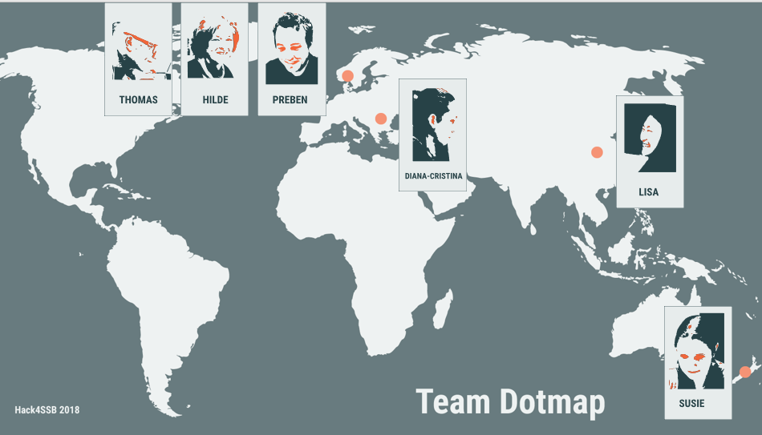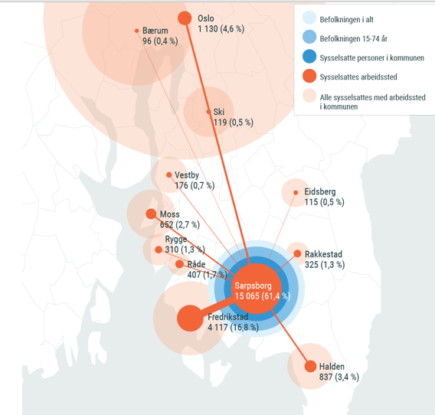

Few managers in the organisation attended the presentation of the hackathon groups. We believe we need to find a better way to get more managers to attend and listen to the ideas. It will be better for them to evaluate the merits of the ideas, their potential for realization and in general to get management excited about the concepts and ideas ahead of planning for the coming year. We think they need more information about the possibilities a hack can give them to get new ideas on their statistics and methods.
Also, we should have adjusted more of the technical tools in front, like information about GitHub and witch area they should get the data from. We also had an agreement with the leaders about not use too much time in front of the hack. The employees just got these four days to work on their ideas. Next time we will arrange different 2 hours course in technical tools in front of our hackathon.

Overall assessment
Both the organising committee and the participants who attended the first hackathon, feel that this is something Statistics Norway should continue doing.
Arrangements like this can be scaled up and down, after the need to the organization and type of approach you want to achieve. The main goal is to see and pick up the good ideas and solution and develop them in your organization.
Our second annual hackathon is thus planned to take place autumn 2019.

