Fact-Based Noise on Social Media: Efforts of Statistical Education in Marketing
Author: Marika Jokinen, Head of education, marika.jokinen@stat.fi

- Introduction
A key challenge today is to distinguish data-based information from experienced-based, or individual-based information. Many people do not see any difference between them, anymore. Whereas communicating and delivering information on social media is relatively effortless and extremely fast, it is no wonder that the information overload describes the ongoing state of affairs so well.
The question is, how to actually attract the attention of your target groups on social media. Contrary to expectations, even under the data privacy of GDPR, you need to make yourself visible on social media. However, this must be done slightly differently.
Statistics Finland is learning how to make noise based on its own leaning on data-based information. Today, we produce videos of all kinds of statistical data-based products and services and deliver them actively on the web. This is done in order to raise media exposure and get more likes for the information that is socially relevant.
In this presentation, I will present two campaigns that are produced for and used in marketing Statistics Finland’s courses of statistical education as an example of making “fact-based noise” on social media. Statistical education offers courses in various statistical themes such as basic concepts of statistics, information search in statistical data and sources of statistical information. The courses are mainly targeted at professional experts that are working with statistics or using statistical data for their own organizational purposes and in addition, at ordinary people that are interested in these topics and want to strengthen their skills in statistics.
Statistical education represents data-based information that is produced reliably, transparently and according to admitted principles founded on the ethos of statistics. In concrete terms, for instance our videos sell the idea that being an expert means knowing, not assuming. That is the main purpose. One of the basics is related to an “old fashioned fact” that knowing is based on research and data-based information not results of the popular vote. Our message is, you are warmly welcome to our courses if you prefer to be an expert. In near future, we will learn to be a bit more radical and to break down conservatives.

- Today we live in a different world
In the beginning of the 2000’s we lived in a quite different world than today. Everyday life is under mediatization (Seppänen & Väliverronen 2015, 10-11). We’ve seen a tremendeous change of online revolution within 15 years. The Internet has undeniably influenced people’s lives more than any other thing in recent years. In addition to the Internet revolution, a shift of a computer-based world to a mobile-based world is also visible. Today the coverage of smart phones is growing faster than ever all over the world, and e.g. in Finland the coverage of smart phones is 80% (Use of information and communications technology by individuals, 2018). The ongoing development has changed the whole understanding of communication and sharing information.
Social media are online applications, platforms, and media which aim to facilitate interaction, collaboration and the sharing of content. In other words, it is a collection of online communication channels dedicated to community based communication. Social media take a variety of forms, including weblogs, social blogs, microblogging, videos, podcasts, pictures, wikis, rating and social bookmarking. These applications are available for anyone who has required facilities and skills, as well as an Internet connection. Globally, there are almost 6 million Facebook likes, over 500 million tweets and over one billion hours of viewing YouTube videos per day (Keväthumaus, 2019). That is somehow beyond comprehension.
Social media has produced a communication culture that strongly supports the individual right to express one’s opinion and enhance the freedom of speech (e.g. Lähde, 2017). How can anyone disagree with the fact that one of the most essential features of democracy is everyone’s right to express his or her opinion? But the challenge of today’s communication on social media is that you can easily find like-minded people and forget the rest. From that perspective, the social trend seems to be a bit threatening - what happens if people prefer to be surrounded only by like-minded people and decline to see the value of different opinions and values? Basically, this is already happening.
How to get people out of cozy hoaxes if there is seriously something relevant you’d like to communicate and share? Sometimes it is even necessary to do so. There is a large amount of information or content based on pure fiction on the Internet that have enormous influence on people. It is essential to highlight how to differentiate between reliable and unreliable sources of information instead of letting people rely on anything that seems to be factual and touch the topic.
Statistics Finland is one of the statistical authorities in Finland, and there is a fair amount of socially meaningful information every day we’d like to share with the public. Our job as a social agent is to tell people, on one hand, how to recognize reliable data and how to find it but also how to differentiate reliable data from fiction. Statistical education is an excellent way of strengthening media literacy among people.
We had to go where people are, on social media, to do our job. However, it had to be done in terms of us leaning on data-based information. At the same time, we were forced to refresh the whole communication culture and adopt so-called best practices used on social media to be noticed. As an official authority it meant a fundamental shift in attitudes and also required the courage to take the first step.

- Communication on social media
In the media society, every citizen is an active player – a potential consumer, user and content provider. The mediatization process has altered the whole understanding of the nature of communication - one-way communication is irretrievable obsolete. The so-called traditional roles of communication are becoming obscured, a user is at the same time a content provider and a content divider. This is called cultural convergence (Seppänen & Väliverronen, 2015). It permits people greater possibility to influence as an active agent – producing and delivering information – instead of being just a passive receiver.
Sharing information is indisputably a relevant feature of social media but from the user’s perspective, as well as the content provider’s perspective it is much more than that. A user is a powerful agent deciding whether to share or not any kind of information he or she likes or dislikes. Sharing means connecting: Any kind of form social media takes in sharing means that a user starts linking information in his or her network. On the other hand, he or she can also hold back from sharing. In the end, this is crucial from the impressiveness point of view. Literally, a posting flies or dies.
For a content provider, social media is basically infinite. Theoretically, a posting on one website can reach the whole world in a few minutes. Delivering information is extremely effortless and fast. Millions of people are potential users of social media and potential sharers of posts on social media.
As an official agent, Statistics Finland has started to make noise on social media, too. Fact-based noise differs from the content based on individual experiences and opinions, which is one of the typical types of content on social media nowadays. Personal opinions, emotions, and expressions are often in focus, and besides, behind these posts there is quite often an interesting person followed by hundreds, thousands or even hundreds of thousands of people. For an organization, the starting point for a social media life has to be different. One of the options is to focus on issues we know best and try to find a fresh perspective to approach and deliver them.
In addition, since GDPR we had no choice. We had many cancellations after unsolicited email marketing was forbidden. We literally lost our participants. Naturally, it was not cost-effective to arrange courses for a handful of participants. New ideas were more than welcome.
In the following sections I will present two successful campaigns in marketing of statistical education as case examples of making noise on social media. Both campaigns are based on the above outlined discussions about the unprecedented change of the Internet revolution and communication culture on social media.

3.1 The first attempt to make noise: A video campaign
According to Cisco (2018) total Internet traffic has experienced dramatic growth in the past two decades. More than 20 years ago, in 1992, global Internet networks carried approximately 100 GB of traffic per day. And finally in 2017, global Internet traffic reached more than 45,000 GB/second (https://www.cisco.com/c/en/us/solutions/collateral/service-provider/visual-networking-index-vni/white-paper-c11-741490.html)
Since last year, in the middle of the communication revolution we found ourselves, too, building a new identity for social media. We started a video campaign for the courses of statistical education. Practically, instead of sending emails or let’s say, in addition to, we shared information of the courses in videos on YouTube. The basic idea was to summarize the courses in a modern, interesting way and to get more likes and especially new followers. We preferred videos that were under or slightly over one minute long.
We offer statistical courses on various topics such as using, finding, understanding and recognizing better statistics and statistical data. How to differentiate facts from fiction is closely linked with it, too. Besides, there are also courses on topical themes based on updated data like working life, economy, population, trade and so on. The third block of topics is based on survey methods, as well as quality and sample issues.
Almost for every course of statistical education we made a customized, highly professional style video with talking heads, music and an interesting variety of backdrops with great help from the communication unit. A blessing was, of course, that there were so many talented people available for the videos: Only our own staff performed in the videos.
One of the most popular videos had altogether 4,500 views on Twitter. It was made for the course of “How to conduct a survey?” (2019-03-05). The idea of the marketing was to be critical and at the same time point out something that is familiar to everyone. You can hardly find anyone who has not got a survey per email and ignored it. What does it mean if everyone does this, do not answer surveys that really matter?
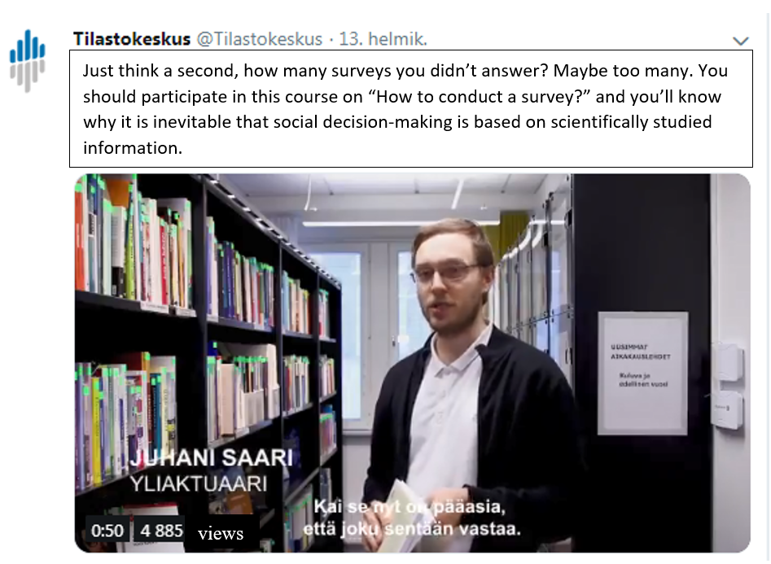

We wanted to get people to think about why it is vital that I, you and everyone else answer surveys conducted by social organizations and authorities. The data are basically used in social decision-making processes for our common good. Without valid data it is impossible to compare, plan, judge, evaluate or justify decisions made by decision-makers. A key challenge is how to make people see the connection of their own behavior and actions in that process. Statistical data does not turn up suddenly from somewhere, it is provided with the help of people.
A second successful video was made for the course of “Self-employed persons in Finland and enterprises” (2019-03-21).
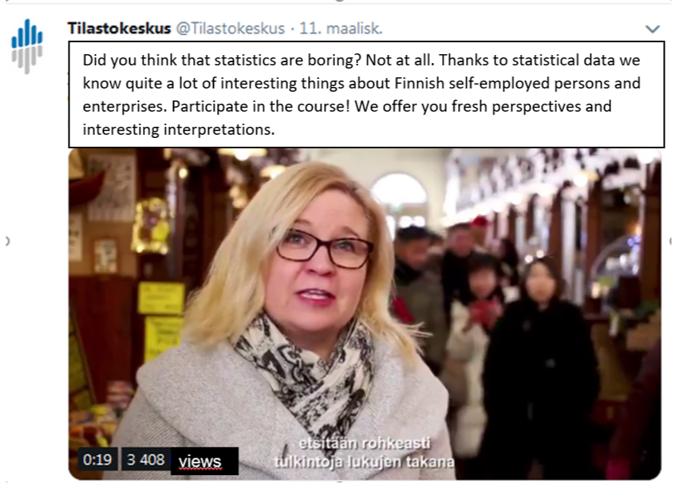

A talented trainer and the host of the course performed in this video. She decided to introduce the course businesslike and wanted to be shot in the market hall in Helsinki. The video had over 3,400 views! The marketing strategy approached the topic with an idea of motivating potential participants and viewers. If someone was thinking that statistical data is boring, they were very wrong. Behind an immeasurable amount of numbers interesting interpretations can be found from the data with the help of experts of statistical data.
A third excellent example of the video campaign was “Work and gender equity” (https://youtu.be/V-EklSG510E). It is available also in English. The video was exceptional – a funny, smart story with subtle humor. Even though the topic was kind of sensitive it succeeded to be very sophisticated and universal at the same time.
In the video, there was a perspective of an educated woman who was irritated by the statistics of gender and working life. She had some feedback to give. The problem was that it was confusing from her perspective that statistical data claims women work mostly in so-called feminine industries, are paid less for work in general, suffer from an unequal share of housework and even argues that her son would be very likely in danger of becoming socially excluded. She would describe her life just the opposite. It was impossible for her to identify herself with the data and especially with the reality the data was representing.
The story goes from the irritation to explanation – it is impossible to describe every single case in statistical data, and to be honest, researchers are not interested in one person but the whole population. This is one of the most difficult challenges researchers are struggling with – how to explain to people that every answer is vital but in reporting, the whole data not a single answer is more important. In the end, there was an explanation phase in the video where it was indicated with statistical data that this woman was an exceptional case. Every indicator in statistical data supports the original arguments presented at the beginning of the video even though the woman was suspicious about them. The power of the video was mainly due to the illustrative nature. Sometimes, not even very seldom, common impressions do not correspond to the researched data and that’s why it is necessary to clear up misunderstandings.
The last example of the video campaign is Statistics of external trade, which was held in March. The host of the course performed in the video. He approached the course topic from a fact-based perspective and wanted to emphasize the usability of the data among experts that work with trade issues. We boosted the video with paid marketing a couple of times and it got over 5,200 views. Still, we had quite some problems to get enough participants to the course.

3.2 Twitter or Facebook, paying or not paying?
Thanks to excellent video production and the talented personalities of our staff we got much more likes than ever before and the growth in visibility was almost radical. Especially the above-mentioned videos were successful. There is, however, a big difference in visibility between various social media channels.
On Instagram it is possible to get couple or hundreds of views like the course Basic concepts of statistics (2019-02-12) gathered. On Facebook, we’ve got dozens of likes for our course videos, such as Can you ask right? and How to make a good form (2019-03-28). This is ok but not that much if you try to be more visible.
Besides, on Twitter we talk about thousands of views. That makes a huge difference. Twitter is based on followers, using effective hashtags and sharing tweets. An absolute advantage of social media is allocation. The difference between paying and not paying for marketing on social media is also significant. Strictly allocating and paying is the most effective strategy to get more views, especially likes and of course also attention on social media.

3.3 Our second attempt to make noise: A face campaign
Are we allowed to be funny? - We had to ask ourselves. Is there any chance we, an official statistical authority, could make people laugh? Hardly, we first thought. Usually the reaction is close to something like “is there anything more boring than official statistics?” Eventually, the idea was exciting enough and worth trying.
At the turn of the year, we launched a marketing campaign which was based on the basic principles and facts of statistics. We made a list of arguments and utterances that were linked to statistics. We also went a bit further. The idea was to shake up the masses not to bore them. We turned everything upside down – we exposed ourselves to risk. We challenged everything we know best. Moreover, we also listed common impressions founded among ordinary people and wanted to challenge them.
In addition, we needed faces because social media loves persons and faces, so it was not an option to use images or even pictures of strangers. We again recruited our own staff, luckily, it was available.
Next, I will show you some examples of the campaign.
This is one of the most popular posts we had on Twitter and Facebook in May. We got dozens of likes without paying. The following examples are based on the same idea of questioning the rooted assumptions of statistics in people’s minds.

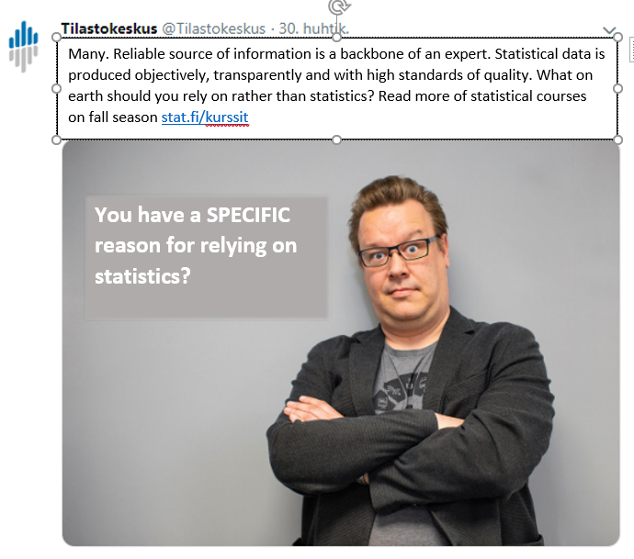

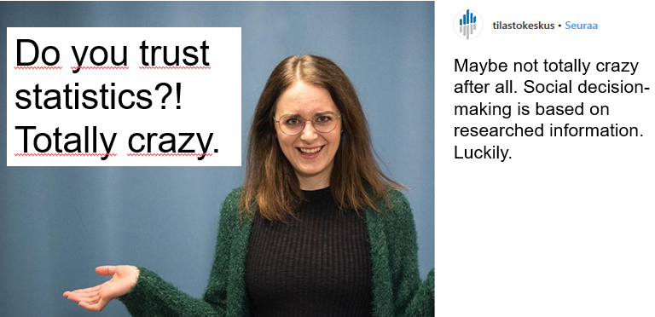

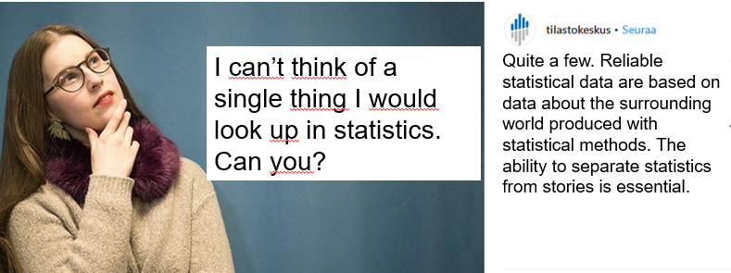

The focus was supposed to be somewhere else than on academic discussion of statistics or statistical data or anything that is conventionally related with the organization or the topic. The reaction we were pursuing was kind of the opposite - “eureka!”, “oh really?”, “that’s true!”, “quite funny!”, “I’ve never thought of that before!” and so on.

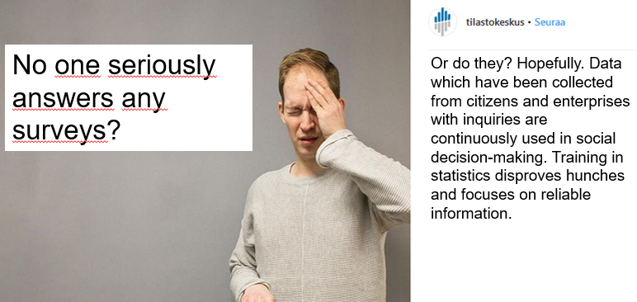

The Finns go crazy when Finnish national sport teams (especially in ice hockey) succeed in international competitions. The first success is from 1995 (the last this year) when the Finnish national ice hockey team won the world championship. Since then, people are used to rush out and gather in the marketplaces to celebrate the success. Pretty odd? The next posting, we had on Twitter is related to that cultural distinction.

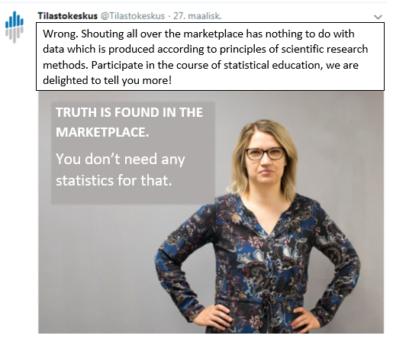

The face campaign has been running the whole year. For the marketing of statistical education, it has offered a new approach to making noise on social media. Fact-based noise with a pinch of self-irony is unconventional (at least for us) but it seems to work. A totally different issue is how to get people to act?
Like I mentioned in the beginning of the paper, a user is a powerful agent deciding whether to share or not any kind of information he or she likes or dislikes. This is a key element of social media. It is not irrelevant for an organization whether a user decides to share something he or she likes or not. It is inevitable and a question of life and death. Connecting networks and sharing posts means real power.

- Efficiency of social media marketing
A clear effect of social media marketing of statistical education was that we did not have any cancellations since 2018. Every course was organized as planned even though we sometimes had a bit less participants than normally. Still, for us it made a big difference that we were not totally forced to give up like we had previously. Just some compromises were necessary, that’s all.
Even though plenty of work was done before every single course was sold out, so to say, social media marketing turned out to be a great potential for us and it continually contributes significantly to the visibility of statistical education. The whole year, we posted approximately one to three times for a single course with varying content. More posts were needed if the course did not seem to be attractive enough (not enough enrolments). We also found paying to be necessary in some cases. Paid marketing on social media is effective because of its potential to pick up interesting target groups linked with essential key words of users’ profiles as well as regional options.
The basic principle was that we pay at most one time, for a course, but in practice, we did not have to pay for every course. In general, we preferred to pay for a specific course instead of for general course marketing because of the targeting options described above. It turned out to be more effective. In addition, being visible through the whole season is as relevant as anything else.

- Conclusion
A big step on the global level occurred on social media when the Wall Street Journal, CNN and National Geographic joined Snapchat (see e.g. https://circaedu.com/hemj/how-social-media-changed-the-way-we-communicate/). Nationally, Statistics Finland is on the same path, and it seems to be the right one. If we want to share reliable content and information among ordinary people, especially young adults, we need to make the content more accessible and desirable. Social media offers more options to be visible than any other communication channel before. Why not take the most advantage of it?
Being visible on social media in an effective way is something that an organization needs to learn first. The instant communication style on social media has revolutionized traditional communication, which was based on totally different principles.
According to Kosonen (2018) it is essential that information flows on social media. Basically, it means sharing knowledge and information. Ideologically, from an economic and marketing perspective, it is the same - sharing means multiple profits and can never be achieved by spending money on products by a single consumer (Angell & Eunjo, 1481).
For us, the key challenge is how to make people share information instead of just glancing it. Statistics Finland as an official authority is engaged to produce and share socially meaningful content linked with statistics, statistical data and other topics related to research and science on social media.
The ongoing “battle” between fact and fiction on the Internet and especially on social media is challenging researchers and other social actors. Authorities and scientists are part of the struggle because they are responsible for defending facts and the truth to the very end.
The video campaign and the face campaign I presented in this paper are examples of new communication tools adapted for influencing on social media. Marketing statistical education on social media in a fresh and more attractive way was a first step to be visible online and acquire more attention and more likes. The first attempt seems to be a success.

References
Brooker, Phillip & Barnett, Julia & Cribbin, Timothy. Doing social media analytics. Big data & Society July-December 2016: 1-12. SAGE.

Castells, Manuel (2009). Communication power. Oxford, Oxford University Press.

Forsgård Christina, Frey Juha (2010). Suhde. Sosiaalinen media muuttaa johtamista, markkinointia ja viestintää. Hansaprint Oy, Vantaa.

Kim, Angell J. & Ko, Eunjo. Do social media marketing activities enhance customer equity? An empirical study of luxury fashion brand. Journal of Business Research 65 (2012) 1480-1486.

Kosonen, Miia (2018). Sosiaalinen media ja tutkijan etiikka. Tieteelliset aikakausiartikkelit. https://erepo.uef.fi/handle/123456789/6958

Laaksonen, S-M., Matilainen, J.& Tikka, M. (2013). Tutkimusotteita verkosta. IN: Laaksonen, Matikainen, Tikka (toim.). Otteita verkosta. Verkon ja sosiaalisen median tutkimusmenetelmät. Vastapaino, Tampere.

Lähde, Ville (2017): Paljon liikkuvia osia. Savukeidas. Tallinna.

Oksaranta, Tuomas (2014). Mediakuluttajan muuttuva rooli: Sosiaalinen kuratointi. Pro gradu, Johtamiskorkeakoulu, Tampereen yliopisto. http://tampub.uta.fi/bitstream/handle/10024/95903/GRADU-1404904635.pdf?sequence=1&isAllowed=y

Richter, A. & Koch, M. (2007). Social software - status quo und Zukunft. Technischer Bericht, Nr. 2007-01, Fakultät für Informatik. Universität der Bundeswehr München.

Rosling, Hans (2018). Faktojen maailma. Otava, Helsinki.

Seppänen, Janne & Väliverronen, Esa (toim.) (2015). Mediayhteiskunta. Vastapaino. Tallinna.

Tufekci, Z. Big Questions for Social Media Big Data: Representativeness, validity and other methodological pitfalls. In: Proceedings of the Eighth International AAAI Conference on Weblogs and Social Media, Ann Arbor, Michigan, USA, 1-4 June 2014, pp. 505-514. Palo Alto, CA: The AAAI Press.

Internet
http://www.zengestrom.com/blog/2019/01/why-social-media-creates-blocks-of-people-who-think-alike.html
https://www.stat.fi/til/sutivi/index_en.html (Use of information and communications technology by individuals, 2018)
https://circaedu.com/hemj/how-social-media-changed-the-way-we-communicate/

https://medium.com/umblernews/how-social-media-has-revolutionised-the-way-companies-communicate-31ca91b4fa3

https://thriveglobal.com/stories/how-social-media-affects-our-ability-to-communicate/

https://www.walkersands.com/how-social-media-is-changing-communication/

https://theknowledgereview.com/effects-social-media-communication-skills/

http://www.ijsrp.org/research_paper_may2012/ijsrp-may-2012-24.pdf

Keywords: statistical education, statistical training, social media, social media marketing, media literacy, sharing information, communication, fact-based videos

