Nordic Mobility Statistics
Kaija Ruotsalainen, Statistics Finland, kaija.ruotsalainen@stat.fi
Ulla Agerskov, Nordic Council of Ministers, ullage@norden.org

The free movement of persons between the Nordic countries is an important part of a common identity and a strength of the Nordic societies. Official statistics are an unbeatable tool for revealing trends and patterns - also in this area. However, approximately 45,000 people are missing from the official national statistics (e.g. labor market and education statistics) because of movements across borders.
To overcome these shortcomings, a project was initiated under Finland’s presidency of the Nordic Council of Ministers in 2016. The project has been coordinated by Statistics Finland and executed in cooperation with the Nordic Statistical Institutes. The motivation for the project was, and is, a great demand for the missing cross-border statistics in the Nordic region.
To cover the statistical gaps in this area, the Nordic Statistical Institutes set out to exchange national micro data concerning education, migration and employment – and produce the statistics. Previously bilateral data exchange has been limited and not covered all Nordic countries. The project has generated an exchange process that contains certain steps including the identification of individuals, data transfer and data matching.
Microdata exchange is enabled by the EU Statistics Act. A major challenge for this project has been, however, the differences in the national legislations on the exchange of microdata between the Nordic Statistical Institutes. These challenges have limited the outcome of the project to a certain degree.
The results of the project will be disseminated on a running basis here: Norden.org/statistik.
In the future, the development of cross border statistics could be in the areas of e.g. social benefits and business statistics. No funding for these purposes is secured as of this point of time.

Keywords: Cross-border, mobility, Nordic statistics, data sharing

1. Background
Demand for cross-border statistics
The free movement of persons between the Nordic countries is an important part of a common identity and a strength of the Nordic societies. Therefore, Finland in its Presidency of Nordic Council of Ministers in 2016, focused on the removal of obstacles to the cross-border freedom of movement between the Nordic countries.
Official statistics are an unbeatable tool for revealing trends and patterns - also in this area. Unfortunately, approximately 45,000 people are missing from the official national statistics (e.g. labour market and education statistics) because of movements across borders. To overcome these shortcomings, a project was initiated by Nordic Council of Ministers under Finland’s presidency in 2016 – the Nordic Mobility project. The project is coordinated by Statistics Finland and executed in cooperation with the Nordic Statistical Institutes.
Nordic Mobility statistics - in the present and the past
In the period 2000 to 2009 a Nordic database – StatNord – containing regional statistics on population, employment and gross pay in the Nordic countries. Labour mobility between countries and regions is displayed with statistics on cross-border commuting and migration. The database and the site are no longer updated. The latest statistics with data from Denmark, Norway and Sweden is from the 2009 and 2010. The database did not contain data from Finland or Iceland. The database was run by Statistics Sweden.
Another product is Nordisk pendlingskarta, a publication that was published six times. The first four reports were produced in cooperation between Denmark, Sweden, Norway and Finland. The two final reports did not include Finnish data.
Finally, there is Örestat, which is an existing open database with cross-border statistics of the Öresund region. The database contains comparable and harmonized statistics on population, employment etc. and is run by Statistics Sweden.
The Nordic Mobility project
The aim of the project is to develop, produce and publish statistics describing the mobility of people and the social benefits paid across the Nordic borders. The duration of the project was initially three years (2016 to 2018) but is as of now extended until 2020 due to major issues in the possibilities of exchanging data between some of the Nordic statistical institutes. The project is coordinated by Statistics Finland and executed as a joint operation by the national statistical institutes (NSI) in the Nordic countries. The total budget of the project for the 2016 to 2018 was EUR 1,500,000 (approx. DKK11.2 million).
The explicit data content was planned in cooperation by the project group. The primary and preliminary selected statistical areas for the project were:
- migration between Nordic countries
- employment in and commuting to another Nordic country
- attendance in education in another Nordic country
- completed educations and degrees in another Nordic country
- social benefits paid to another Nordic country
- mobility aspects of businesses.
However, during the project it became obvious that it was not possible to focus on the last two topics due to resource and scheduling reasons.
2. Method
3.1. General descriptions of method
The aim of the project was to produce and publish statistics describing the mobility of people and the social benefits paid across the Nordic borders. Since the obstacles to free movement are already identified, listed and prioritized, the goal of this statistical account was to describe the amount of people possibly being affected by obstacles to the freedom of movement in the Nordic countries through statistics. Statistics in the selected statistical areas were produced and published.
In all Nordic countries, statistical production is strongly based on the use of administrative resources and registers. Each country has a population register that includes a permanent population in the country, and on that basis statistics on demography, families and migration are drawn up. Data on person's activities, employment and studies are also collected in administrative registers. In addition, in each country, the National Statistical Institute maintains a statistical education register, which includes the qualifications of the population,
Generally, the statistics based on the registers are comprehensive and of high quality, but in some statistical areas there is some under-coverage and some phenomena are left out in the national statistics. For example, there is under-coverage in the number of qualifications completed abroad. There is no comprehensive data collection on the qualifications of migrants, nor on the qualifications completed abroad by the national population. There are no comprehensive regular statistics on persons working or studying in another Nordic country either.
Particularly in terms of employment, under coverage is highlighted in the border areas, like in the Tornio-Haparanda region between Finland and Sweden, in Öresund between Sweden and Denmark or in the Västra-Götaland region between Sweden and Norway. In register-based statistics, this is reflected, for example, in Southern Sweden by an employment rate several percentage points below the actual employment rate (Örestat III-projektet, no date). According to the European Labour Force Survey, southern Sweden’s 19.1 thousand cross-border commuters were almost entirely working in the Danish capital city region in 2013. This is a result of Swedes deciding to work in the Danish capital, but also of a number of Danes choosing to move from Copenhagen to Sweden, while maintaining their jobs in Denmark and commuting back to their ‘home’ country (Eurostat, Statistics on commuting patterns at regional level).
To cover the statistical gaps in the above-mentioned statistical areas, the Nordic Statistical Institutes set out to exchange national microdata concerning education, migration and employment – and produce the statistics. Previously, bilateral data exchange has been limited only to employment and commuting data, and not covered all Nordic countries.
The project has generated an exchange process that contains certain steps including the identification of individuals, data transfer and data matching.
Microdata exchange is enabled by the EU Statistics Act 223/2009 Article 21, based on which confidential data can be released from one ESS authority to another in order to develop and produce European statistics and improve their quality. This type of data exchange is likely to be the first of its kind, at least in the history of Nordic statistical institutes.
Because there is no common personal identity code in the Nordic countries, exchange of data is based on a persons’ identification by means of name, date of birth and sex. Information needed for identification of persons are:
• Date of birth
• Sex
• First names
• Last name (present)
• Last name (former)
A persons’ identification as the same person based on the above-mentioned data in two different registers (e.g. country A's register of qualifications and country B's population register) is made with SAS/SQL software that compares the sex and name data of persons born on the same day. Identified persons receive different status values depending on how complete the identification is. If all data of a person are similar in both registers and only one person is found, the identification is total. In most cases, those who have small deviations in the register either regarding first or last names can also be considered as being 100 per cent identified.
After the name matching and identification, the serial number of identified persons was sent back to country A, where relevant data (completed education, employment, studies) were added for the person and sent once again to country B, where the data were processed, and the compilation of statistics and matrices was done (Figure 1). The data on the person's highest qualification was also stored in the register of qualifications.
3. Challenges
Main challenge: different national legislation
At the launch of the project, risks were assessed. Among others, project coordination and management were on the risk list due to the fact that the project has participants from several countries and organisations. In addition, different sources of data and different national laws were identified as risks. Of those, differences and interpretations in national legislation were the biggest challenge.
Even though the EU Statistics Act gives the opportunity to exchange unit-level data, national legislation and conventions concerning data release, research use and data storage must be considered. In order to store data permanently in the databases of another country, the practices related to further utilisation of data and releasing to third parties must be similar in the country releasing and receiving the data.
All Nordic countries have more or less similar legislation and practices on further use of statistical data and release of unit-level data outside statistical institutes. During the course of the project, certain small differences and interpretations were encountered, which prevented data exchange between Sweden and Denmark and Sweden and Norway.
According to Swedish legislation, statistical data released to some authority are its property and the data can be released further to third parties without permission from the statistical institute. In other Nordic countries the practice is different: the ownership of statistical data remains with the statistical institute and, if some other party wants to use the same data, the statistical institute grants permission to it. In addition, all data coming to the statistical institute in Sweden are considered equal pursuant to the publicity principle, so data meant to be kept temporarily can be subject to a data request by some authority. The authority must, however, have the right by law to process personal data in order to consent to the request.
In order to compile statistics on cross-border commuters, Statistics Sweden has since 1997 had data exchange of individual data with Statistics Denmark, and since 2001 with Statistics Norway. Ambiguity has also stopped this traditional statistics compilation describing cross-border mobility between Sweden, Denmark and Norway and is threatening its continuity (News Øresund , 2018).
Problem solution: detailed project description
From the project’s viewpoint, Sweden’s participation was seen as crucial. Sweden is located in the middle of the area and neighbours three Nordic countries, so it naturally has most connections with all countries. Therefore, finding a solution to the problem was seen as extremely important.
According to Article 21 of Regulation (EC) No 223/2009 on European statistics, transmission of confidential data from one ESS authority to another may take place provided that this transmission is necessary for the efficient development, production and dissemination of European statistics or for increasing their quality (Official Journal of the European Union, L 87/164, 2009) . According to the regulation, any further transmission beyond the first transmission requires the explicit authorisation of the authority that collected the data.
According to Swedish legislation, all data a public authority has in its possession is, based on the publicity principle, subject to release provided that there is grounds for the data release. Thus, there is no agreement that would exclude data released by other Nordic statistical institutes from this practice.
This was seen as a clear discrepancy between Swedish legislation and the Regulation on European statistics. The Regulation on European statistics requires authorisation from the original data owner, while no such authorisation is needed based on Swedish legislation.
The project group was not able to solve the problem themselves, so a solution was sought in cooperation with the legal advisers of the statistical institutes. Finally, a solution was found based on which data exchange can probably continue, at least to some extent.
In this project, the solution was that the project description was updated with more specific references to EU legislation. In addition, a detailed list of variables to be exchanged was appended to the description, and whether the variable is part of a ESS statistics or not (reference to the regulation in question). Based on these changes, Statistics Sweden can, if necessary, refuse to release data outside the organisation by citing EU legislation, which is a precondition set by Denmark and Norway for data exchange.
4. Statistical results
Due to the problems related to data exchange, the project has been delayed considerably and actual results on data exchange only exist on qualifications attained abroad. Here, the results of the data exchange between Sweden and Denmark and Sweden and Norway are also missing.
Since the problems have been solved to a certain degree, data exchange can be carried out between all Nordic statistical institutes. However, background data on migration between Sweden and Denmark and Sweden and Norway, and some individual variables in other statistical domains are excluded from the data exchange as they could not be justified to be part of ESS statistics production.
The aim of the project is to complete the data exchange in all agreed on statistical domains and write the final report by the end of 2019.
Next, we will present the first results concerning exchange of qualifications data.
Exchange of qualification data
All Nordic countries have a statistical register of education that contains data on degrees and qualifications completed by the population. The quality of the education registers is high as a rule because educational institutions are obliged to deliver data to the education registers annually. A big problem is caused, however, by the lack of data concerning qualifications attained abroad. No comprehensive register-based data source exists with data on the qualifications of immigrants attained in their home country nor on qualifications attained abroad by the original population.
The aim of the data exchange is, on one hand, to improve the coverage of registers of qualifications, but also to describe movement between the Nordic countries. Qualifications attained in another Nordic country can be seen as a sign of the movement of the population from one country to another. It means that the person has had a relatively long relationship with the country in question: he or she has lived there to study or lived there permanently and moved to another country after becoming an adult.
Table 1 shows received data on at least upper secondary qualifications (ISCED 3-8) attained by the population at the end of 2016 in another Nordic country. In total, nearly 90,000 persons were reported through the data exchange to have attained a qualification in another Nordic country. The highest educational qualification attained in each country has been included. It should, however, be noted that this is still missing the results from the data exchange between Sweden and Denmark and Sweden and Norway. It is likely that the number of qualifications will increase considerably.
Table 1. Qualifications attained in another Nordic country, qualification data received through data exchange for the population at the end of 2016, ISCED 3-8 qualifications.
Country of residence | Country of education
 | Total | Denmark | Finland | Iceland | Norway | Sweden
Denmark | 9,785 | . | 1,793 | 2,216 | 5,776 | ..
Finland | 14,524 | 891 | . | 129 | 573 | 12,931
Iceland | 9,052 | 5985 | 179 | . | 719 | 2,169
Norway | 23,915 | 17,347 | 3,748 | 2,820 | . | ..
Sweden | 31,265 | .. | 31,265 | .. | .. | .
Effect on the national statistics on the educational structure of the population
The data exchange also provided data on qualifications attained in other countries than the one releasing the data. In addition, Denmark, Finland and Iceland also combined data for other populations than that of 2016. Thus, as a whole, the volume of exchanged data was clearly higher than that mentioned above (Table 2).
All data received in the data exchange will not, however, end up in the national register of qualifications. A person can already have a higher or equal qualification in which case the data received through the data exchange will not replace the existing data. However, data on the highest qualification attained was updated in national registers of qualifications for nearly 60,000 persons. Around one-third, 20,000 persons had no previous qualification data.
Table 2. Number of qualifications received through data exchange from other Nordic statistical institutes
Reporting country | All persons having ever lived in the country | Population on 31 December 2016 living in the country
 | 3 - 8 at least upper secondary level qualifications | 3 - 8 at least upper secondary level qualifications | Highest education update for the person | of those having no entry in the national register
Denmark | 104,549 | 14,379 | 9,785 | 9,123
Finland | 198,376 | 31,735 | 13,125 | 6,590
Iceland | 49,317 | 13,296 | 5,905 | 1,029
Norway ¹⁾ | .. | 29,113 | 11,061 | 5,767
Sweden | .. | 36,567 | 19,730 | 2,468
- Population on 31 December 2015
The data exchange had the biggest effect on the quality of the register of qualifications for Iceland. There, 2.2 per cent of the population aged 15 or over received new data on the highest qualification attained, while the share in the other countries was around 0.2 to 0.3 per cent (Table 3).
Table 3. Share of updates for the population aged 15 or over, 2016
Country | Population | Highest education update for the person | %
Denmark | 4,787,201 | 9,785 | 0.2
Finland | 4,609,119 | 13,125 | 0.3
Iceland | 271,533 | 5,905 | 2.2
Norway ¹⁾ | 4,320,607 | 11,061 | 0.3
Sweden | 8,234,159 | 19,730 | 0.2
- Population aged 16 or higher at the end of 2015
Effect on the educational structure of Finnish population
At the moment, no detailed analysis is available for all countries. Next, we will present some key results concerning the data exhange of the qualifications for the Finnish population 2016.
Around 13,100 persons received a qualification that is higher than the data in Statistics Finland’s Register of Completed Education and Degrees through the data exchange. A little over one-half of these, or around 51 per cent, were women.
Most qualifications from the other Nordic countries were upper secondary level qualifications. They amounted to around 32 per cent of the received qualifications: 37 per cent of men's qualifications and 25 per cent of women's qualifications. For women, completed qualifications focus on tertiary level education qualifications: they made up almost 60 per cent of the received qualifications. The corresponding share for men was around 43 per cent. (Figure 1)
Figure 1. Qualifications from other Nordic countries for the population of 2016 by level of education. Finland
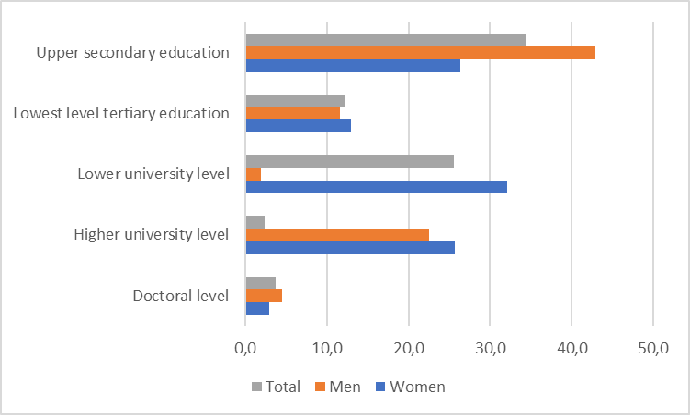
The most common fields of education received from other Nordic countries were engineering, manufacturing and construction (20.2 %), health and welfare (16.4 %), business, administration and law (14.7 %). A little more than half of qualifications were in these fields. (Figure 2)
Figure 2. Qualifications from other Nordic countries for the population of 2016 by field of education. Finland

The undercoverage in the Register of Completed Education and Degrees affects examinations that focus on those with no post-comprehensive level qualification. This is most visible in regions where there are many immigrants or from where it is common to go abroad to study. Thus, it is probable that the level of education is lower than the actual level in Uusimaa due to immigration and in Åland because young people from Åland often complete their degree in Sweden or elsewhere abroad. (Witting 2017)
According to Statistics Finland’s Register of Completed Education and Degrees, 71 per cent of the population aged 15 or over had completed at least upper secondary qualifications at the end of 2016. The educational level was highest in Pirkanmaa, where around 74 per cent had completed a qualification, and lowest in Åland, where 63 per cent of the population aged 15 or over held an upper secondary or tertiary level qualification. This is about eight percentage points lower than the value for the whole country.
Around 13,100 of the qualifications obtained from the other Nordic countries’ registers of qualifications were accepted as the person’s highest completed qualification. Around one-half of them already had some lower level degree in Statistics Finland’s Register of Completed Education and Degrees. Thus, for around 6,600 persons, who did not have an entry in the register of qualifications, data on completed education were received. This raised the share of those with at least upper secondary qualifications by 0.1 percentage points.
As assumed, the biggest change in the share of people with qualifications was in Åland, 4.1 percentage points. After the data exchange, the share of the population aged 15 or over with educational qualifications was slightly over 67 per cent. The share of those with tertiary level qualifications also rose by nearly five percentage points. (Ruotsalainen, 2018)
Figure 3. Share of the population aged 15 or over with qualifications at the end of 2016, before and after the data exchange. Finland
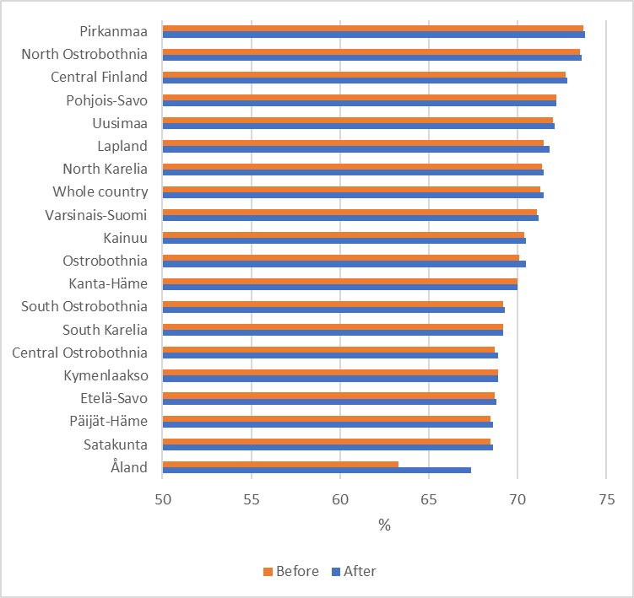

5. Conclusions
The purpose of the project was initiatilly to produce statistics on mobility between the Nordic countries. As all of Nordic countries have more or less similar legislation and practices on further use of statistical data and release of unit-level data outside statistical institutes, which is a condition to produce mobility statistics.
This however turned out to be one of the main focus points of the project as certain small differences and interpretations were encountered, which prevented data exchange between Sweden and Denmark and Sweden and Norway.
These challenges have partly been solved by utilizing the framework of EU-regulation. It is however still an unsolved issue, that unit level data cannot be exchanged freely between Sweden – and – Denmark and Norway, unless the data is subject to EU-regulation.
The countries are now exchanging unit level data and most of the initially planned statistics is being produced. Nordic cross-border statistics are expected to be disseminated by the end of the year and will be presented in Nordic Statistics Database.
Due to the problems related to data exchange, the project has been delayed considerably and actual results on data exchange only exist on qualifications attained abroad. Thus, in this paper the first results concerning only exchange of qualifications data are presented.
All Nordic countries have a statistical register of education that contains data on degrees and qualifications completed by the population. The quality of the education registers is high as a rule but there is undercoverage concerning qualifications attained abroad. By the data exchange, data on the highest qualification attained was updated in national registers of qualifications for nearly 60,000 persons. Around one-third of them had no previous qualification data. In this context, it has to be noticed that the results of the data exchange between Sweden and Denmark and Sweden and Norway are still missing.
The data exchange had the biggest effect for Iceland. There, 2.2 per cent of the population aged 15 or over received new data on the highest qualification attained, while the share in the other countries was around 0.2 to 0.3 per cent.
At the moment, more detailed results are available only for Finland. Around 13,100 of the qualifications obtained from the other Nordic countries’ registers of qualifications were accepted as the person’s highest completed qualification. Around one-half of them already had some lower level degree in Statistics Finland’s Register of Completed Education and Degrees. Thus, for around 6,600 persons, who did not have an entry in the register of qualifications, data on completed education were received. This raised the share of those with at least upper secondary qualifications by 0.1 percentage points.
As assumed, the biggest change in the share of people with qualifications was in Åland, 4.1 percentage points. After the data exchange, the share of the population aged 15 or over with educational qualifications was slightly over 67 per cent.
6. References
Official Journal of the European Union L 87/164 (31.3.2009). Regulation (EC) No 223/2009 of the European Parliament and of the Council of 11 March 2009. Available at: https://eur-lex.europa.eu/legal-content/EN/TXT/?uri=uriserv:OJ.L_.2009.087.01.0164.01.ENG&toc=OJ:L:2009:087:TOC
Ruotsalainen, Kaija (2018). Data exchange between the Nordic countries improves the image of Finland’s level of education. Available at: http://tilastokeskus.fi/org/tilastokeskus/nordic-project-on-cross-border-mobility-and-benefits_en/data-exchange-between-the-nordic-countries-improves-the-image-of-finlands-level-of-education.html
Statistics on commuting patterns at regional level, Eurostat. Statistics Explained. ISSN 2443-8219
Statistik över gränspendlare i fara – Norge och Danmark kan sluta utbyta data med Sverige. An article in News Øresund on 9.5.2018. Available at: https://www.newsoresund.se/statistik-over-granspendlare-i-fara-norge-och-danmark-kan-sluta-utbyta-data-med-sverige/
Witting, Mika (2017). Nuoret vailla perusasteen jälkeistä tutkintoa – eniten Uudellamaalla ja Ahvenanmaalla? Tieto&trendit 20 November 2017 (only in Finnish). Available at: http://www.stat.fi/tietotrendit/blogit/2017/nuoret-vailla-perusasteen-jalkeista-tutkintoa-eniten-uudellamaalla-ja-ahvenanmaalla/
Örestat III-projektet: saknas: 45 000 personer (eller ungefär 122 fulla tunnelbanetåg). Available at: http://www.orestat.se/sites/all/files/morkertalen_web_se.pdf

