The key to good quality
mixed mode surveys:

Cooperation, hard work and patience
Laura Sauli, Statistics Finland, laura.sauli@stat.fi
Abstract
Four years ago, Statistics Finland set a strategic goal: All our social surveys should be mixed mode surveys by 2018. The work had already started some years earlier with preliminary research, questionnaire testing and web pilots, but by 2014 it was time to start preparing for a total transition. This was the starting point of a programme called Developing mixed mode data collection. In January 2019, after some four years of hard work and multi-professional cooperation – as well as some trials and errors – we were ready to launch the first mixed mode surveys in the new system.
During the past four years this programme has included 17 projects which have all concentrated on different aspects of data collection such as questionnaires, mixed mode designs and new ways of reaching the respondents. From early on it was also clear that mixed mode surveys could not be conducted cost-effectively without a new data collection system based on automatization and common tools and processes. Transforming surveys into mixed mode is a fundamental change, not just a technical shift. It is also a starting point for even more profound changes; alternative data collection methods are just around the corner. In order to maintain the quality of the data, comparability over time and between modes as well as tackle the challenge of growing nonresponse we have to invest in careful planning, innovating and testing different solutions and processes. We should also be prepared to learn from our mistakes and setbacks, as they are bound to happen along the way.
In this paper I will present the factors that made the shift to mixed mode happen at Statistics Finland. I will also discuss the lessons learned and what to avoid in order to achieve good quality mixed mode surveys.
Keywords: Data Collection, survey, mixed mode

In the beginning: doubts and fears, outdated technology and lack of knowledge
Statistics Finland started taking the first concrete steps towards implementing mixed mode surveys back in 2012. Before that, preliminary work had already been done in the form of some research and web pilot tests.
When the work started, the general opinion of Statistics Finland survey experts was very much against them. We had already some proof that changing the data collection method from interviews to self-administered questionnaires could result in changes in time series, especially with opinion-based questions like the Consumer Confidence Survey. On the other hand, some surveys – like the fast and continuous Labour Force Survey or the long and conceptually challenging EU-SILC – were considered too difficult or burdensome to manage as mixed mode surveys.
Either way, implementing mixed mode was seen mainly as a threat and a waste of money and effort. The surveys were running sufficiently well with interviews, so why change anything? The main purpose of the first pilot tests as well as other reviews and reports seemed to be to justify why mixed mode data collection shouldn’t be implemented at all or at least not in a certain survey.
Despite the resistance, there were strong arguments in favour of the change. The nonresponse rates were growing, and some new effort was needed to fight this development. The costs of the interview work were high and expected to rise, and the state budget was not very promising regarding the future funding. For these reasons, “offering web as an option” in household surveys was already included as one of the goals in Statistics Finland’s strategic plan for the years 2012–2015.
It was obvious that the change would not be easy, and it would require coordinating and support. And then there was the question of IT infrastructure. With the existing data collection system and tools, it would not be possible to run mixed mode surveys effectively and without a considerable amount of manual work. Each survey had its own tailored production process which usually relied on the experience of a certain person in charge. If web questionnaires were used in some occasions, interviews and web data collection could not be managed in the same system, and the data collection could not be monitored properly.
The old system (or rather a group of separate systems) was not performing effectively and a new system was needed. However, no resources were available for developing a new system, because at the same time a new production system was being built for the business database. The start of the concrete work was therefore postponed by two years.

Establishing a programme and setting new goals
In 2014 it was time to roll up the sleeves and start the development work. The Mixed Mode Data Collection Programme was established, and four objectives were defined for the programme:
- Developing tools for managing mixed mode surveys effectively
- Creating possibilities to save data collection costs (in the long term)
- Finding ways to fight the growing nonresponse rates
- Offering better customer service for respondents.
To achieve these goals, work needed to be done in four focus areas: building the new data collection system, developing questionnaires, rebuilding processes and developing statistical methods (Figure 1). Even more importantly, these focus areas needed to be brought together with proper change management and effective communication. It was essential that the goal was clear for all people involved in the projects and working with implementing the change.
Figure 1. Components of the Mixed Mode Data Collection programme
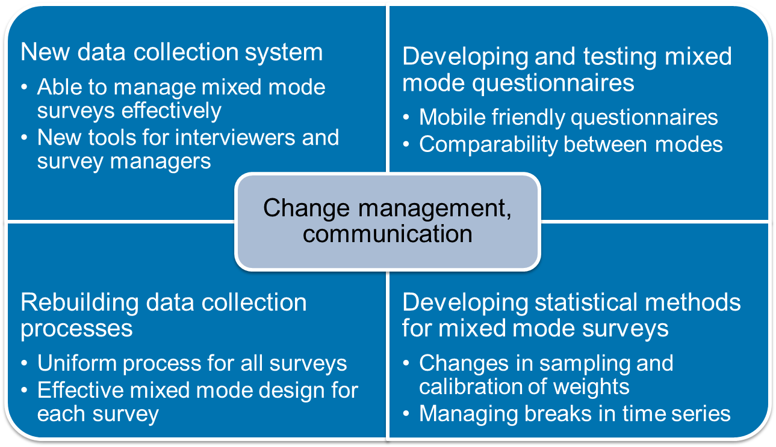
A new strategic plan of Statistics Finland was confirmed in 2015 and implementing mixed mode in all household surveys was set as one of the key strategic goals. This meant more direct involvement and interest from the side of the management. A common steering group with three directors as members as well as a full-time programme manager were appointed to coordinate the big picture.

Slow progress and setbacks with the IT
After a couple of years of waiting, work finally started with the new data collection system as well. The plan then was to design and build the new system during 2015 and then test it with a Labour Force Survey mixed mode pilot in 2016. Preparations started also with the Use of ICT Survey, where the new Blaise 5 software was to be used for the first time in a web pilot survey.
The target was clear, but the work with the new system progressed slowly. Pretty soon it was obvious that the expectations had been far too optimistic regarding the timetable and resources. Modernizing existing systems using current methods was not enough; we were dealing with building a complex system with several new elements as well as connections with other systems (such as the data warehouse for person and household data or the system of identification and authentication of web respondents) still in the planning phase or under development. The Blaise 5 software that was supposed to be integrated into the system also turned out to be more unfinished than expected. Due to these reasons the start of the LFS mixed mode pilot was postponed from February 2016 to November in order to allow more time for the finishing of the system.
The first considerable setback came in February 2017, when the second wave of the – already once postponed – LFS mixed mode pilot had to be interrupted due to technical problems. Although the prototype of the new data collection system had already been tested with a group of interviewers and approved satisfactory for piloting, it turned out to have several deficiencies in real production.
The most severe problems had to do with unreliable data communications that resulted in errors in the timeliness of the data. Statistics Finland has a decentralized interviewing organisation where most interviewers work part-time from home all over Finland via remote access. The quality of the network connections varies a lot, but the reliability of the data communications still has to be top class. The data must transfer flawlessly between modes and users as well as different parts of the system. For example, if the modes are concurrent and a respondent answers in web, the information about the received answer has to reach the interviewing system immediately. This way the interviewers can keep track of who to call or not.
By then it was too late to take back the decision to carry out the Adult Education Survey 2017 in the new system, because a change in plans would have required too much work with the already quite finished questionnaires. So, Statistics Finland went through with the AES as planned and managed quite well in the end – thanks to hard-working interviewers and a web questionnaire that performed reliably. After this in June 2017 the prototype of the system was withdrawn from production and returned to the design table for further development.

Questionnaires: from desktop to mobile first
While the development of the data collection system staggered on, the work with mixed mode questionnaires continued relatively successfully. The biggest challenges had to do with the changing business environment; internet use and especially the devices people use to access internet were changing rapidly. Back in 2016 when the AES web questionnaire was being designed, it was still a relevant solution to recommend answering with laptops or desktops instead of mobile devices. But the use of mobile devices was growing fast: According to the statistics on the use of ICT in 2018 mobile devices were the most common devices to access internet in Finland; 75 % of the population aged 16 to 89 had used the internet with their mobile phones over the past three months (http://tilastokeskus.fi/til/sutivi/2018/sutivi_2018_2018-12-04_tie_001_en.html).
The rapid growth of mobile internet use posed challenges to questionnaire design. Since mobile phones are the primary or even only devices for internet use for so many respondents, offering desktop only questionnaires would not be good service and would probably lead to growing nonresponse rates. Also, in the Statistics Finland data collection infrastructure there is no way to technically block answering by mobile devices. Therefore, the focus in questionnaire design needed to be shifted towards mobile friendly questionnaires.
Questionnaires originally developed for a certain mode can rarely be shifted to other modes as such – not even if they are well tested and working in the original mode. Statistics Finland has a policy to test all new questionnaires using cognitive and usability testing methods, and testing was considered particularly important when converting old questionnaires into mixed mode versions. Despite its incompleteness regarding mixed mode features, Blaise 5 was working well with web questionnaires from early on, so were able to develop and test questionnaires for the Labour Force Survey, Adult Education Survey and ICT Survey. A common layout for web questionnaires was designed and in general the questionnaires got positive reactions from the testers.

Changing to the fast lane with the IT system development
After the rough spring 2017 it was time to rethink the whole development work regarding the new data collection system. At that time some changes in project management were taking place at Statistics Finland in general; new professional project managers were recruited, and agile methods began to take over. A new project was established on that basis.
At the start of the new project the situation of the data collection system was re-evaluated. It became obvious that the system – then named as Ruuti, which means gun powder in Finnish – needed a lot more work. The logic of the data communications, the choice of technologies used as well as the design of the user interfaces needed rethinking. Having a good product owner, a project manager and well-defined backlog was not enough, Statistics Finland needed to invest more in a working development team and testing.
After six more months of planning, reasoning the need for extra funding and shopping for developers, the scrum team was up and running in the spring 2018. From then on, the work started to progress. By the end of the year, the Ruuti system was ready to be launched in production and the shift to actual implementation was finally at hand.
The new Ruuti system offers new tools for ca. 200 people: all interviewers as well as personnel working with data collection or interviewer management. The Ruuti system includes the data collection management “engine” for managing surveys and the work of interviewers, the interview channel with a user interface for conducting telephone and face-to-face interviews, the web channel for collecting data by web questionnaires as well as the data communications between these different parts. For the moment all questionnaires are implemented with Blaise5, in the future it is also possible to add interfaces to other questionnaire tools.

Spring 2019: First mixed mode surveys in production
The first surveys running in the new Ruuti system were the Travel Survey (from January 2019) and the Consumer Confidence Survey (from February 2019). This was definitely a milestone but by no means meant that the system was ready or that the change was done. On the contrary, the work just seemed to increase. The past few months have been a very intensive period of bug fixing and releasing new features as well as user training and support. The challenge now is to be able to get all the benefits from what has been invested.

What have we done right and what have we learned?
From 2014 to 2019, the Mixed Mode Programme has included 17 projects that had to do with developing and testing the new data collection system and different aspects of 9 different surveys: questionnaires, mixed mode designs and new ways of reaching the respondents (Figure 2).
Figure 2. Projects of the Mixed Mode Data Collection Programme 2014–2019
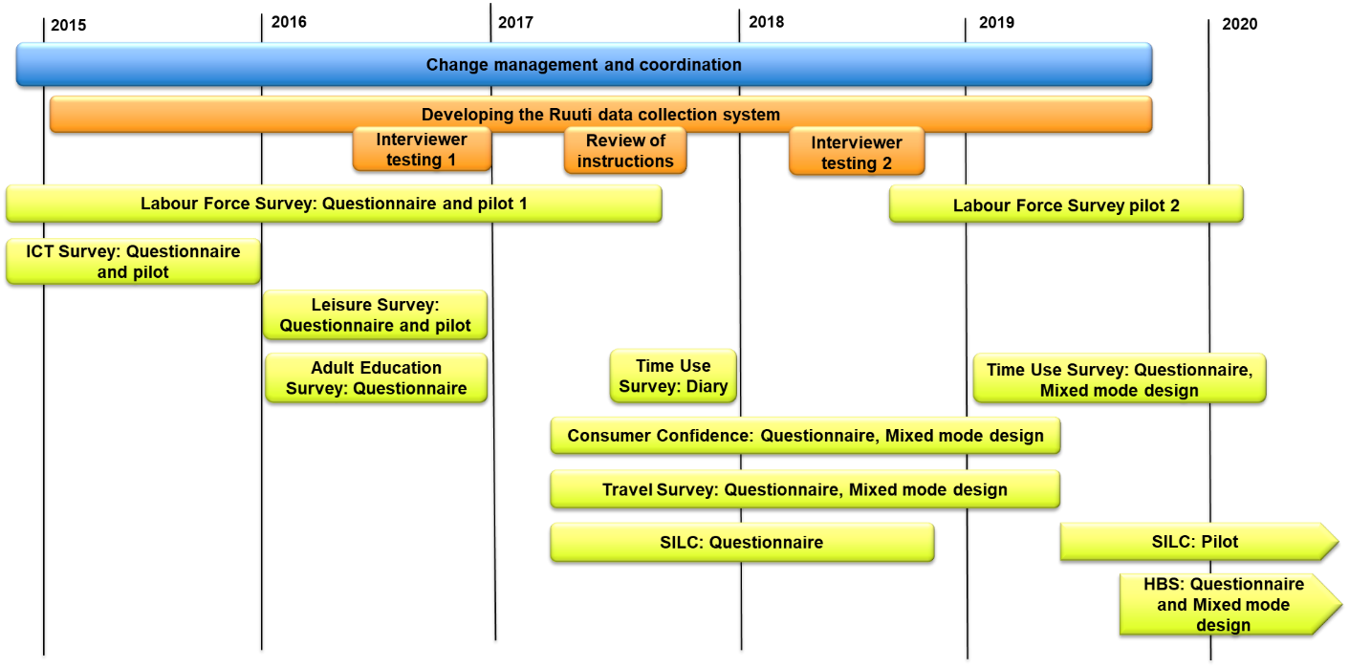
Looking back, the following aspects have in my personal opinion contributed the most in getting results:
- Coordinating the big picture by organizing a programme. Centralizing the decision making has ensured that the decisions made in one project do not contradict with the goals of another. It has also enabled us to prioritize and coordinate resources more effectively.
- Expertise in questionnaire design and testing. Statistics Finland has a professional and experienced Questionnaire Design and Testing team, which also contributes actively in the field of questionnaire development. Thanks to this, the questionnaires have received good feedback from respondents. Active networking internationally also lead us to change our strategy to mobile first just in time.
- Appointing a good product owner for the new system. It is very important that the product owner has profound understanding about the business goals and knows the users of the system. It is equally important to give the product owner enough time to do the work, even though this means that a replacement has to be recruited for the duration of the project.
- Investing in a full-time development team. Although somewhat belated, the decision to invest in a full-time development team with the right capabilities was crucial to the finishing of the system.
- Communication and cooperation. There are maybe 250–300 people at Statistics Finland working with questionnaires, designing and organising surveys, statistics based on those surveys, interviewing as well as the IT systems. To achieve a common understanding about the goal and to keep up to date in a changing environment requires daily communication and multi-professional cooperation.
All in all, it is essential to understand that the shift to mixed mode is not just a technical one, but a profound change of culture. The whole idea of survey data collection needs to be transformed from a simple waterfall process where the survey is planned, executed and then analysed to an organic and reactive process that is able to change in time and utilize cumulative knowledge. This change takes time and patience as well as determination and consistent decision making.

