A Leadership Lost: Reclaiming the Nordic’s place in the Open Data Space
Tryggvi Björgvinsson, Statistics Iceland, tryggvi.bjorgvinsson@hagstofa.is
Abstract
Open data create value. A report from 2013, by the McKinsey Global Institute, stated that opening up data in only 7 areas of the global economy, could generate an additional value of $3 trillion a year. The Open Data Barometer – an index that shows the state of open government data – revealed that in that same year, the Nordic countries were global leaders in open data. The Nordic countries ranked between 3rd and 14th place globally. Only 4 years later, the same open data index ranked the Nordic countries between 13th to 36th place. In 2018, none of the Nordic countries were included in a special leaders edition focusing on the top 30 performers of 2017 in the open government data space.
The Nordic countries are no longer regarded as leaders in open data. This fall from grace, raises questions as to what happened and what the Nordic countries can do to regain their position as global champions of open data. How can the Nordic countries continue to unlock social, economic, and political value with open data?
The paper looks at the different open data indices and metrics that show the state of open data around the globe, with a focus on open statistical data. The paper uncovers the reason behind the lower ranking of the Nordic countries; a mix of stagnation, misplaced efforts, and faults in the methodology of the global open data indices. Furthermore the paper looks at the current open data initiatives in the Nordic countries, specifically efforts of the Icelandic government in which Statistics Iceland participates, and recommends what approaches should be shared between the Nordic statistical offices to improve public service through unhindered access to statistical data.
Keywords: open data, indices, nordic countries, global comparison

Introduction
Data help us understand society and make better informed decisions. They are the foundation of the DIKW hierarchy (Rowley, 2007). If we follow the outline of that hierarchy data become information when they are processed, adding context to the information creates knowledge, and internalising that knowledge and applying judgment is wisdom. Without access and the possibility to use the data, the other levels of the hierarchy crumble or are limited to only a select few users.
A report by McKinsey, published in 2013 (Manyika et al., 2013), researched the economic value of data, particularly government data, and found that by removing the obstacle for data use in only seven sectors could generate more than $3 trillion USD a year in additional value in the global economy.
How can these obstacles for data use be removed? By publishing the data as open data and actively encouraging the use of the open datasets.

Open data
Open is not a synonym for published. The term open data refers to published data that encourages reuse of the data. Informally, open data is data that can be used, modified, and shared by anyone and in any purpose. The Open Definition (Open Knowledge Foundation, n.d.) lists four requirements for work to be open:
- The work must be in the public domain or be published under an open license
- The work must be accessible online as a whole, at no more than a reasonable one-time reproduction cost
- The work must be accessible in a machine readable format
- The work must be published in a format that places no restrictions on its use
The first of these requirements requires further explanation, specifically what open licenses are. For that, we must first look at copyright.

Copyright
Modern copyright laws apply automatically to creative and original works and grant the creator an exclusive right for a limited time to determine if and how the work is used and shared. Anyone, who creates anything that can be regarded as original work, is an author and gets these exclusive rights over their work, immediately and automatically upon creation
Another aspect of copyright is that not all creative work is necessarily expressed by the work’s author. A composer of music is regarded as the author, but the performer playing the composition for an audience will also get special rights over their performance. Such copyright-type rights are referred to as related rights or neighbouring rights and are very similar to copyright.
Datasets are for instance protected by neighbouring rights – mostly for economic reasons – because the act of compiling datasets may require a lot of work even if the work is normally not considered to be creative.
These neighbouring rights automatically grant the creators of a dataset, exclusive rights over the dataset when the dataset is created. Interested users therefore need to contact all creators and negotiate if they want to use and build upon the data, even if the dataset is available online for anyone to access.
Requiring contact and negotiations to use published data can be an obstacle for users. For government data, it can even be claimed that restricting public use of the data in such a way is wrong because the general public funded its creation. The economic reasons of neighbouring rights no longer apply.

2.2. Open licenses
To remove obstacles for the use, modification and sharing of work, creators normally attach a specific type of a license, called an open license. Open licenses are a clever way to use copyright and neighbouring rights to reverse those same rights and remove obstacles for use.
Normally, when a creator who has exclusive rights, wants to allow a particular user to build upon the work, the creator grants that user a license detailing the intended usage. In the same way, an open license is a written legal text that declares that any user can freely use, modify and share the work.
The Open Definition (Open Knowledge Foundation, n.d.) lists nine required permissions a license must grant users and all licenses that comply with the requirements are considered to be open licenses. Such a license is considered a core part of the definition of open work.
Various initiatives already provide ready-to-use, legally sound, open licenses that can be attached to works to make them open. Notable open licenses for data are Creative Commons version 4 and the Open Database License. As a result, creators who want to open up their work for further use, modification and sharing only need to pick a license they like and attach it to their work.

Status of open data globally
Many different organisations and initiatives are interested in the publication of open government data. Some of these organisations provide pressure on governments to publish open data, through reports that gauge the status of open data globally.
The idea behind such an index or a report is to uncover the impact of open data initiatives around the world (World Wide Web Foundation, 2018) and provide feedback to governments and help them understand where they have gaps in their open datasets (Open Knowledge Foundation, 2017).
Updated indices tend to be released annually and therefore provide feedback on progress for each year. This paper examines four popular open data indices from the perspective of the Nordic countries and changes over time:
- The Open Data Barometer (ODB)
- The Global Open Data Index (GODI)
- European Open Data Maturity Landscaping (EDP)
- The Open Data Inventory (ODIN)
These open data indices were initiated in or after year 2013. They are still active and in development today, making comparison between years possible to some degree.

The Open Data Barometer
The Word Wide Web Foundation spearheads the Open Data Barometer, which analyses global trends and ranks countries based on three equally weighted sub-indices:
- Readiness
- Implementation
- Impact
The sub-indices are compiled through three forms of data:
- Surveys
- Dataset assessments
- Secondary data
The first four annual editions of the Open Data Barometer gauged open data status on a global scale but the latest edition, called the leaders edition, measured only governments that have publicly committed to open data, either by adopting the International Open Data Charter Principles or signed the G20 Anti-Corruption Open Data Principles. The result was an Open Data Barometer edition limited to only 30 countries.

The Global Open Data Index
The community driven Global Open Data Index benchmark facilitated by the Open Knowledge Foundation with assistance from the Open Knowledge network, intentionally limits itself to dataset publication by national governments. By focusing on data publication only, the Global Open Data Index aims to provide a standardised, robust and comparable assessment of the state of the publication of data.
The Global Open Data Index assesses the openness of data categories in a peer reviewed process through six scored yes and no questions relating to availability, license, and format.
The latest rendition for year 2018 focused on providing a regional index, closer to the communities, instead of a national index.

European Open Data Maturity Landscaping
The European Data Portal harvests metadata of Public sector information (PSI) available on public data portals across European countries, making open data in Europe available via a single data portal (European Union, 2019). Capgemini has conducted a study as part of the European Data Portal project to assess the open data maturity of European Union and European Free Trade Association member states.
The first three iterations of the European Open Data Maturity Landscaping focused only on the maturity of open data policies and open data portals. In 2018 the European Open Data Maturity Landscaping was updated to give more visibility and weight to two new dimensions: Impact and quality.

The Open Data Inventory
The international, non-profit organisation Open Data Watch works toward changing organisations that produce and manage official statistical data. One of its projects, the Open Data Inventory or ODIN for short, assesses coverage and openness of official statistics around the globe.
ODIN is based on the premise that national statistical offices are responsible for providing access to all official statistics. It targets 20 data categories within social, economic and environmental statistics. For each of the dataset categories, ODIN assesses 6 attributes relating to coverage and openness.

Nordic countries status
The open data status of the Nordic countries and its change throughout the years is interesting, especially as one of the indices, the Open Data Barometer points out in its 4th edition that “... [t]he Nordic countries, which were once open data leaders, do not seem to be prioritising open data as highly as before, as evident by their decreasing rankings” (World Wide Web Foundation, 2018). At the first look, this claim seems correct.
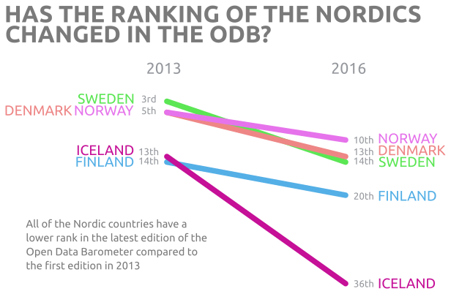
Figure 1: Rank change between 1st and 4th edition of the Open Data Barometer

The rank change between the first and fourth edition of the Open Data Barometer indicates a fall from grace for all of the Nordic countries, as evident in figure 1.
Ranks of all countries, especially Iceland, have decreased. All Nordic countries except Iceland keep their place in the top 10 but Norway, Denmark, and Sweden who were in the top 5 are no longer in the top 5. That raises the question about which countries have taken their place in the top 5. The fact is that the majority of changes between the 1st and 4th editions are caused by shifts in ranks within the top 20. That is, countries that were in the top 20 in the 1st editions are still in the top 20 in the 4th edition, just in different ranks within that top 20 list.
Out of the countries in the top 20 list of the 1st edition, only 4 countries fell off the top 20 list in the 4th edition: Iceland being one of them, but also Israel and Russia, and Estonia a country that fell by 30 places from 14th to 44th place. These four countries were replaced by 4 other countries: Brazil, Mexico, Switzerland, and Uruguay which were all in the top 35 in the 1st edition as shown in figure 2.
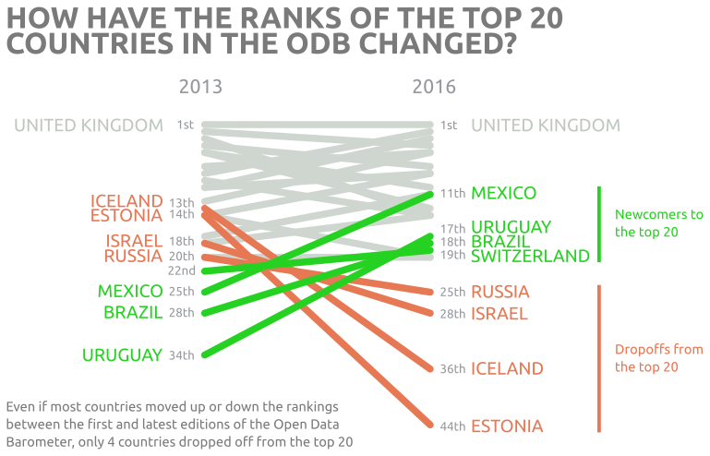
Figure 2: Shifts within the top 20 between the 1st and 4th edition of the Open Data Barometer

If we look at the ranking in whole for all the years it becomes clear that, even if the Nordic countries may have decreased a little bit between each edition, they are still at the top as shown in figure 3. Norway, Sweden and Denmark all remain in the top 10%, Finland is still in the top 20% and Iceland is in the top 30%. Every edition of the Open Data Barometer added more countries but the Nordic countries roughly kept their places between the editions.
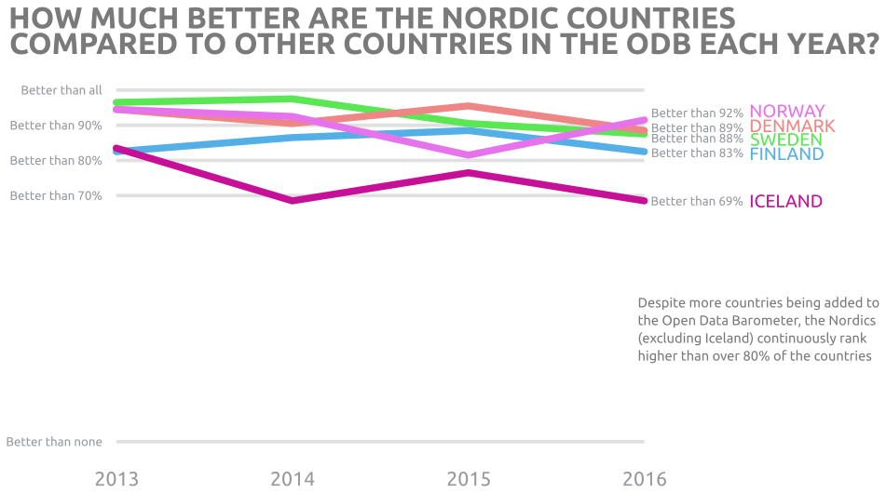
Figure 3: Position of the Nordic countries compared to all countries in the Open Data Barometer

The same story is evident in figure 4, which shows the position of the Nordic countries relative to all countries in the global open data index. The countries are in the top 10% except Iceland and Sweden which are in close to being in the top 20%.
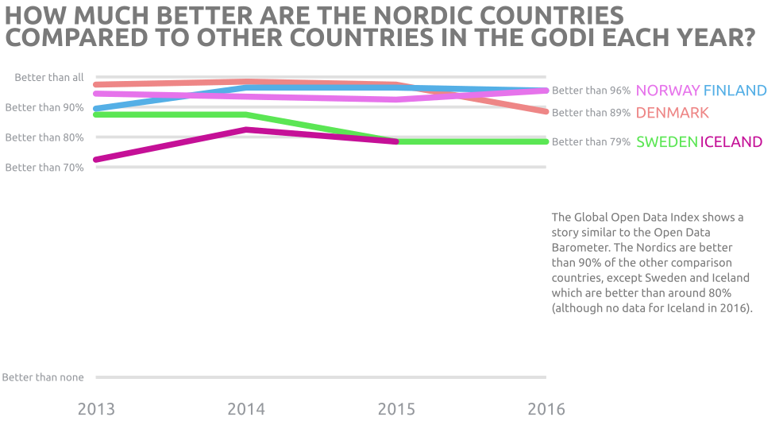
Figure 4: The position of the Nordics compared to all countries in the Global Open Data Index

The claim that the Nordic countries are no longer leaders in the open data space does not hold. However, the claim of the 4th edition of the Open Data Barometer is not completely wrong. It claims that the Nordic countries “[…] do not seem to be prioritising open data as highly as before”. Although the decreased ranking doesn’t really indicate the lack of prioritisation, the underlying data still does.
The Open Data Barometer computes a scaled score, recording the ratio of the country’s score compared to the highest total score. If the scaled score is 90, it means the country’s score is 90% of the highest score.
This scaled score reveals that out of all the Nordic countries, only Norway etched towards the highest score between the 3rd and 4th editions of the Open Data Barometer, while the rest of the Nordic countries increased the difference or kept the same distance (figure 5). The average stayed the same so the increased difference seems to indicate stagnation in open data efforts for most of the Nordic countries.
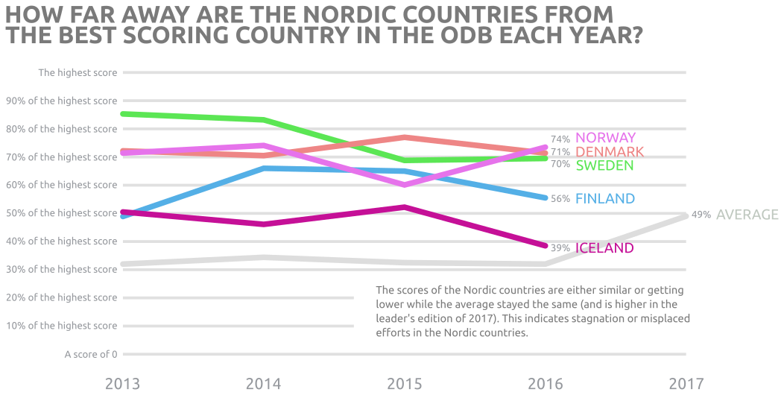
Figure 5: Change in scores of the Nordic countries and the average score compared to the highest score in the Open Data Barometer

Figure 5 also shows the bump in the average for the leader’s edition which targets only G20 countries and those who have publicly adopted the open data charter. Those two efforts seem to have a positive effect on the scores although it is only limited to about 25% of the countries analysed in the 4th edition. None of the Nordic countries have adopted the open data charter so there is an opportunity for improvement in such an adoption that may reverse the concerning trend.
Another indication of a potential fall from grace in the near future can be found in the study conducted by Capgemini for the European Data Portal – The Open Data Maturity Landscaping project. In the first four reports the Nordic countries were trendsetters or fast-trackers at some point (excluding Iceland which only reached a follower status when it was finally included in the 2017 edition). The most recent edition of the Open Data Maturity Landscaping reports lists all of the Nordic countries as followers except Finland which is in the lower half of the fast-trackers after having been a trendsetter all the previous years, and Iceland which is considered a beginner in the 2018 report.
This corresponds with the comparison between the Nordic countries and the rest of the European Union and EFTA members throughout the years. Figure 6 shows how all of the Nordic countries dropped between years 2017 and 2018 except Iceland which stayed the same in the second to last position (only Liechtenstein has a lower score). Compared to the rest of Europe, the Nordic countries are now in the lower half.
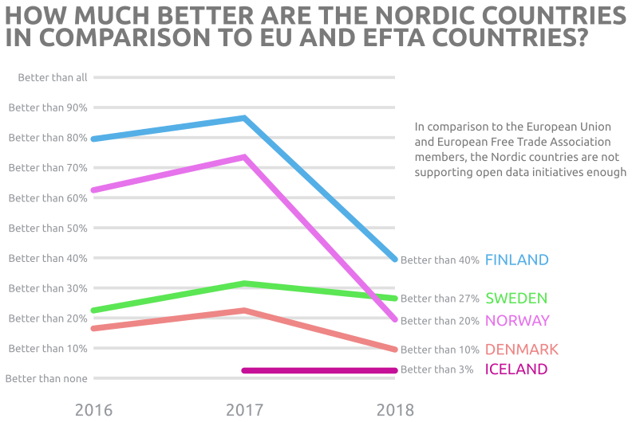
Figure 6: Position of the Nordic countries compared to the rest of the EU and EFTA members in the Open Data Maturity Landscaping project

The Open Data Maturity Landscaping project puts emphasis on different aspects than the other indices. It focuses more on the supporting environment for open data initiatives, rather than the actual implementation. It answers questions relating to how likely open data initiatives are to be successful and in the 2018 version what the impact of the initiatives have been.
The Open Data Maturity Landscaping project reveals that the supporting environments are missing or not mature enough and that impact of open data initiatives have been largely unsuccessful. The lack of impact of initiatives is for example the biggest contributor for the worse outcome for Finland in the 2018 report (European Union, 2019).
The Open Data Barometer also makes an attempt to measure readiness and impact which raises a question why the impact and supporting environment score so low in the Open Data Maturity Landscaping project while it does not seem to have the same effect on the score in the Open Data Barometer. The reason comes down to the different approaches of the two indices.
The Open Data Barometer measures impact via an expert survey where trained experts are asked to provide evidence of the impact. This allows The Open Data Barometer to ask questions like: “Are entrepreneurs successfully using open data to build new businesses in the country?” and assess a score on the scale of 0-10 based on the responses.
The Open Data Maturity Landscaping on the other hand targets national representatives. They are expected to consult experts while answering questions that put more emphasis on a rigorous process by the federal government to actively monitor and support the outcomes of the open data initiatives, asking questions like: “Activities to monitor the economic impact of Open Data since [date of previous update]”.
These different results based on the approaches combined with good outcome of indices that measure the openness of particular datasets indicate misplaced efforts on the federal government part. The Nordic governments seem not be aware of or not actively support and monitor open data initiatives. Success is mostly left to individual government agencies which open data on their own without any real support from the federal governments and without real weight behind open data initiatives.

4.1. Status of Nordic statistics
The Open Data Inventory project by Open Data Watch limits itself to open statistics and therefore gives a good indication of how open the national statistics offices in the Nordics are compared to other offices. The Nordic countries have been tracked since the 2016 report and have since then been the leaders of open statistics. All of the Nordic countries, except Iceland, are in the top 10, with Sweden ranked in the first place in 2016 and replaced by Denmark as number one in 2017.
This is clear when looking at figure 7 where the colourful ribbon at the top shows how the Nordic countries almost take turns at being the best. Iceland however seems to lag behind but is in the top third. The change in Iceland’s position also reveals that other national statistical offices seem to be getting more open.
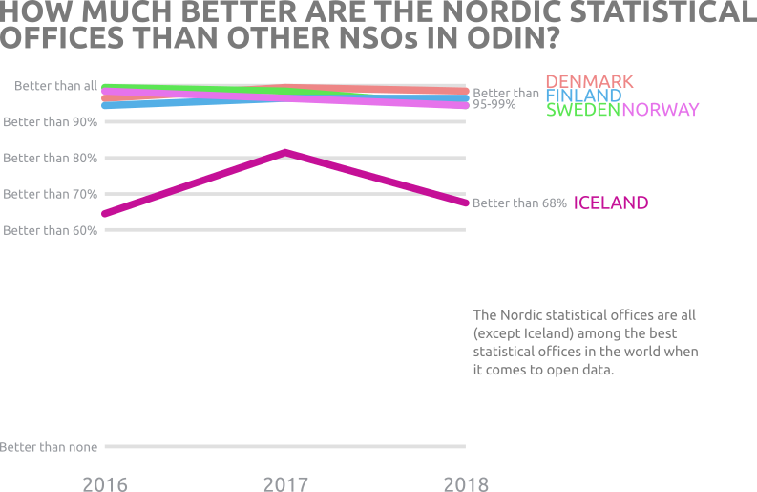
Figure 7: The Nordic countries compared to other countries in the Open Data Inventory

Iceland’s score in 2017 was 57 out of the total score, as shown in figure 8. The year after, in 2018, the score was 54 out of the total score. This small decrease still caused Iceland to fall from 34th place down to the 58th between years. This is also evident from the average score which was slightly higher in 2018 than it was in 2017 as can be seen in figure 8.
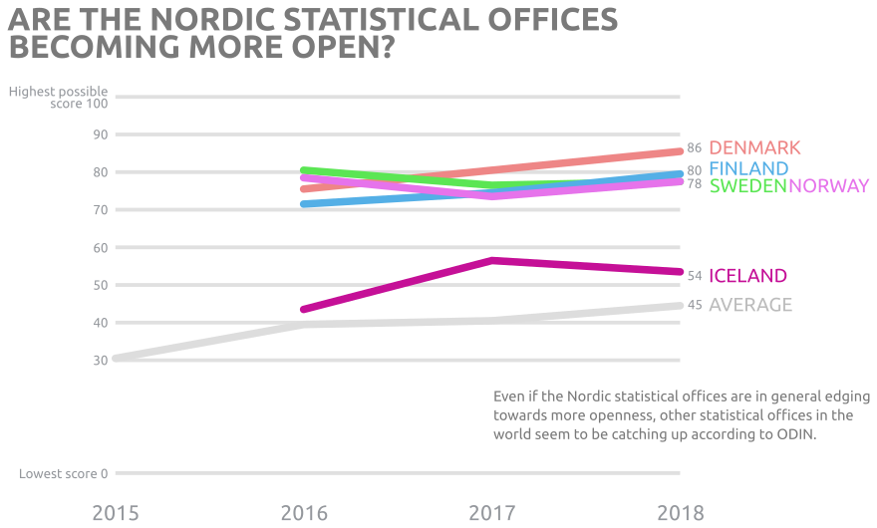
Figure 8: Change in overall score for the Nordic countries and the average of all countries

The good outcome of the Nordic countries is backed up by the official statistics datasets as measured in the Open Data Barometer and the Global Open Data Index. Combined, the Open Data Barometer, the Global Open Data Index, and the Open Data Inventory look at 11 aspects of the datasets through yes/no questions.
In rare cases do the datasets of the Nordic countries score a 0 (where the answer to all questions is no). All the Nordic countries score a 0 for all statistics datasets in a question about linked data and some countries in a question of data availability in bulk. Those seem to be the biggest opportunities for improvements across the Nordic countries.
Another low scorer is the availability of some of the measured datasets, most notably air and water quality datasets. The difficulty of analysing those scores is that it may come down to a matter of definition. For example, Iceland scores 0 in all questions about election results in the Global Open Data Index even if election results are made available by Statistics Iceland. The reason is that the definition of the dataset requires data at a polling station level. Due to tradition and size of the Iceland, the elections are conducted in such a way that polling station votes are combined at regional tallying stations. Therefore Iceland will not be able to collect the data without making fundamental changes to the country’s election system setup.
Another aspect and perhaps the biggest reason for the continually low scores of Iceland in all of the indices can also be chalked up to a matter of definition. In all of the indices Iceland always gets a score of 0 about the openly licensed datasets even if all government published data in Iceland is by default open.
The requirement in all of the indices is that an open license is attached to the dataset. The problem in Iceland is that there are laws for re-use of all public information (Icelandic Laws no. 45/2018, 2018). Article 4 in those laws, called “Generic terms for reuse of public information”, is compatible with Creative Commons Attribution Share-Alike. By calling the article “Generic terms” public bodies in Iceland are not allowed to put any other terms on the information. So in effect it is forbidden by law to remove openness from public information. However this also forbids public bodies to attach any license, even an open license to the datasets without risking breaking the laws. In essence it is easier and less risky in Iceland to be open through normal government operations than try to be open by using a license.
Unfortunately, the indices treat the lack of license as bad. This means that all of the indices do not look at the end result, freely usable data for any purpose – they only look at one means to the end, the licenses. To combat this, the Icelandic open data portal created guidelines that tell users that the dataset is by law open (Þjóðskrá Íslands, 2019) but it is unclear whether those guidelines are considered sufficient in the indices.

Open data initiatives in the Nordic
The Nordic governments continue to work towards more openness albeit without a clear direction and monitoring of progress as evident in the Open Data Maturity Landscaping project (European Union, 2018). However some progress is being made.

Denmark
Denmark participates in global initiatives that relate to open data such as the Open Government Partnership (Open Government Partnership, 2019) along with most of the Nordic countries, where Denmark is developing an action plan. Denmark claims in the 4th edition of the Open Data Barometer to support the Open Data Charter (World Wide Web Foundation, 2018) although Denmark has not adopted it publicly (Open Data Charter, 2019).
The national data portal is a result of collaboration between cities and regions and as such the datasets mostly come from municipalities. A few datasets come from public agencies and Statistics Denmark exists on the platform as an organisation but hasn’t published any datasets (Open Data DK, 2019). A new effort called datafordeler.dk, the data distributor, is an effort to increase availability of public data via a uniform data access platform (Styrelsen for Dataforsyning og Effektivisering, 2019).

Finland
Just like the majority of the Nordic countries, Finland is also a member of the Open Government Partnership (Open Government Partnership, 2019) and is marked as currently developing an action plan. According to the 4th edition of the Open Data Barometer Finland seems to fund a variety of open data initiatives and have appointed a steering committee and a secretariat for the open government action plan.
Three ministries are in charge of open data projects. The Finnish open data portal is very active with 1700 datasets from more than 800 organisations, including 9 datasets from Statistics Finland (Väestörekisterikeskus, 2019). Numerous organisations in the country manage events such as hackathons and challenges to engage the public.

Iceland
The Nordic problem child of open data, Iceland, is not as committed as other Nordic countries. Iceland is not an Open Government Participant, it hasn’t adopted the Open Data Charter (Open Data Charter, 2019) and the national open data portal has just over 100 datasets with around 60 of them from Reykjavik city but none from Statistics Iceland (Þjóðskrá Íslands, 2019).
Efforts of the Icelandic government seem to be sporadic and not properly resourced (World Wide Web Foundation, 2018). A few working groups have been established and courses given to public bodies, without any proper funding to follow up on the initiatives. It is quite clear that the open data initiatives in Iceland are driven largely by an interest of a few dedicated civil servants rather than commitment from the federal government.
However, the first steps in a new action plan by the government were taken by creating specific laws on reuse of public information that were a part of the country’s information laws before. Those laws were extended to include articles that for example, require public bodies to list datasets on the national data portal which makes any steps toward DCAT (Data Catalogue Vocabulary) support easier. (Icelandic Laws no. 45/2018, 2018). Other planned efforts have not materialised so all open data initiatives in Iceland still seem sporadic and unfocused.

Norway
The Norwegian government seems to have put a lot of effort into open data. Norway is a member of the Open Government Partnership and is developing an action plan (Open Government Partnership, 2019). The Agency for public management and e-Government in Norway is not only a member of the open data working group of the Open Government partnership but also a member of the European Commission Public Sector Information expert group and the OECD expert group for open data. The national data platform of Norway is well resourced with 2-3 persons per year (World Wide Web Foundation, 2018).
The Norwegian open data platform has a staff of 2-3 persons per year and over 1100 datasets by more than 80 organisations, including 10 datasets from Statistics Norway (Difi, 2019). The open data catalogue has DCAT support and according to responses in the 4th edition of the Open Data Barometer is able to harvest data using DCAT. In addition the open data platform records user applications that are built on open data in Norway and operates a data hotel for businesses who wish to open up their data.

Sweden
Up until the middle of 2016 the open data initiative in Sweden was run by Vinnova, the Swedish agency that administers state funding for research and development. In 2016 the budget was about 3.5 million SEK but had been 3 million SEK in the prior years (World Wide Web Foundation, 2018). In the middle of 2106 the open data initiative was moved to the National Archives and the Swedish government stated in its 2017 budget bill that public authorities should strive for open data. Sweden like the other larger Nordic countries is a member of the Open Government Partnership and is currently developing an action plan.
Vinnova fostered a vibrant community through various reuse activities and hackathons. Hack for Sweden has been popular in Sweden where many public bodies provide data. Around those efforts, various groups in Sweden have been formed to tackle different aspects relating to open data and open government. The national data portal has more than 1200 datasets from over 100 organisations; of those are 16 from Statistics Sweden (Myndigheten för Digital förvaltning, 2019). Moreover Vinnova funded work to enable quick publications of metadata according to DCAT-AP on the national portal (Open Government Partnership, 2019), work that made DCAT harvesting in the open data platform CKAN possible.

Conclusions
Claiming that the Nordic countries were once leaders in open data but are no longer prioritising open data is not entirely correct. All Nordic countries, except Iceland, can still be regarded as leaders in the open data space. However, all of the efforts seem to be mostly run by engaged civil servants with lack of support and monitoring from the federal governments. The federal government needs to step in to avoid stagnation. An exciting area for improvement for all Nordic countries is linked data.
Iceland, not only federal government but also civil servants need to look at the other Nordic countries and the results of the indices and work towards more openness but the indices also need to evaluate their methodologies and strict definitions for smaller countries and openness by default, without licenses.
Statistics offices in the Nordic should build bridges from PX-based software to the national portals to make the official statistics available as open datasets, accessible via the portals. A good approach would be to base these bridges on the DCAT standard. A more radical opportunity would be for the statistical offices to start a joint effort to collect and publish statistics to enable monitoring of the status of open data in their respective countries.

References
Difi, (2019). Norwegian National Open Data Portal. Åpne offentlige data i Norge. Available at: https://data.norge.no (Accessed: 28 June 2019)
European Union. (2019). European Data Portal’s Open Data in Europe. Available at: https://www.europeandataportal.eu/en/dashboard (Accessed: 28 June 2019).
Icelandic Laws no. 45/2018. (2018). Lög um endurnot opinberra upplýsinga.
Manyika, J., Chui, M., Groves, P., Farrell, D., Van Kuiken, S. and Doshi, E.A., (2013). Open data: Unlocking innovation and performance with liquid information. McKinsey Global Institute, 21.
Myndigheten för Digital förvaltning. (2019). Swedish National Open Data Portal. Öppna data och PSI. Available at: https://oppnadata.se (Accessed: 28 June 2019).
Open Data Charter. (2019). Open Data Charter website. Available at: https://opendatacharter.net (Accessed: 28 June 2019)
Open Data DK. (2019). Danish National Open Data Portal. Open Data DK. Available at: https://portal.opendata.dk (Accessed: 28 June 2019)
Open Government Partnership. (2019). Open Government Partnership website. Available at: https://www.opengovpartnership.org (Accessed: 28 June 2019)
Open Knowledge Foundation. (2017). The Global Open Data Index. Available at: https://index.okfn.org (Accessed: 28 June 2019)
Open Knowledge Foundation. (n.d.), The Open Definition. Available at: https://opendefinition.org (Accessed: 28 June 2019).
Rowley, J., (2007). The wisdom hierarchy: representations of the DIKW hierarchy. Journal of information science, 33(2), pp.163-180.
Styrelsen for Dataforsyning og Effektivisering. (2019) Datafordeler. Available at: https://datafordeler.dk (Accessed: 28 June 2019).
Väestörekisterikeskus. (2019). Finnish National Open Data Portal. Avoindata.fi. Available at: https://www.avoindata.fi (Accessed: 28 June 2019)
World Wide Web Foundation. (2018). Open Data Barometer. Available at: https://opendatabarometer.org (Accessed: 28 June 2019).
Þjóðskrá Íslands. (2019). Icelandic National Open Data Portal. Opin gögn. Available at: https://opingogn.is (Accessed at: 28 June 2019)

The seven sectors, researched in the McKinsey report, are: Education, transportation, consumer products, electricity, oil and gas, health care, and consumer finance.
https://opendatacharter.net/
http://www.g20.utoronto.ca/2015/G20-Anti-Corruption-Open-Data-Principles.pdf
No data were collected for Iceland for the Global Open Data Index of 2016.
No data available for year 2015 of the Open Data Maturity Landscaping project.
The laws include a short list of exemptions.

