**Making our external economy data more comprehensible**

Caroline Bo, Statistics Denmark, [cbo@dst.dk](mailto:cbo@dst.dk)

Casper Winther, Statistics Denmark, [caw@dst.dk](mailto:caw@dst.dk)

**Abstract**

*The economic globalisation that has taken place the past decades has increased the complexity of international trade, and consequently the statistics reflecting this activity. In addition to an increased complexity in conducting statistics within this field, it has become harder for statistical users to understand what the statistics actually show. Therefore, informative descriptions of statistics, such as international trade statistics and the balance of payments, is necessary. Because of the complexity, it is also essential that producers of statistics also analyse these data instead of leaving it solely up to users to do this.*

*Recently, we at External Economy, Statistics Denmark, have increased our efforts to analyse and explain our data to our users. This is to shed light on our statistics, and more importantly, it is an attempt to make a very complex field more comprehensible. We are using different formats of dissemination – descriptive papers and more analytical work. Emphasis is on disseminating across domains, giving users a more complete picture and thus making it easier to understand economic globalisation. Further, focus is also on using more graphics and not too technical wording. By implementing these measures, we are trying to make it easier for our users to understand what our statistics show and which conclusions one may draw.*

*The efforts are ongoing, and changes to the regular dissemination of International trade in goods statistics, International trade in services statistics, and the Balance of payments are being considered. So far, users have reacted positively to these efforts. However, we can conclude that we still struggle to describe our statistics in a way that is easy to understand. Despite these struggles, users have responded that our descriptive papers and analytical work is highly appreciated and much needed. In addition, it has made it easier for e.g. journalists to pick up conclusions that one can draw from our data that they most likely would not have otherwise detected due to the complexity of the topic.*

**Keywords:** Dissemination, Analyses, Globalisation

# Introduction

With the economic globalisation and technological development, that has taken place the past decades, global trade has become more complex. Consequently, it has become more difficult to produce statistics reflecting global trade, and complicated what to conclude from these statistics. One of the key challenges is that an increasing part of Danish exports is not crossing the border and is not included in the traditional cross-border statistics on trade. Due to this, statistical users find it more challenging today to understand what the statistics on global trade actually show. Therefore, informative descriptions of statistics, such as international trade statistics and the balance of payments, is necessary. Moreover, users also express interest in getting more detailed information on economic globalisation. Thus, new statistical products on globalisation are needed – if possible. Due to the complexity, it is essential that experts on statistics also analyse these data instead of leaving it solely up to users to do this.

At External Economy at Statistics Denmark, we have increased our efforts on analysing and explaining our data to our users. It entails different formats of dissemination – descriptive papers and more analytical work. Extra focus is put on using more graphics and not too technical wording. Also, additional information on globalisation has been provided. A key part is the integration of the various statistical domains in the dissemination. A traditional stovepipe approach to dissemination makes it difficult to get a complete overview of economic globalisation. By implementing these measures, we are trying to make it easier for our users to understand what our statistics show and which conclusions one may draw. Hopefully, this will provide a better understanding of the Danish trade patterns in a globalised world, and the impact of globalisation on the Danish economy.

# Why is it necessary to make changes?

Capturing the activities of global production is a challenging aspect of macroeconomic statistics. It has complicated the work for all parties involved – the companies reporting the activities, the NSIs producing the statistics, and the users studying the statistics.

## New guidelines and reported data on global activities

In 2014, the Danish balance of payments adapted the new international guidelines, stipulated in the latest Balance of Payments manual, BPM6. The new manual reflects changes that have occurred in the global economy since the last manual was published in 1993. One of the major reasons to revise the old manual was globalisation. Global production has evolved and now encompasses a broad range of business arrangements, which implies an increased use of cross-border production processes and complex international company structures. The new manual aims at giving a better description of globalisation – especially global production. Moreover, with the introduction of BPM6 the balance of payments now follows the principle of change in ownership.

With the implementation of the new guidelines, the trade in services questionnaire was expanded with more questions regarding global production activities. This opened up the possibility for a more direct comparison of information reported to other statistics. As a result, Statistics Denmark carried out a systematic mapping of the activities abroad by some of the largest Danish companies. The comparison showed that the reported information had not been adequate. Especially, trade activities associated with global production arrangements were lacking. It led to a significant data revision in 2016 of both the balance of payments and the national accounts. The exercise stressed that companies struggle to understand how to report global production activities. Consequently, focus on the reporting to Statistics Denmark by the largest companies has been increased which, among other things, has resulted in the establishment of a Large Cases Unit (LCU).

## How reported data on global activities is recorded in the statistics

Understanding how global production activities are reflected in the statistics is also tricky. As mentioned, today, most of the largest Danish companies organise their activities globally and trade activities span many countries. Usually the organisation also entails that some of the trade activities abroad are managed from Denmark. These global business models complicate the understanding of statistics on international trade. When Danish trade activities take place outside Danish territory, but are operated from Denmark, things start to become complicated. This is due to the fact that these activities are statistically regarded as Danish trade activities. It is hard for our users to comprehend, which is understandable. Global production patterns affect the statistics in a way that ‘old school economics’ did not teach us. Instinctively, one thinks of a country’s international trade as being the goods (and services) crossing the borders of the country. Most of our users think of Danish goods exports as being the goods leaving Danish territory when sold to a customer abroad. However, global production patterns muddle this understanding. Today, part of Danish goods exports is taking place outside Danish borders, and the goods, which are sold, have never been in Denmark. This kind of exports should by definition be included in the export figures in the Danish balance of payments, and thus have an impact on the Danish national accounts. It is, however, not part of the international trade in goods statistics, since the latter statistics only includes goods crossing the Danish border.

Thus, Danish exports outside Denmark’s borders occur when Danish companies sell products abroad, which they own, and which has not passed Danish borders. Precisely how these exports are recorded in Denmark’s balance of payments is dependent on whether the product is sold abroad after processing, or if it is simply purchased as a commodity and subsequently sold without further processing. This latter process is known as merchanting.

The definition and recording of processing activities abroad are as follows

* Processing activities abroad take place when a Danish enterprise (domestic resident) buys production services from a foreign enterprise (non-resident) outside Denmark (non-resident territory), and the Danish enterprise owns the goods during the processing. The Danish enterprise may buy raw materials both in Denmark and abroad for the processing abroad. After the processing, the Danish company sells the finished goods to a foreign enterprise abroad.
* The payment for processing abroad is recorded in the International trade in services statistics as an import of a processing service. It covers both payroll and any supplementary purchasing of raw materials undertaken by the foreign enterprise in relation to the further processing of the Danish goods. The goods purchased by the Danish company and sent to abroad are recorded in the International trade in goods statistics as exports. However, as Danish ownership remains constant and no change to a non-resident occurs, this movement of goods will not be classified as an export in the balance of payments. On the contrary, raw materials purchased abroad are not recorded in the International trade in goods statistics as exports, but are included in the balance of payments as imported goods, due to the change from foreign to Danish ownership. After processing, the products are sold to a foreign customer, and have never crossed Danish borders. The sale of goods abroad after being processed abroad is recorded as an export in the balance of payments.

The definition and recording of merchanting activities abroad are as follows

* Trade of merchanting goods takes place when a Danish enterprise (domestic resident) buys goods from a foreign enterprise (non-resident), and resells them directly to a foreign enterprise (non-resident) abroad (non-resident territory). Thus, the goods are never entering Denmark, and they are not altered between the purchase and the sale.
* In the balance of payments, merchanting is treated as a net export (selling price minus acquisition price)

Companies can easily shift between the two business models, and the physical trade patterns will appear unaltered. However, how Danish companies choose to organise their production and sales in the global economy are crucial for how the activities are recorded in the statistics. When a company chooses to use one form of organisation instead of another, it will have an effect on how the transactions are recorded in the balance of payments and whether it is included in the calculation of Danish production or only in Danish income.

To be able to make sound conclusions of the Danish trade activities and the impact of globalisation on the Danish economy it is thus necessary to understand how global activities are registered in the international trade statistics, the balance of payments, and in the end in the national accounts. Against this backdrop, we realised that due to the complexity of it all, we needed to enhance our efforts on making our external economy data more comprehensible to our users.

# Increased focus on explaining our data

We started our work in 2016. At the same time similar efforts were put into place for the entire Statistics Denmark. We have had – and still have – ongoing discussions on what is needed. In addition to new forms of dissemination, we have also concluded that we need to provide more detailed information on global trade activities. This is to shed light on our statistics; and more importantly, it is an attempt to make a very complex field more comprehensible.

The International trade in goods statistics, the International trade in services statistics, as well as the balance of payments are all produced at External Economy. The fact that they are all produced in the same office provides opportunities when developing new practices of disseminating the field of international trade and economic globalisation, and especially when explaining the interrelations between the statistics.

## Our users

When considering new initiatives on explaining our data we needed to keep in mind that we have a mixed group of users asking for different things. Overall, we can characterise our users as belonging to one of two main groups – common users and experts.

* The first group includes, among others, students and journalists. Hence, people with limited knowledge of our statistics. It is important to stress that journalists play an important role since they are the ones who spread our numbers to the general public, and thus it is important that they understand the basics of our statistics. We have come to realise that this group has difficulties in understanding our statistics on a more general scale. They are looking for a more overall explanation of our statistics in a not too technical wording.
* The latter group comprises experts who already have an in-depth knowledge of our statistics and are completely familiar with the economic terms. It is important that this group has a deep understanding of our statistics as they play a key role in providing facts about society and thus affects the political decision-making. We have come to realise that this group also have difficulties in understanding our statistics; especially how global production setups are included in the statistics. In addition to understanding how global activities are reflected in Danish international trade figures, this group is asking for more analytical work focused on economic globalisation and the trade patterns linked to it.

Against this backdrop, when planning new initiatives, we have kept in mind that we have users with very different demands.

## Measures

We have taken several measures to make the topics of international trade and economic globalisation more comprehensible. It includes providing different formats of dissemination – descriptive papers and more analytical work. Emphasis is on using more graphics and not too technical wording. Also, we have provided more detailed data on economic globalisation. We have increased our collaboration with colleagues from the national accounts and the central bank to add additional aspects to our numbers, and we plan to do this more in the future. Our measures so far are described below.

### Analyses

Our analytical papers are typically written in a language that demands general knowledge of economics. However, we try to incorporate graphics as much as possible to ease the understanding. Our analyses are written in Danish. We have chosen, however, also to translate them into English. In that way we are able to reach a greater audience, and share them with colleagues internationally. Also, it can get more attention as it is published twice. So far we have published the following analyses:

* [*Large increase in sales of goods abroad by Danish manufacturing industries*](https://www.dst.dk/en/Statistik/Analyser/visanalyse?cid=28057)(published twice in 2016)

It describes how enterprises organise production internationally, with special focus on Danish manufacturing industries’ production and sales abroad. One of the graphs from the analysis is shown below.

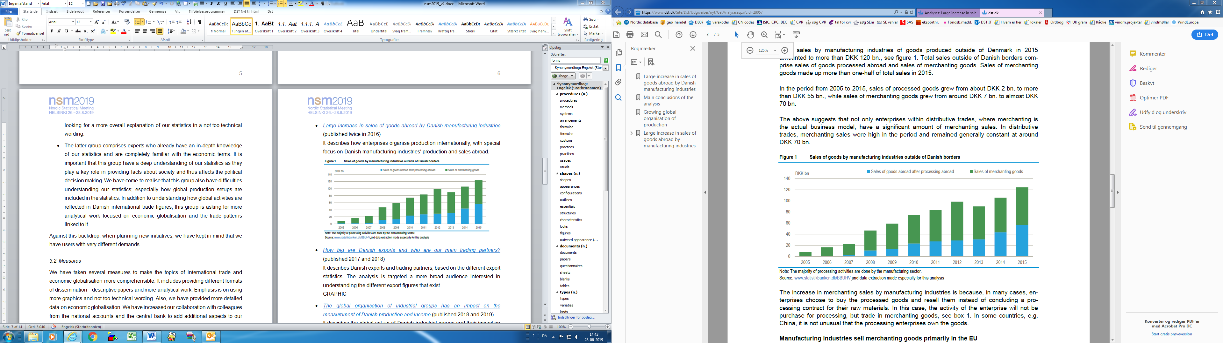

* [*How big are Danish exports and who are our main trading partners?*](https://www.dst.dk/en/Statistik/Analyser/visanalyse?cid=30239)(published 2017 and 2018)

It describes Danish exports and trading partners, based on the different export statistics. The analysis is targeted a broader audience interested in understanding the different export figures that exist. Some graphics from the analysis are shown below.

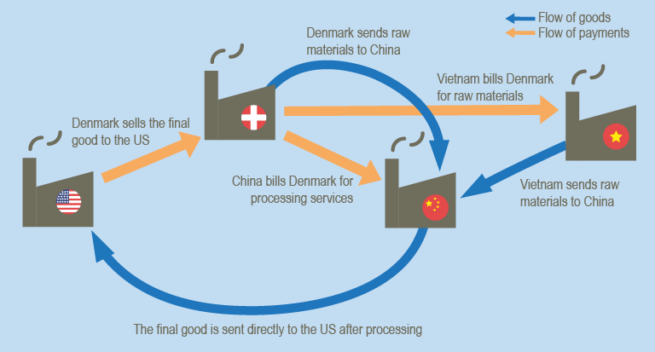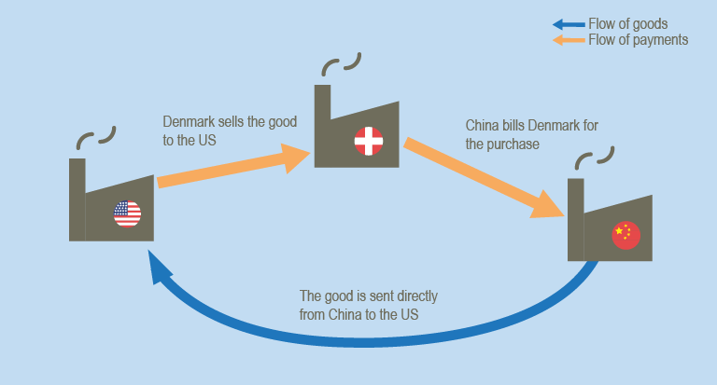

Largest export markets for goods: international trade in goods and balance of payments. 2016



* [*The global organisation of industrial groups has an impact on the measurement of Danish production and income*](https://www.dst.dk/en/Statistik/Analyser/visanalyse?cid=32695)(published 2018 and 2019)

It describes the global set-up of Danish industrial groups and their impact on the Danish economy. Focus is on the close correlation between Danish exports and income from subsidiaries abroad. The analysis is an extension of the analysis from 2016. Some graphics from the analysis are shown below.

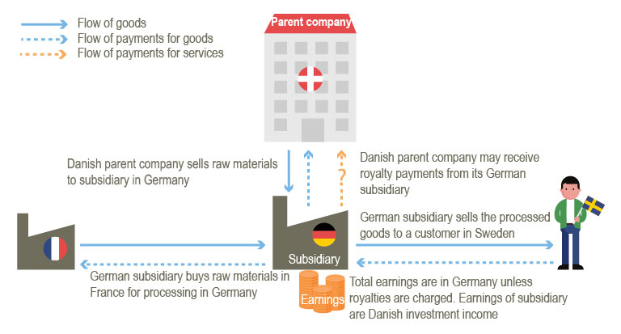

Danish industrial groups’ earnings from production abroad. 2016



### Behind the numbers – Bag Tallene (only in Danish)

*Behind the numbers* are articles written in a more simple way and with a minimum of numbers in them. They are produced in collaboration with the communication team at Statistics Denmark. These articles are produced on a regular basis. Screenshots of two of the most recent ones are shown below.

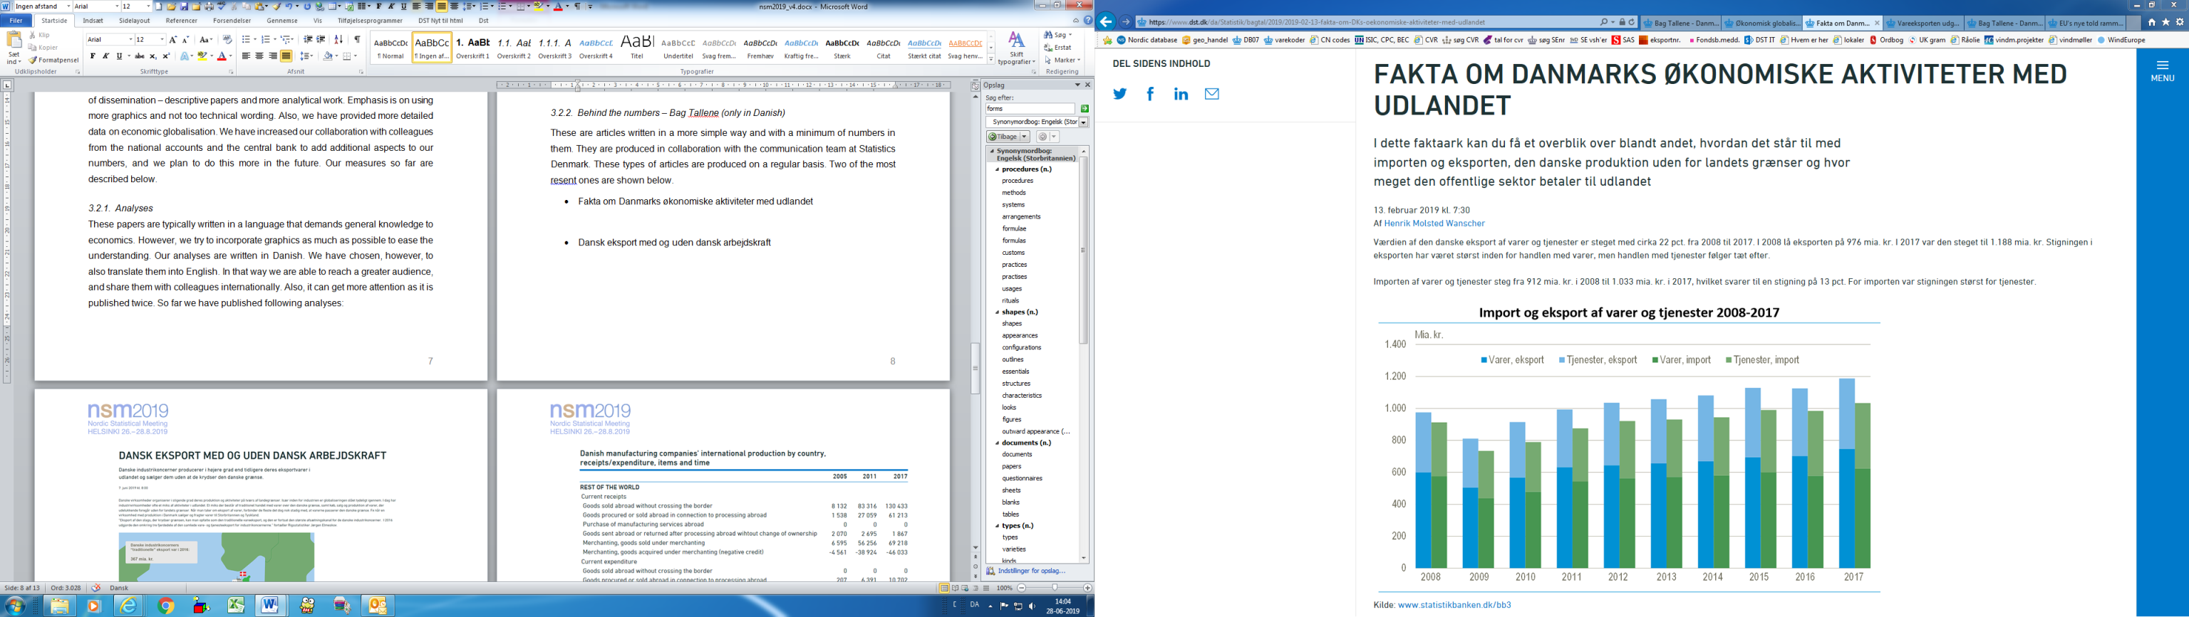

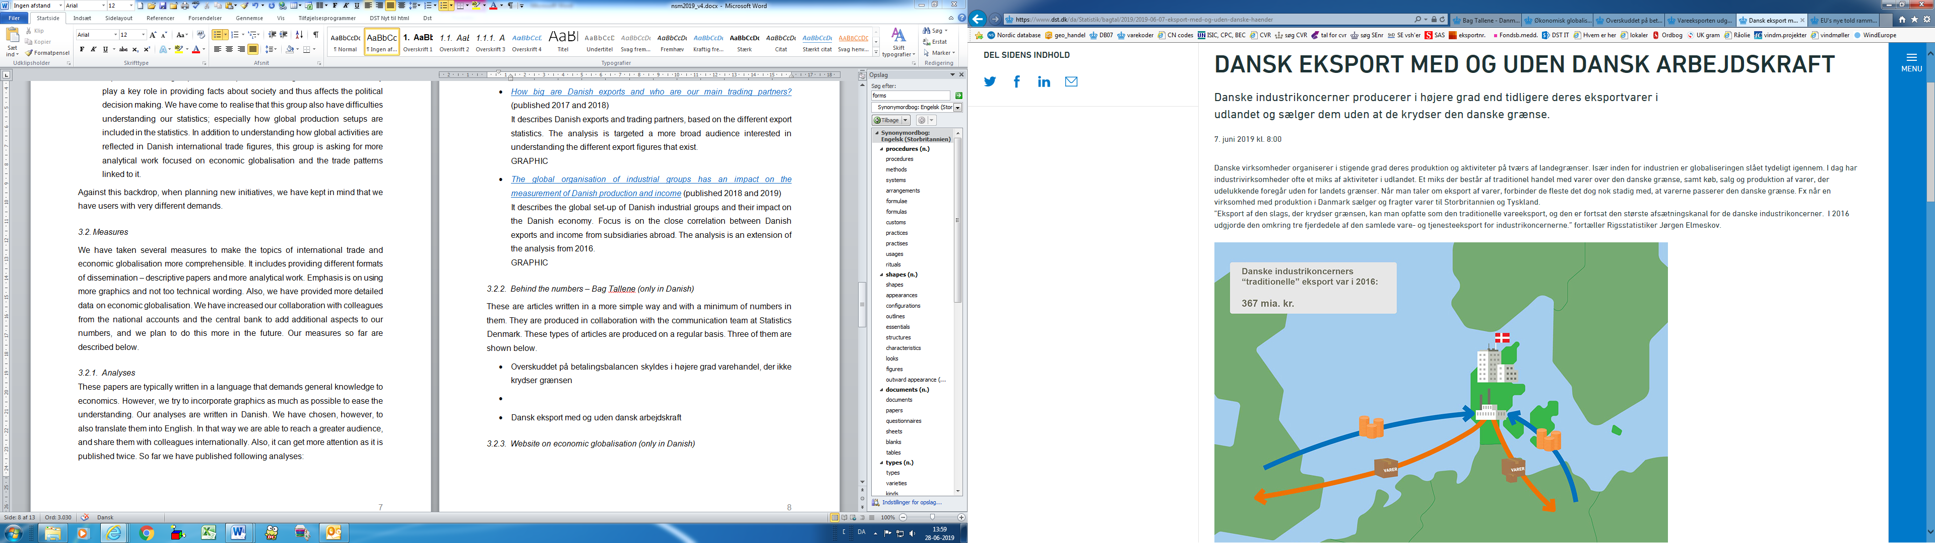

### Website on economic globalisation (only in Danish)

* The [website](https://www.dst.dk/da/Statistik/emner/erhvervslivet-paa-tvaers/globalisering/oekonomisk-globalisering) on economic globalisation was launched in 2017. It gives an overview and explanation of all statistics, publications and newsletters that Statistics Denmark produces on economic globalisation. Moreover, it links to international websites related to the topic. A screenshot of the first section of the website is shown below.

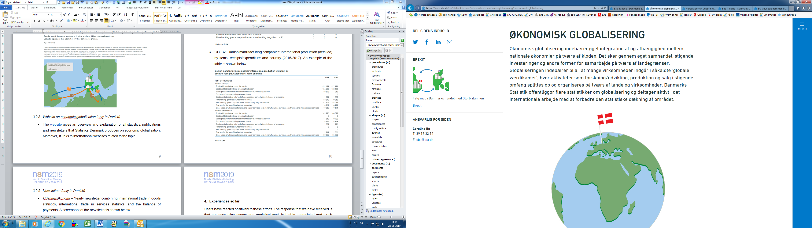

### Tables on globalisation

The tables on Danish manufacturing companies' international production were launched in 2018.

* The table GLOB1 has data on Danish manufacturing companies' international production broken down by items, receipts/expenditure and country (2005-2017). An example of the table is shown below.

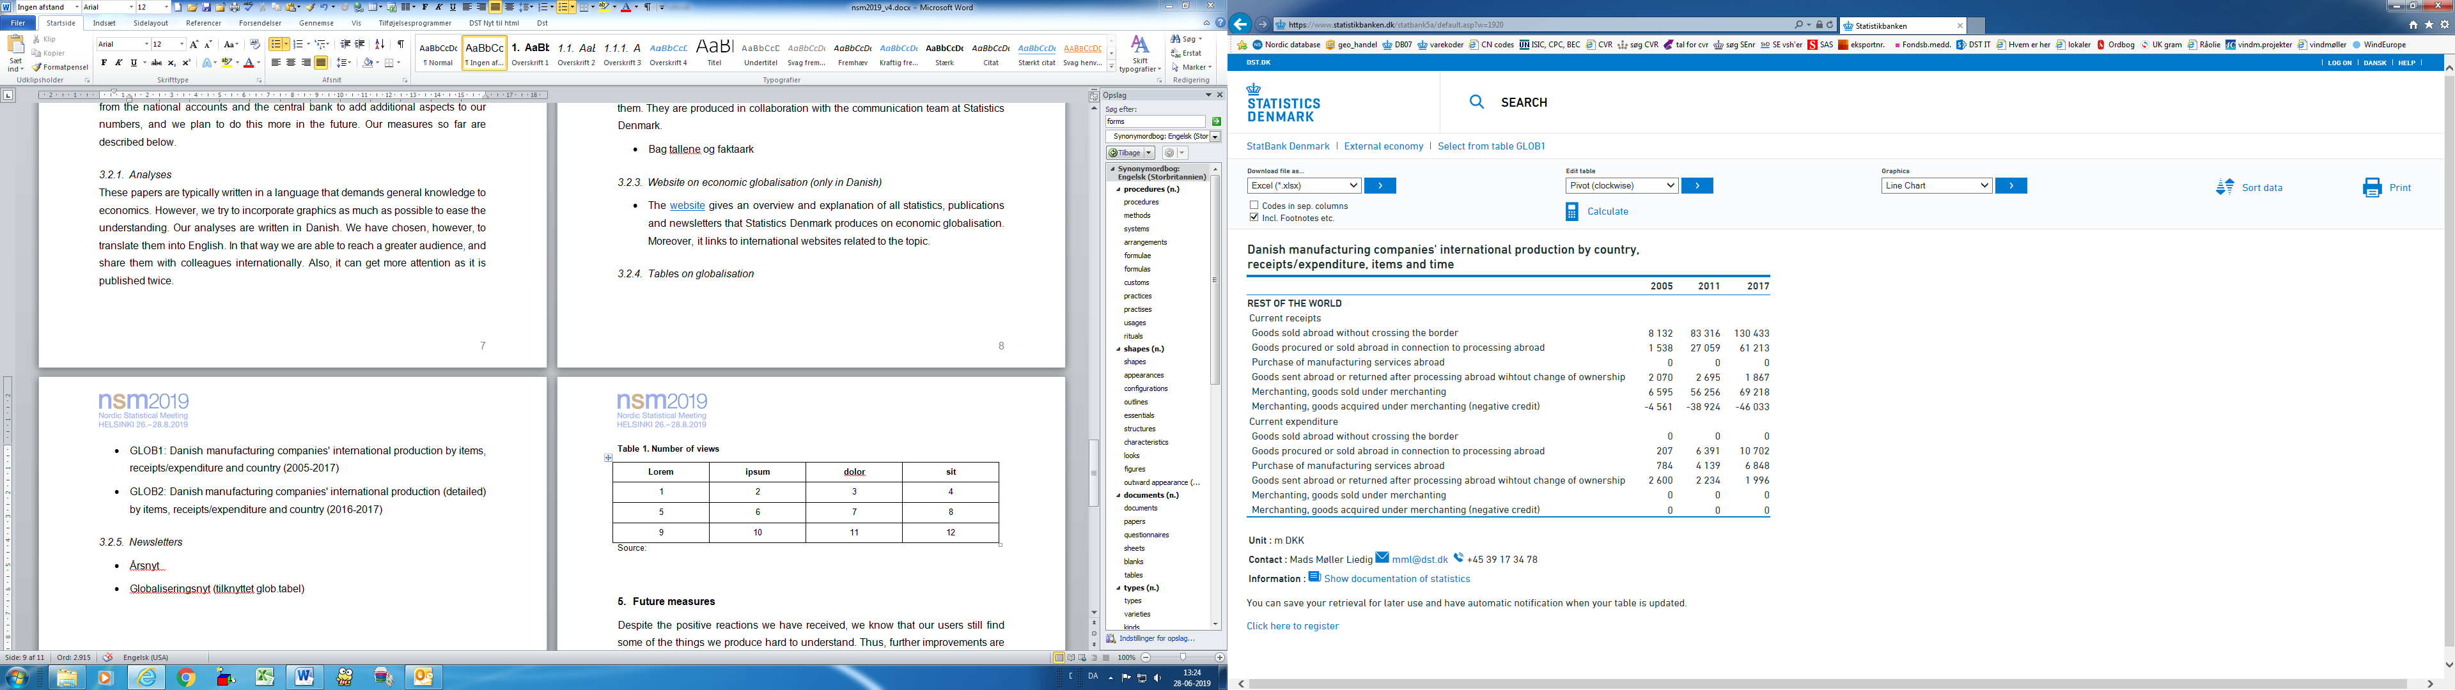

* The table GLOB2 has detailed data on Danish manufacturing companies' international production broken down by items, receipts/expenditure and country (2016-2017). An example of the table is shown below.

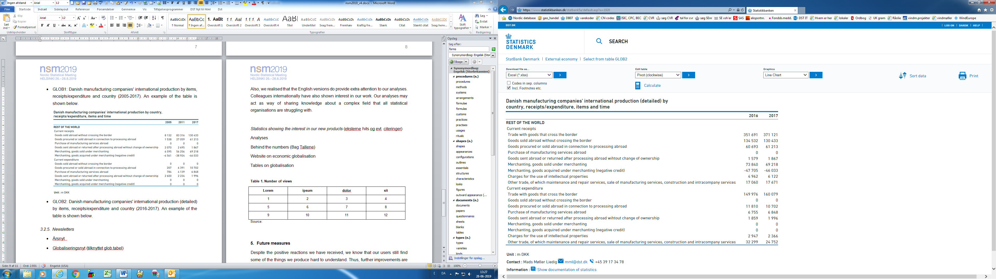

### Newsletters (only in Danish)

* *Udenrigsøkonomi* – The newsletter was launched in 2014. It is published yearly and combines international trade in goods statistics, international trade in services statistics, and the balance of payments. A screenshot of the first section of the newsletter is shown below.

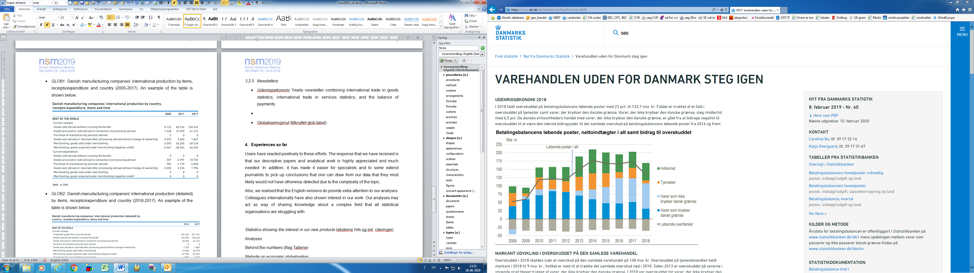

* *Fremstillingsvirksomhedernes internationale produktion* – The newsletter was launched in 2018. It is published yearly and describes Danish manufacturing companies' international production. Numbers are taken from the tables GLOB1 and GLOB2. A screenshot of the first section of the newsletter is shown below.

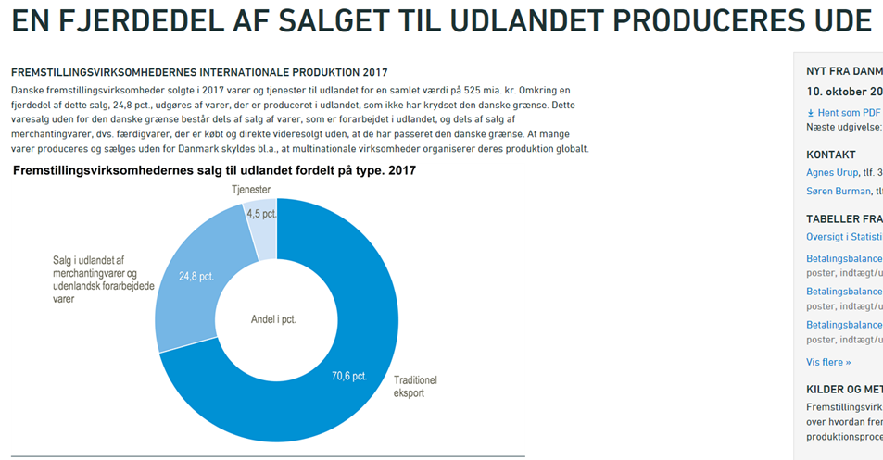

# Experiences so far

Users have reacted positively to our efforts. The response has been that our new products are highly appreciated and much needed. Moreover, users have told us that they hope we will continue our efforts in explaining our data, conduct analyses, and provide more detailed data where possible. Furthermore, our measures have made it easier for experts and to some extent journalists to pick up conclusions that one can draw from our data that they most likely would not have otherwise detected due to the complexity of the topic. Also, we have noticed that the English versions do provide extra attention to our analyses.

Table 1 shows how much attention our initiatives have got. It should be noted that a low number of views shall not be regarded as a failure. As mentioned, we have different products aimed at different users. Some products are targeted experts and others are targeted common users. The latter group is of course much bigger than the first one. The table stresses this. Two of our analyses (1 and 3 in the table) and one of our newsletters (8 in the table) are aimed at experts and have received less attention in number of views. However, these publications have not gone by unnoticed. Several experts have shown great interest in them. These publications have led to people contacting us from ministries, trade unions, industrial organisations, and universities with questions regarding the underlying data and the topic in general.

It is thus most interesting to look at table 1 to see if our initiatives, aimed at our broad audience of common users, get as much attention as we are hoping for. We have e.g. made a paper with a general introduction to the exports definition (2 in the table). The table shows that this analysis has indeed received a lot of attention. In fact, it is the most read analysis of the ones published by Statistics Denmark in 2017. Some users have contacted us due to this paper, mentioning that they appreciate our efforts in explaining the exports definitions as they are far from clear cut to understand. Another product aimed at the greater masses is our newsletter combining the International trade in goods statistics, the International trade in services statistics, and the balance of payments (9 in the table). As seen in the table the newsletter has a large audience. It is also among the most read newsletters produced by Statistics Denmark. Moreover, table 1 shows that the website on economic globalisation has been viewed a lot since it was launched in 2017. In the spring of 2019 the website had approximately a thousand views per month.

**Table 1. Number of views as of June 2019 for some of our new products**

|  |  |  |  |  |
| --- | --- | --- | --- | --- |
|  | **Product** | **Published** | **Number of views since launch (external users)** | **Target group** |
|  | **Analyses** |  |  |  |
| 1 | Large increase in sales of goods abroad by Danish manufacturing industries | DK Oct 2016  (UK Nov 2016) | DK 671  (UK 460) | Experts |
| 2 | How big are Danish exports and who are our main trading partners? | DK Dec 2017  (UK Feb 2018) | DK 5,443  (UK 919) | Common users |
| 3 | The global organisation of industrial groups has an impact on the measurement of Danish production and income | DK Oct 2018  (UK May 2019) | DK 472 (UK 29) | Experts |
|  | **Bag Tallene\*** |  |  |  |
| 4 | Fakta om Danmarks økonomiske aktiviteter med udlandet | Feb 2019 | 955 | Common users |
|  | **Website** |  |  |  |
| 5 | Website on economic globalisation | April 2017 | 17,554 | Common users / experts |
|  | **Tables** |  |  |  |
| 6 | Glob1 | Oct 2018 | 141 | Experts |
| 7 | Glob2 | Oct 2018 | 72 | Experts |
|  | **Newsletters** |  |  |  |
| 8 | Fremstillingsvirksomhedernes internationale produktion | Oct 2018 | 879 | Experts |
| 9 | Udenrigsøkonomi | Feb 2019 | 3,114 | Common users |

* Since we produce Bag Tallene on a regular basis only one is included in the table.

Colleagues internationally have also shown interest in our work. Our analyses may act as a way of sharing knowledge about a complex field that all statistical organisations are struggling with. In addition, when studying and explaining this topic, we at External Economy probably have an advantage compared to most of our international colleagues. As mentioned before, the statistics on international trade in goods, the statistics on international trade in services as well as the balance of payments are all placed at External Economy. Quite often some of these statistical areas are placed at either customs, national accounts and/or the central bank.

# Future measures

We still have a lot of work ahead of us. Despite the positive reactions we have received, we know that our users still find some of the things we produce hard to understand. Thus, further improvements are needed when it comes to describing our statistics in a way that is easy to grasp.

We have two main areas we need to focus on when regarding future measures. First, we need to keep explaining our statistics and definitions in a not too technical language to make sure our common users know what our statistics show, and where they can find them. We are challenged by rigid definitions. However, we will keep trying to reduce this problem by explaining our statistics in text, graphics and putting our numbers into a context that is easy to understand. Secondly, our expert users are asking for more analytical work and detailed data to understand the impact of globalisation on the Danish economy. Here we need to stress that this is also a challenging task for us. In this work we have to keep asking ourselves: How do we explain the topic best to get the ‘full picture’? What dimensions do we need to add? Do we have data on it? And who do we need to collaborate with to improve the explanation of this area of interest?

On top of that we are looking into more general measures. One of the things we are discussing is to have a more integrated way to describe our statistics instead of disseminating them separately. Also, we are looking into putting new dimensions on our published data. The international trade in goods statistics for instance, includes a lot of relevant information which is not published today. Also, we are already collaborating with colleagues outside External Economy e.g. experts working within national accounts and experts at the central bank. However, we need to do this more. This, to better understand and explain Danish trade patterns in a globalised world, and the impact of globalisation on the Danish economy.

# Conclusion

The past several years we at External Economy at Statistics Denmark have increased our efforts to shed light on our statistics. We have taken several measures to make the topics of international trade and economic globalisation more comprehensible. It includes providing different formats of dissemination. Emphasis has been on using more graphics and not too technical wording. Also, we have provided more detailed data on economic globalisation. The response that we have received from our users has been positive. The feedback has been that our descriptive papers and analytical work is highly appreciated and much needed. However, we still have some work to do to make sure our external economy data is comprehensible to our users. To succeed with this task we need to be more active in explaining and analysing our data as the world of statistics has become more complicated with globalisation.