Reaching the young population

Camilla Stabell, Statistics Norway, camilla.stabell@ssb.no
Kathrine Remers Hanssen, Statistics Norway, kathrine.hanssen@ssb.no

Abstract
Statistics Norway has made a strategic choice to make schools a target group for a simpler and adapted dissemination of statistics. Our goal is to reach as many potential users as possible while they are still at school to:
- improve statistical literacy,
- familiarise pupils with the value of official statistics in society,
- make official statistics a preferred source of factual information for them as they grow up,
- give us insight into user needs and behaviour of future users.
We aim to reach the teachers. They know their pupils, they are experts in their fields and they know what the pupils need to reach the attainment targets within the national curriculum. For every teacher we reach, we also reach a potentially large number of pupils at the same time.
The attainment targets of the Norwegian school system are the fundament for the products that we develop. We have a section on our website especially for teachers which give them a quick way to find good statistical products. Examples of content on the site are factsheets, infographics, and short videos made especially for schools.
We have launched a newsletter for teachers which present recent analysis or articles, publications, new infographics, or other products published on the website.
Statistics Norway invites school classes for a course on our premises. We have made a program with various components, like how to find statics on our website and how to use statics to research a specific topic. In 2019 we will start courses for teachers. To make these courses accessible for pupils and teacher all over Norway, we will also develop electronic courses.
Keywords: teachers, students, youngsters, statistical literacy, school, curriculum
1. Introduction
Statistics Norway (SSB) has made a strategic choice to make schools a target group for a simpler and adapted dissemination of statistics. We call the initiative “SSB School”.
The dissemination work aimed at the emerging generation is one of the pillars of our communication strategy. It enables us to familiarise potential users with official statistics at an early age and to create better content that can also meet the needs of the generation above. As such, we want to reach out to them and provide a solid basis for them to make decisions in their own lives.
But how do SSB reach the young population?
This paper presents how SSB chose to reach the young population when they are in the school environment: We will discuss three related question that form the background for our priorities:
- Why did we choose the school as the target?
- Why did we choose to limit the target group to the upper secondary level schools?
- Why did we choose to reach the teachers as the main target group and not the pupils?
The paper also describes the most important activities we have carried out and the experience we have gathered so far.
With this paper we hope other statistical offices can get useful insight and practical advice that can easily be put into practice in their own work. We welcome fruitful discussions, networks and more cooperation between statistical bureaus in the future.
2. Background
SSB’s role as a provider of official statistics to all user groups is part of the dissemination fundament. The European Statistics Code of Practice states that “Available statistics meet users’ needs” and this is followed up in SSB’s main strategy where we emphasise that the “content of ssb.no will be organised and presented according to specific target groups and users’ needs”.
The Norwegian Government proposed a new law on official statistics and Statistics Norway in April 2019. The new law has not yet passed the legislative process in the parliament but is on the agenda the 13th of June. We welcome the new object of the law: “The purpose of the Act is to promote the development, preparation and dissemination of official statistics that can contribute to general public education and support analysis, research, decision making and general public debate.”

SSB decided in 2017 to actively target schools to reach young people. In our communication strategy we state: “Reliable statistics are an important tool for understanding the outside world and as a basis for critical thinking. We will develop plans and methods to reach children and young people through the school, both to provide them with a good basis for making decisions in their own lives and because they are tomorrow's decision makers and possible data providers for Statistics Norway's statistics production. We will communicate statistics and analysis in a way that is easily accessible, clear and engaging.”
Young people of today are exposed to information continuously throughout the day. Fake news, echo chambers and manipulation of political arguments are part of huge debates worldwide. A quality study from the University of Oslo in 2017 shows that a group of 16- to 17-year-olds believed that they can recognise fake news, but at the same time admitted to not pay much attention to the sources of the social media content (Mathé, N. E. H., 2017).
Reliable statistics are an important tool for understanding the outside world and as a basis for critical thinking. Statistics allow us to evaluate claims based on quantitative evidence and help us differentiate between reasonable and dubious conclusions.
3. How can SSB reach the young population?
When developing SSB School, SSB carried out different kinds of research. We have been given useful insights from Statistics Finland and Statistics Sweden. We also looked at the statistical bureaus in Spain, Ireland, Netherland and Eurostat. The ESS project for Digital communication, User analytics and Innovative products (DIGICOM) has identified statistical agencies’ common challenge by asking the question ‘How do we reach the new generation?’. One of the sub-projects in DIGICOM focuses on reaching young people and creating targeted statistics, where the products are designed with the user group in mind. The deliveries from this project have been useful to us.
The Norwegian Parliament, the Norwegian Broadcasting Corporation, and the United Nations Association of Norway, have all developed learning resources. They have shared their experiences and given use useful insights.
3.1. Targeting the schools
SSB decided to use the school as the place to reach the young population. There are several reasons for this choice. The information SSB can provide is relevant for young people in a learning environment. We do not provide information that are useful to youngsters in their leisure time, such as assisting in developing skills in social relations, safe sex, drug advice, etc.
Statistical literacy is on the other hand part of the core curriculum in primary and secondary education. Schools in Norway have long traditions for using SSB as an educational resource. The printed publication Statistical yearbook of Norway used to be in the high school syllabus up until 2013, when the production was shut down. Several school books include graphs and infographics from SSB. For instance, a mathematics book for lower secondary school that used infographic on population statistics combined with questions where the answers could be found in the infographic.

Figure 1. Example of an infographic from SSB in a mathematic book
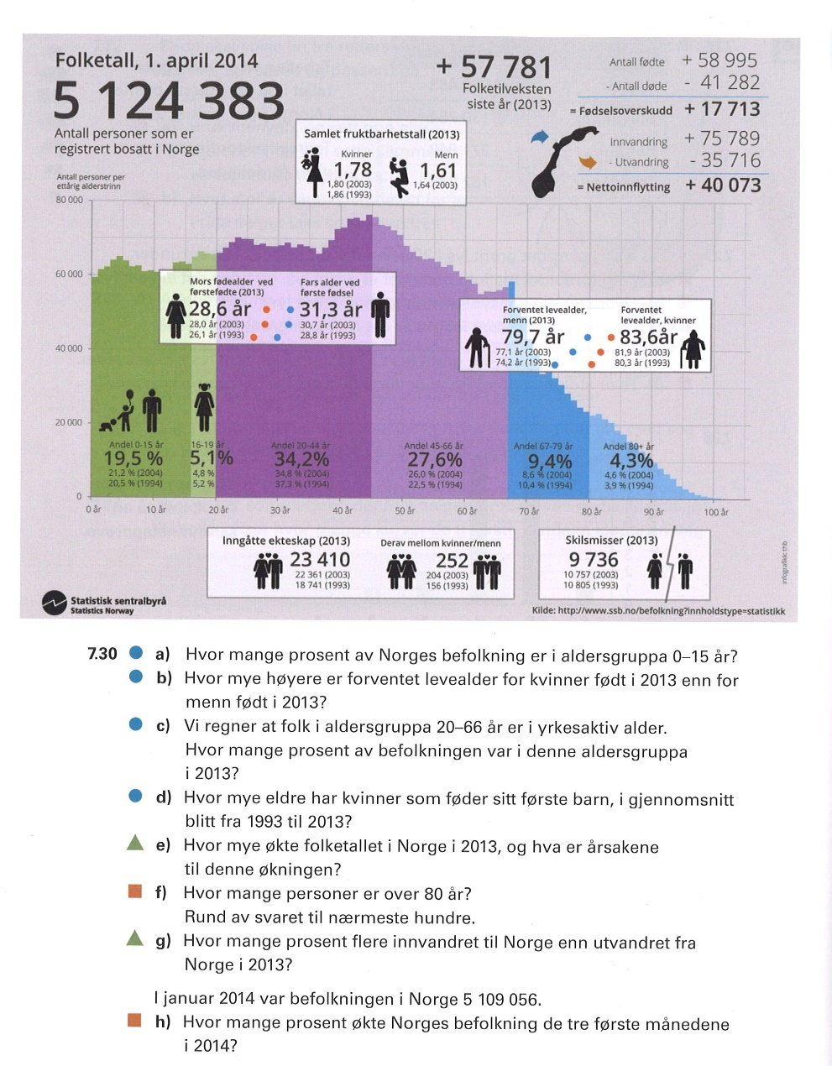
Source: Bakke, Bakke, Elektronisk Undervisningsforlag AS (2014)
In addition, SSB’s website is one of the few accepted web resources during exams in upper secondary school. For several years, schools have made requests for visiting SSB so that the pupils can learn more about our website. SSB has therefore, in a small scale, arranged courses for school classes.
Even if most schools in Norway do use SSB’s website to some extent, there is a potential for a more systematic approach to reach young people within the education system. There are especially three major opportunities for SSB to promote the use of official statistics in school:
- In school, young people learn how to be conscious and make use of reliable sources. Digital skills are one of the core skills in the education system defined by the Norwegian government. Within this topic there are several relevant attainment goals related directly to the use of references, like “Pupils should be able to use and evaluate different sources in work with subjects» (upper secondary school) and “Pupils should be able to use search strategies and refer to sources in their own work” (secondary school).

- Within social science the standard for being able to count is defined as: “Being able to count on social sciences means being able to collect, work with and evaluate the speech scope of the academic topic, and to present this in tables, graphs and figures.” Within a variety of subjects there are also several attainment goals that refer to statistics that SSB provide. For example, in Social economics at the upper secondary school level: “explain how the income distribution is in Norway” and “explain how employment and unemployment are measured”.

- The Norwegian schools’ curriculum allows schools to decide on what teaching materials to use: “The curricula for subjects are designed so that the school will have the opportunity to choose content, teaching materials, activities and working methods. The local action space gives schools the opportunity to adapt the training to their students and through the elections contribute to increased learning outcome”.
This creates a space for SSB to make our statistics available and useful for the schools.
SSB’s goals for targeting schools are to:
- improve statistical literacy,
- familiarise pupils with the value of official statistics in society,
- make official statistics a preferred source of factual information for them as they grow up,
- give us insight into user needs and behaviour of future users.
SSB does not rule out reaching young people in their leisure time. We continuously develop content for the social media. Here we use simple infographics, videos and humour to present at different side of SSB. Facebook is our main some channel, but this is no longer the preferred social media among youngsters. We are currently developing a plan for SSB’s Instagram account, where we aim to reach a younger population. Our goal is to strengthen both our reputation and the awareness of the existence of SSB, rather than adding to the educational knowledge. We also experiment with more fun and interactive activities on our website with young people as our target group.
3.2. The upper secondary school level
In the first phase of SSB School, we focus on teachers and pupils at the upper secondary school level, age 16 to 19. There are two reasons for this.
The first reason is that we already have a lot of experience in making content for this age group. The website ssb.no aims to make the main part of the content available and understandable for 16-year-olds and above. If a 16-year-old understands the content, it is also understandable for a large part of the population. This means that pupils in upper secondary level is already part of the target group for a lot of the products that SSB make. This is the case for articles, facts sheets, tables, infographics etc.
SSBs guidelines on writing states that “a text is ready when readers find what they need, understand the text and can use what they find, to do what they are supposed to”. The guidelines on writing includes concrete advice on how to write. Employees are encouraged to consider target groups and the use of language when they write. This includes even headings in tables. We want them to be easy understandable and concrete.
Two years ago, the Communication Department developed a new product on the website aimed at the younger population, where you can find main facts after specific topics. In these fact sheets we have gathered key figures from various statistics to say something about a certain topic. For example, the topic gender equality. The fact sheet will give you statics about salary, education, employment, part-time employment etc. The fact sheet gives you numbers, short explanations, graphs and visualisations. If the user wants more in-depth information, they will be able to click on the reference and explore further. We have created fact sheets for 21 different topics so far. They can be used as a quick way to get the numbers you need and as a guideline to more information. We believe the product is perfect for upper secondary school.
Figure 2. Fact sheet on gender equality
The picture shows a small part of the fact sheet. Visualisations and graphs dominate the design.
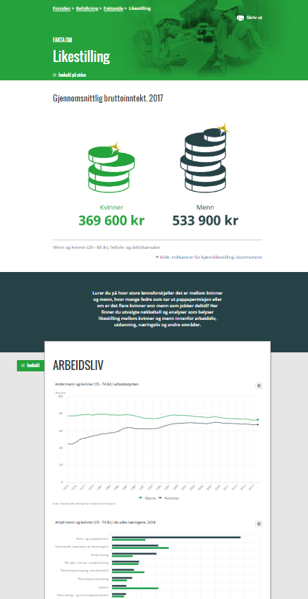
Source: www.ssb.no/befolkning/faktaside/likestilling
Our annual publication This is Norway contains figures and short easy-read texts on a variety of topics. This is one the very few publications that SSB still prints. Teachers can order sets for the class. This publication is popular among teachers, also in primary and secondary education. In 2019 we have developed a digital version of this publication, not just a pdf, but a different product with more interactive options, but based on the same facts. It is also accessible on your mobile.
In 2017 SSB made another strategic choice that SSB School can benefit from: SSB News. SSB News targets journalist especially. Articles written for SSB News should be short, easy read and have a clear news angel. These articles are also of use and understandable for pupils in upper secondary school.
With all these statistical products already made available for 16-year-olds, SSB School can use these and guide the teachers to the content that can be of use in classrooms. We will explain more about in chapter 4.
The second reason for choosing the upper secondary school is resources. The long-term aim is to include both primary and secondary education, but it demands a lot more knowledge, research and production of specialised content to work. It will demand more human resources and technological resources to develop new products.
3.3. The teacher
SSB has decided to target the teachers, and not the pupils directly in SSB School. Limited resources are also a reason behind this priority. But there are also other reasons for choosing the teacher.
From our experience with communication with teachers for many years, we know that many teachers have knowledge of SSB, have trust in SSB and use our website, especially in upper secondary level. Since ssb.no is one of the references allowed during exams in upper secondary school, many teachers encourage the pupils to use and learn the website.
During a recent workshop SSB held with teachers, they said they used the website for planning lessons. They especially looked for ready-made graphs and updated figures. The school books are not updated often, and the teachers use the website to get numbers, for example on unemployment, GDP, CPI, etc. If they guided their pupils to use the website, they gave them a direct URL to a table or article. They rarely let the pupils just try to find something for themselves. The teachers find the website complicated and must make the time to prepare themselves to guide the pupils. If SSB School can provide help and content that the teachers need, it will be easier for them to guide the pupils.
The teachers follow a strict plan and know the educational targets for the pupils. They know what information the pupils need, and at what time. This will vary from school to school, subject to subject, teacher to teacher, and between different levels. It is challenging for SSB to provide the right information at the right time, if we wanted to reach the pupils directly. We experience this in the courses we give to classes that visit SSB. The course has a set format, and the pupils might find this only partly relevant at the time they are there, while it is possible that the information would be more relevant if they got it at a time they needed it. If we help the teacher, he or she can find the information they need, when they need it.
Most of the information made from other institutions that target schools, like the parliament and the public broadcaster, is organised after attainment targets defined by the Norwegian Directorate for Education and Training in Norway. In the recent workshop, the teachers said it was important that the information was organised according to these targets. In their research for lessons, they search for information relevant for specific attainment targets. This can be done quite easily. If we were to target the pupils, this structure might not be inspiring for the pupils. It will demand more planning when it comes to the use of language and visualisations. We will also have to change channels more rapidly. The teachers can be reached in already established channels, like the website and Facebook.
Relevant for this priority, is also the fact that for every teacher we reach, we also reach a potentially large number of pupils at the same time. This is a very efficient way for SSB to work.
This said, it does not mean that we do not try to aim the pupils at all. The fact sheet on the website, for example, is a product we think the pupils can easily access themselves without the teachers. We know that only 15 per cent of our users start at front page of the website. We worked with Google search optimization on the fact sheet, thinking that young people and others will reach the pages through Google when searching for facts, for example about unemployment and immigration. We will continue to welcome classes for school visits, where we can have direct contact with the pupils. For 2019, SSB will also join the European Statistics Competition that are aimed at the pupils directly.

4. Activities
In this section we describe our main activities and our experience with them.
4.1. Communication with the teachers
We communicate with the teacher on several platforms and in different ways. In November 2018, SSB joined a large nationwide exhibition for teachers. During the two days teacher could come visit our stand at the exhibition and ask questions, and we would do instant courses on how to find what they needed on our website.
In February 2019 we produced our first newsletter for teachers. We use a newsletter template (MailMojo) that is customised with SSB’s graphic profile. The content for the newsletter is based on links to relevant content that either has recently been produced by SSB, like a new topic for a fact sheet, a visualisation, an article that we think might be relevant for the teachers, or content that are relevant in a certain period. For example, the international women’s day. A week before we sent out a newsletter with different resources that could be used if the teacher wanted to discuss this topic in connection with that day.

Figure 3. Newsletter from SSB School
The picture shows an excerpt of the newsletter.
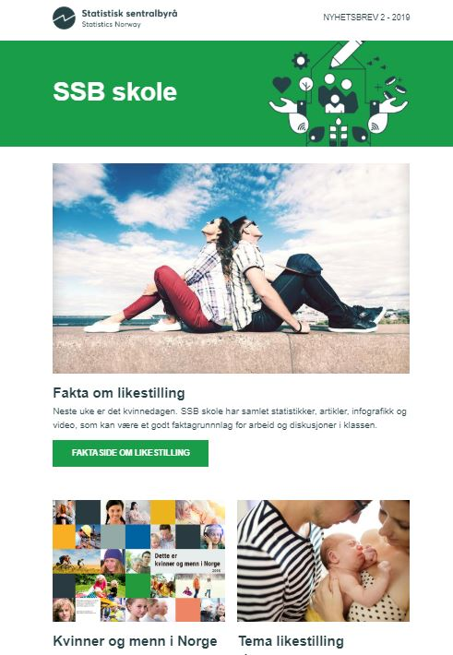
To get teachers to sign up for the newsletter we have advertised in different ways. At a teacher exhibition in November, teachers could sign up for the newsletter. We advertised in the largest labour union magazine for teachers and we had a sponsored post directed at teachers through our Facebook page. Through research, we have found two large, and very active groups, for teachers on Facebook. We have joined these groups, both to observe and learn more about the needs of the teachers and to inform the members about the newsletter and other products. We also used our network of teachers that we have had contact with the recent years.
The original goal was four newsletter a year and to have 1000 teachers sign up for the newsletter by the end of 2019. After the start up, we have found that making the newsletter is not too time consuming and we will produce more than four. Instead of setting an exact number we produce a newsletter when we have enough relevant content or if there are special occasions. For example, we prepare a newsletter with statistics on election this autumn when Norway will have local elections.
Getting close to six months into the annual plan, we see that our goal of getting 1000 teachers to sign up for the newsletter by the end of the year, was too ambitious. The numbers do increase, but in a slow pace. The statistics show us that advertising increase the sign-ups. We also hope that if the teachers do find the newsletter useful, that the word will spread. In November we will join the national teacher exhibition. This will be a great opportunity to tell teachers about the newsletter.
In April we had our first workshop with teachers. The workshop had two parts, and two goals. We invited teachers to join a focus group, where we asked about the use of our website when planning lessons. The second part was a course in how to find what you need on our website. We invited all upper secondary schools in Oslo and in the municipalities around Oslo. Around 30 teachers signed up, and they were divided into three different focus groups. The insight from these focus groups have been very useful in understanding teachers’ needs and gave us several tips on how to develop SSB School further. The teachers are short of time, and therefore need to find what they need fast. They asked for short films that explain how to find things on the website, and they wanted to show videos on different topics during their lessons. Many of the teachers expressed that they found it complicated to navigate on the website.
We communicate with both teachers and pupils during the class visits at SSB. We have around 20 classes visiting us each year. We have made a program with various components, like how to find statics on our website and how to use statics to research a specific topic. During the years, we have altered the program according to feedback from the teachers. At SSB we have general courses in how to find your way on our website for adults from all sectors. Recently, some schools have contacted SSB and asked for a course for a group of teachers at their school. So far, we have just responded positive when asked, but in the future, we like to offer more courses for teachers.
4.2. The website
In the beginning of 2019 we published SSB School on our website. It is a section on our website especially for teachers. The aim is to gather the best content for educational purposes which is already published on our website and organise it in a way that is easily accessible for teachers. For example, employment and unemployment, which is one of the most important topics in social economics in upper secondary school. We have written a couple of short articles that guide the teachers to the fact sheet and relevant articles. We give advice on which tables to choose in the Statbank and we make short videos. At the website in general, we have many good visualisations. At the SSB School site, we gather the best visualisations that we believe can be used in the classroom to discuss a topic. We also link to This is Norway and other publications.
We decided not to have a separate design profile for SSB School. SSB is greatly trusted by the population. By using the same graphic profile on all the visual products we make, we continue branding SSB and building more trust. But we have made a form of logo for SSB School, which is a small picture made of icons. We use this element on the website, the newsletter, in adverts, and other communication regarding SSB School.
Figure 4. SSB School logo
5. Conclusion
We think that we are on the right track reaching the young population through the school. This is the right place for young people to get used to statistics and be aware of different sources.
We are also pleased with the dialogue and the feedback we get from teachers, and we think is was a right priority to focus on the teacher. The teachers are a well of insight and good information about their pupils.
We should, and we will, reach for younger pupils. At the teacher exhibitions we talked to teachers at all levels, and there were interest and need for statistics. But for the first operational year, it was necessary to start up in a small scale.
The next big event for SSB School is the European Statistics Competition. This will give us further experience and insight. The autumn 2019 will be important for the planning of 2020 and how to take SSB School to the next level.
Still, with limited resources, we need to think smart on how to reach as many as possible, at the same time. E-learning and video will be explored. There are several ongoing e-learning projects in SSB, and SSB School will use this experience to see if we can develop a useful e-learning course, either for the pupils, or for the teachers.
SSB School is not just a limited project, but a strategical choice for SSB. It is described in both SSB’s main strategy and the communication strategy. This is important for the stability and the future development for SSB School. The object in the new law on official statistics in Norway that emphasise general public education, is also of great importance. It clarifies the dissemination responsibilities SSB have. To target the young generation, is an important part of public education.
6. References
The Norwegian Directorate for Education and Training, the national curriculum, complete (in Norwegian): https://www.udir.no/laring-og-trivsel/lareplanverket/ and English summary https://www.udir.no/in-english/

Statistics Norway’s strategy for 2017-2020: https://www.udir.no/laring-og-trivsel/lareplanverket/

Statistics Norway’s Communication strategy for 2017-2020: https://www.ssb.no/en/omssb/om-oss/vaar-virksomhet/planer-og-meldinger/kommunikasjonsstrategi-for-statistisk-sentralbyra-2017-2020%281%29

Proposal for a new Law on Statistics and Statistics Norway, 5th April 2019: https://www.regjeringen.no/en/aktuelt/a-new-law-on-statistics-to-meet-current-needs/id2640436/
Mathé, N. E. H. (2017). Engagement, Passivity and Detachment: 16-year-old Students’ Conceptions of Politics and the Relationship between People and Politics. British Educational Research Journal. https://www.uv.uio.no/ils/forskning/aktuelt/aktuelle-saker/2017/gi-ungdom-trening-forsta-politisk-kommunikasjon.html

