Municipal waste
- existing data ready to be utilised

Lars Viklund, lars.viklund@scb.se
Louise Sörme, louise.sorme@scb.se
Abstract
Due to the focus on circular economy, waste statistic is gaining more attention. Consequently, waste statistic production has to evolve and adapt in order to meet increasing demands from society and decision makers. In the strive to be constantly up to date Statistics Sweden reached out to actors within the municipal waste management sector to get hold of valuable, previously unavailable waste data. Together with the leading Swedish waste management software developer, Statistics Sweden has gained access to data on collected municipal solid waste on the level of waste generators (e.g. household, enterprises). This was done through a machine-to-machine solution that enabled data to be transferred from the municipal waste management software to Statistics Sweden via API (application programming interface). Due to the machine-to-machine solution it is possible to gain access to large datasets and at the same time keep the respondent burden to a minimum. The solution utilizes the high tech aspects of municipal waste management. Radio-frequency identification (RFID) tags are attached to the waste bins, and the garbage collection vehicles are equipped with bin-weighing equipment. Upon waste collection, the waste is automatically weighted and the data is instantly transferred to the waste management software. The data is then delivered to Statistics Sweden via the implemented machine-to-machine solution. It is possible to combine the waste data with other data sources, such as the business register. Thus, enabling us to investigate waste generation by different reporting groups and to study seasonal variation in a way that has not been possible before. This project has proven to be a successful example of identifying an existing data source and extending the data chain from the administrative software of the respondent to the national statistical producer. Since waste management in the Nordic countries shares characteristics, this approach could probably be implemented elsewhere.
Keywords: machine-to-machine, register data, API, municipal waste
1. Introduction and background
The aim of this paper is to describe how Statistics Sweden got hold of waste data from municipalities via an implemented machine-to-machine solution. The planning and the progress of the project is described. Then it comes to the potential of the data source, a special focus has been to learn more about waste from supermarkets.
Due to the focus on circular economy, waste statistic is gaining more attention. Consequently, waste statistic production has to evolve and adapt in order to meet increasing demands from society and decision makers. In the strive to be constantly up to date Statistics Sweden reached out to actors within the municipal waste management sector to get hold of valuable, previously unavailable waste data. Together with the leading Swedish waste management software developer, Statistic Sweden has gained access to data on collected municipal solid waste on the level of waste generators (e.g. household, enterprises).
  - Environmental impacts of food waste
Food waste related topics have gained a lot of attention in recent years – due to increased focus on the environmental aspects of food production. Production and consumption of food have vast environmental impact and contribute to greenhouse gas emissions, as well as eutrophication (Swedish EPA, 2018). Stakeholders try to reduce negative environmental impact linked to food waste in different ways. Setting measureable and relevant goals and taking actions to reach those goals, is one way to tackle the environmental problems. Food waste related goals and targets exist across global, national, regional as well as local decision-making levels. For instance, one of the indictors within the UN Sustainable Development Goals is specifically linked to food waste. Indicator 12.3 reads: “By 2030, halve per capita global food waste at the retail and consumer levels and reduce food losses along production and supply chains, including post-harvest losses”. Food waste issues are also addressed in Sweden.
Within the system of environmental objectives, one of the milestone targets is “Better resource management in the food chain”. It stipulates: “measures are to be taken so that, by 2020, resource management in the food chain is improved through separation and biological treatment of at least 50 per cent of food waste from households, catering services, shops and restaurants, with the aim of recovering plant nutrients, with at least 40 per cent treated in such a way that energy is also recovered”.
  - Growing demand for food waste statistics
It is clear that the food waste question is important to society. Therefore there is a need for food waste statistics. Which, in turn, stresses the need for reliable data sources. Regarding the Swedish milestone target mentioned above, different data sources are being used to follow up whether the target is met. One of the most important data sources is detailed waste data from municipalities. In Sweden, municipal waste operations cover many different areas of responsibilities. In order to manage the waste operations, municipalities use waste management software to organize the waste collection tasks (invoicing, customer registers, collection schemes, collected waste, etc.). This means that the municipal waste management software handles a lot of information. Information that can be used to produce statistics, for example collected amounts of mixed municipal solid waste and separately collected food waste from different types of customers. This data is needed to follow up on the Swedish milestone target.
However, this data has not been easily accessible before. The data is imbedded in the waste management software, but it is not stored and structured in a way that makes it easy for municipalities to export and deliver data to a statistical producer. This challenge exists since the primary purpose of the software is waste management, and not to deliver data to a statistical producer.
None the less, this presents a problem when it comes to produce statistics. Even if the respondents, the municipalities, are positive to contributing with data, they are not able to extract/export the needed data without the support from the waste management software developer. Since the respondents cannot fulfil the data request by themselves, the respondent burden has to be described as high. In terms of following up on the Swedish milestone, this challenge results in a very time-consuming data collection and high levels of non-response. In order to tackle the problems with non-response and the time-consuming data collection, Statistics Sweden reached out to the leading Swedish waste management software developer. The aim was to find a way to make it easier for municipalities do deliver data to Statistics Sweden.
2. Getting hold of waste data
One of the leading waste management software developers in Sweden is a company called EDP. Approximately 260 out of 290 municipalities use their waste management software. Therefore, EDP could play an important role when it comes to enabling municipalities to deliver data to Statistics Sweden.
The first talks between EDP and Statistics Sweden were without pre-conditions and took place in early 2016. After a while, the dialog formalized into an actual pilot project. In June 2018, the EDP software system was updated with a machine-to-machine solution: A technical solution imbedded in the waste management software making it possible for the municipalities to deliver data to Statistics Sweden with only a few keystrokes.
The planning and the progress of the project is chronologically presented below.
- February 2016
The first dialog between Statistics Sweden and the software developer. The informal talks focused on the type of information available in the software; how the data is structured; and how EDP can help municipalities to deliver data to Statistics Sweden.
- March 2016 – July 2017
After the first talks in February 2016, it took some time to determine the conditions for the project and securing the financial and personal resources needed to initiate a pilot project. In the end of this period, three municipalities were approached and asked if they were interested in participating in the pilot project. All three agreed to participate.
- August 2017 – June 2018
The pilot project started formally in August 2017. Swedish EPA was the commissioning body and the SMED consortium carried out the project in cooperation with EDP. One of the first tasks of the project group was to decide what kind of solution to implement. Two options were on the table, a human-to-machine solution or a machine-to-machine solution. A human-to-machine solution would have been easier to implement, but would require more effort from the respondents because they would still need to send the data manually to Statistics Sweden. Instead, the pilot project decided to implement a machine-to-machine-solution. Extensive data-transferring tests were conducted during spring 2018 to make sure that the API (application programming interface) worked flawlessly. In June 2018 the machine-to-machine solution is finalized and implemented in the waste management software. This solution enables municipalities to transfer data from the municipal waste management software to Statistics Sweden with just a few keystrokes. The data is transferred via the API and thanks to the machine-to-machine solution, it is possible for Statistics Sweden to gain access to large datasets while keeping the respondent burden to a minimum.
Figure 1. How municipalities deliver data to Statistics Sweden with the implemented machine-to-machine solution.
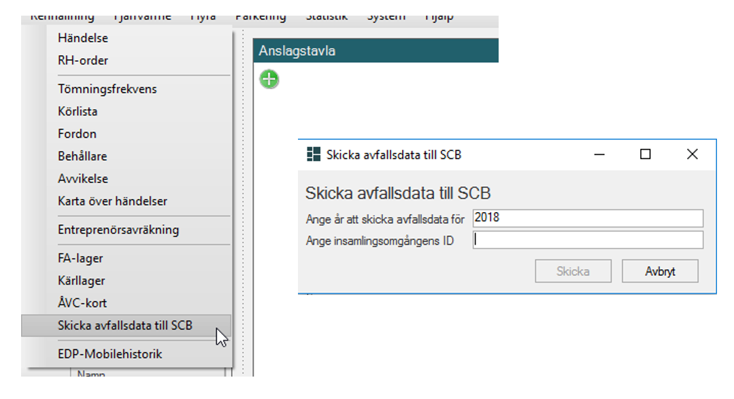
Source: Screenshot from waste management software (EDP Future).
- August 2018 – November 2018
After receiving data from the three municipalities, Statistics Sweden evaluated the data. The obtained waste data contained more than 4 million rows of detailed information about collected waste (e.g. waste type, date of collection, weight, type and size of bin, customer and waste collection address). The evaluation was carried out with two different approaches: a top-down based evaluation and a bottom-up evaluation. In the bottom-up evaluation test were carried out to assign the objects in the received data to groups, such as individuals (households in single-family houses) or companies by economic activity. The evaluation showed that more than 98 % of the objects could be assigned to a specific reporting group, see table 1.
Table 1. Number of facilities per client-category and municipality
Municipality | Individuals in single-family houses  (%) | Companies in NACE A-F  (%) | Companies in NACE G-U  (%) | Companies in unknown NACE (%) | Unknown objects (individuals or companies)  (%)
X | 90,0 | 1,2 | 7,3 | 0,2 | 1,4
Y | 90,5 | 0,9 | 6,3 | 0,1 | 2,2
Z | 92,0 | 0,6 | 5, 7 | 0,1 | 1,7
Total | 90,7 | 0,9 | 6,5 | 0,1 | 1,8
Note that sector G-U includes apartment blocks (e.g. NACE 68)
From a bottom-up perspective, the conclusion is therefore that the data source is of very good quality. But, depending on how the survey situation is defined, it is also important to assess the degree of coverage of the municipal waste registers in relation to the group you want to study. For example, of all restaurants in a municipality, how many are covered by the data source? The top-down evaluation focused on a few types of enterprises (defined by NACE codes) and showed that the data source do not (directly) cover all enterprises in a municipality. Given the structure of municipal waste management, this is not unexpected. It is common that property-owners provides garbage/recycling room for tenants to use. In those cases, the property-owner is registered as a client in the municipal waste management software, the tenants are not. Resulting in a lacking link between the (de facto) waste generator and the client in the waste management software. The evaluation was completed in November 2018.

  - High tech waste management
The solution utilizes the high tech aspects of municipal waste management. Radio-frequency identification (RFID) tags are attached to the waste bins, and the garbage collection vehicles are equipped with an RFID antenna. The RFID tags enables the waste management software to keep track on to whom the waste bin belong to. Upon waste collection, waste data is instantly transferred to the waste management software. The data is then delivered to Statistics Sweden via the implemented machine-to-machine solution.
Figure 2. Schematic flow of municipal waste data
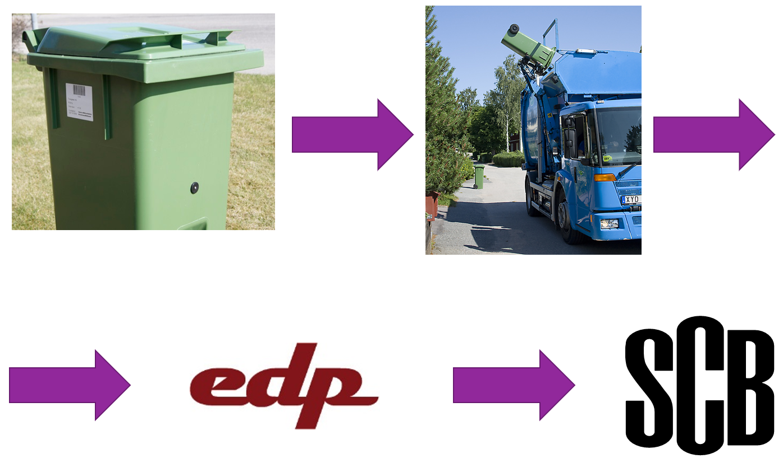
Source: Statistics Sweden.
In Sweden, municipalities have a key role in terms of waste management. In the environmental code it is clarified that the municipalities are responsible to collect household waste from households and similar waste from commerce, business and enterprises. Even though the obligations are the same for all municipalities, waste collection can be organized in different ways. For instance, although all Swedish municipalities apply some version of pay as you throw pricing model (according to the polluter pays principle), there are different fee systems in practice. The most common pricing model is the volume based fee system. The fee is based on the volume of bin, larger sized bins means higher fees. This system do not require that the garbage collection vehicles to be fitted with bin-weighing equipment. In the context of the implemented machine-to-machine solution, this means that the delivered data to Statistics Sweden includes, among other things, waste type and date, but not the weight of the collected waste.
Figure 3. Municipalities with weight based fee system.
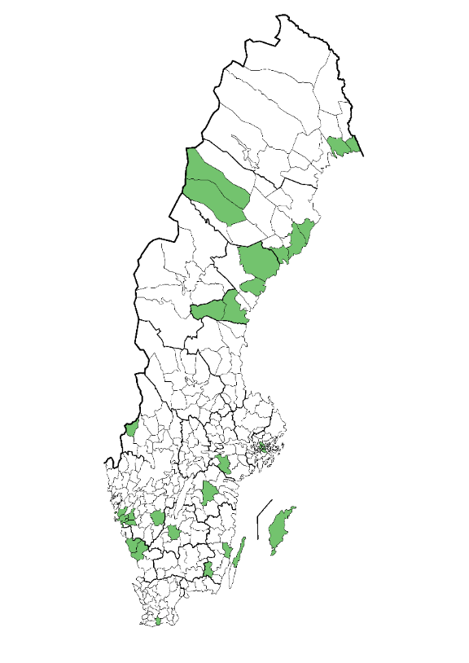
Source: Statistics Sweden
Besides the volume based fee system, there are also weight based fee systems. In those cases, the fee is based on the weight of the collected waste. In Sweden there are approximately 30 municipalities, out of 290, that apply a weight based fee system, see figure 3. The three municipalities taking part in the pilot project all practice a weight based fee system. This enables data on a very fine and detailed level. The weight based fee system requires that the garbage collection vehicles are equipped with bin-weighing equipment. Upon waste collection, the waste is automatically weighted and the data is instantly transferred to the waste management software. The data is then delivered to Statistics Sweden via the implemented machine-to-machine solution.
3. Applications of the data source
Data obtained by the machine-to-machine solution is used to follow up on the Swedish milestone target mentioned earlier. But, the data can also be used within many other fields of waste statistics.
In an ongoing study, the municipal waste data is used to gained enhanced knowledge about waste generation, over time, from supermarkets in Sweden. Both municipal solid waste/residual waste and separately collected food waste is included in the study. Since the obtained data is detailed, it is possible to preform trend analysis and to study seasonal variation of waste generation.
Figure 4. Illustration on municipal waste collected from a supermarket.
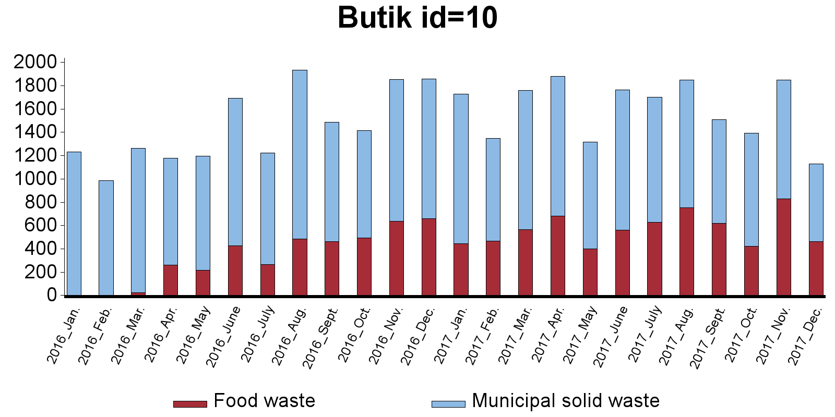
Source: Statistics Sweden
In the study, waste data from municipalities is combined with information from the business register to identify supermarkets. When combining detailed waste data with information from other sources there is possible to produce descriptive statistics as well as getting input to analysis.
4. Concluding remarks
This project has proven to be a successful example of identifying an existing data source and extending the data chain from the administrative software of the respondent to the national statistical producer. The data source is already used to produce statistics and to follow up environmental targets. But, the data source also open up possibilities to produce new kinds of statistics. For instance, if waste data is combined with population statistics, it will be possible to produce waste statistic on a very detailed level. Therefore, the full potential of the data source is yet to be utilised.

5. Acknowledgements
Contribution to the work was gained from Swedish Environmental Protection Agency, Grant 802-0088-17, as well as fund from agreement 2240-17-005 Swedish Environmental Protection Agency and internal funds at Statistics Sweden.
In the ongoing study with focus on supermarkets, Statistics Sweden leads the project, and the Swedish Environmental Institute and Linnaeus University are members.
6. References
Swedish Environmental Protection Agency, 2018. Food waste in Sweden, Generation and treatment 2016. Available at http://www.naturvardsverket.se/Documents/publikationer6400/978-91-620-8811-8.pdf?pid=22466

https://unstats.un.org/sdgs/indicators/indicators-list/
http://www.swedishepa.se/Environmental-objectives-and-cooperation/Swedens-environmental-objectives/Milestone-targets/
Swedish EPA is responsible for waste statistics in Sweden, but Statistics Sweden are producing the statistics together with other organisations in a consortium called SMED. www.smed.se
Photos courtesy of: Waste bin with RFID tag: Ånge kommun (municipality of Ånge). Garbage collection vehicles: VafabMiljö Kommunalförbund (local federation VafabMiljö).
Swedish Code of Statutes (SFS) 1998:808

